CODE:

import os
os.environ["OMP_NUM_THREADS"] = "4"
os.environ["MKL_NUM_THREADS"] = "4"
os.environ["OPENBLAS_NUM_THREADS"] = "4"
os.environ["NUMEXPR_NUM_THREADS"] = "4"
os.environ["VECLIB_MAXIMUM_THREADS"] = "4"

import subprocess, sys, importlib, gc

def install_package(package):
try:
importlib.import_module(package.split("==")[0].replace("-", "_"))
print(package)
except ImportError:
print("Installing " + package)
subprocess.check_call([sys.executable, "-m", "pip", "install", package])

for pkg in ["numpy", "pandas", "scikit-learn", "xgboost",
"imbalanced-learn", "matplotlib", "seaborn", "joblib", "scipy", "shap"]:
install_package(pkg)

try:
import torch
print("PyTorch " + torch.__version__)
except ImportError:
subprocess.check_call([sys.executable, "-m", "pip", "install",
"torch==2.0.1", "torchvision==0.15.2", "torchaudio==0.2.2",
"--index-url", "https://download.pytorch.org/whl/cpu"])
import torch

torch.set_num_threads(4)

import numpy as np
import pandas as pd
import xgboost as xgb
import torch.nn as nn
import torch.nn.functional as F
from torch.utils.data import DataLoader, TensorDataset
from imblearn.over_sampling import SMOTE

SHOW_FIGURES_ON_SCREEN = True

import matplotlib
try:
get_ipython()
get_ipython().run_line_magic('matplotlib', 'inline')
except NameError:
if SHOW_FIGURES_ON_SCREEN:
for backend in ["TkAgg", "Qt5Agg", "QtAgg", "GTK3Agg"]:
try:
matplotlib.use(backend)
print("Interactive backend activated: " + backend)
break
except Exception:
continue
else:
matplotlib.use("Agg")
print("No interactive backend available -> save-only mode")
else:
matplotlib.use("Agg")

import matplotlib.pyplot as plt
import seaborn as sns
import shap

if SHOW_FIGURES_ON_SCREEN:
try:
plt.ion()
plt.rcParams['figure.raise_window'] = False
except Exception:
pass

import warnings, time, logging, json, joblib, platform
from datetime import datetime
from pathlib import Path
from collections import Counter
warnings.filterwarnings("ignore")

from sklearn.preprocessing import StandardScaler, LabelEncoder, label_binarize
from sklearn.metrics import (accuracy_score, precision_score, recall_score, f1_score,
confusion_matrix, classification_report,
matthews_corrcoef, cohen_kappa_score,
precision_recall_fscore_support,
roc_curve, auc, precision_recall_curve,
average_precision_score, brier_score_loss)
from sklearn.calibration import calibration_curve
from sklearn.base import BaseEstimator, ClassifierMixin
from sklearn.svm import SVC
from sklearn.ensemble import RandomForestClassifier, StackingClassifier
from sklearn.linear_model import LogisticRegression
from sklearn.impute import SimpleImputer
from sklearn.feature_selection import SelectKBest, mutual_info_classif, VarianceThreshold
from sklearn.utils.class_weight import compute_sample_weight
from sklearn.model_selection import train_test_split, learning_curve
from sklearn.decomposition import PCA
from scipy.stats import binomtest

RANDOM_SEED = 42
np.random.seed(RANDOM_SEED)
torch.manual_seed(RANDOM_SEED)
RNG = np.random.RandomState(RANDOM_SEED)

try:
plt.style.use("seaborn-v0_8-darkgrid")
except OSError:
plt.style.use("seaborn-darkgrid")
sns.set_palette("husl")
plt.rcParams.update({"figure.figsize": (12, 8), "font.size": 12})

COLOR_NSL = "#3B6E8F"
COLOR_CIC = "#C8553D"
COLOR_HYB = "#2A9D8F"

class Config:
def __init__(self):
self.fast_mode = False
self.nsl_kdd_folder = Path(r"C:\Users\desir\Desktop\CARINE EX FINAL\NSL-DD dataset\nsl-kdd")
self.nsl_kdd_train_path = self.nsl_kdd_folder / "KDDTrain+.txt"
self.nsl_kdd_test_path = self.nsl_kdd_folder / "KDDTest+.txt"
self.cicids2017_folder = Path(r"C:\Users\desir\Desktop\CARINE EX FINAL\CICIDS 2017 DATASET")
self.results_folder = Path(r"C:\Users\desir\Desktop\CARINE EX FINAL\results")
self.results_folder.mkdir(parents=True, exist_ok=True)
self.models_folder = self.results_folder / "models"
self.models_folder.mkdir(parents=True, exist_ok=True)
self.test_size = 0.3
self.nsl_cnn_epochs = 15
self.cicids_cnn_epochs = 15
self.cnn_patience = 4
self.cnn_subsample = 20_000
self.min_class_for_smote = 100
self.max_smote_ratio = 5.0
self.run_baseline_no_smote = True
self.run_ablation = True
self.run_shap = True
self.run_extended_viz = True
self.run_split_comparison = True
self.shap_max_samples = 500
if self.fast_mode:
self.nsl_sample_limit = 8_000
self.cicids_n_features = 25
self.cicids_max_per_class = 4_000
self.smote_target = 3_000
self.nsl_smote_target = 3_000
else:
self.nsl_sample_limit = None
self.cicids_n_features = 55
self.cicids_max_per_class = 40_000
self.smote_target = 10_000
self.nsl_smote_target = 5_000

def as_dict(self):
return {k: (str(v) if isinstance(v, Path) else v) for k, v in self.__dict__.items()}

config = Config()

class _Tee:
def __init__(self, *streams): self.streams = streams
def write(self, data):
for s in self.streams: s.write(data); s.flush()
def flush(self):
for s in self.streams: s.flush()

def setup_run_logging():
run_id = datetime.now().strftime("%Y%m%d_%H%M%S")
log_path = config.results_folder / ("run_log_" + run_id + ".txt")
log_file = open(log_path, "w", encoding="utf-8")
sys.stdout = _Tee(sys.stdout, log_file)
logging.basicConfig(level=logging.INFO, format="%(asctime)s - %(levelname)s - %(message)s")
print("Run log: " + str(log_path))
return run_id, log_path

def save_run_manifest(run_id):
manifest = {
"run_id": run_id,
"timestamp": datetime.now().isoformat(),
"random_seed": RANDOM_SEED,
"python_version": platform.python_version(),
"platform": platform.platform(),
"classes": ["Botnet", "Brute_Force", "DDoS", "DoS", "Normal", "Port_Scan"],
"excluded_classes": ["Web_Attack", "Infiltration", "Other"],
"library_versions": {
"numpy": np.__version__, "pandas": pd.__version__,
"xgboost": xgb.__version__, "torch": torch.__version__,
"shap": shap.__version__,
},
"config": config.as_dict(),
}
out = config.results_folder / ("run_manifest_" + run_id + ".json")
with open(out, "w", encoding="utf-8") as f:
json.dump(manifest, f, indent=2, ensure_ascii=False)
print("Reproducibility manifest: " + str(out))
return manifest

NSL_KDD_COLUMNS = [
"duration", "protocol_type", "service", "flag", "src_bytes", "dst_bytes",
"land", "wrong_fragment", "urgent", "hot", "num_failed_logins", "logged_in",
"num_compromised", "root_shell", "su_attempted", "num_root", "num_file_creations",
"num_shells", "num_access_files", "num_outbound_cmds", "is_host_login",
"is_guest_login", "count", "srv_count", "serror_rate", "srv_serror_rate",
"rerror_rate", "srv_rerror_rate", "same_srv_rate", "diff_srv_rate",
"srv_diff_host_rate", "dst_host_count", "dst_host_srv_count",
"dst_host_same_srv_rate", "dst_host_diff_srv_rate",
"dst_host_same_src_port_rate", "dst_host_srv_diff_host_rate",
"dst_host_serror_rate", "dst_host_srv_serror_rate",
"dst_host_rerror_rate", "dst_host_srv_rerror_rate", "attack_type"
]

NSL_CATEGORY_MAPPING = {
"normal": "Normal",
"back": "DoS", "land": "DoS", "neptune": "DoS", "pod": "DoS",
"smurf": "DoS", "teardrop": "DoS", "apache2": "DoS", "udpstorm": "DoS",
"mailbomb": "DoS", "processtable": "DoS", "worm": "DoS",
"ipsweep": "Probe", "nmap": "Probe", "portsweep": "Probe",
"satan": "Probe", "mscan": "Probe", "saint": "Probe",
"ftp_write": "R2L", "guess_passwd": "R2L", "imap": "R2L",
"multihop": "R2L", "phf": "R2L", "spy": "R2L",
"warezclient": "R2L", "warezmaster": "R2L", "sendmail": "R2L",
"named": "R2L", "snmpgetattack": "R2L", "snmpguess": "R2L",
"xlock": "R2L", "xsnoop": "R2L", "httptunnel": "R2L",
"buffer_overflow": "U2R", "loadmodule": "U2R", "perl": "U2R",
"rootkit": "U2R", "sqlattack": "U2R", "xterm": "U2R", "ps": "U2R",
}

def _read_nsl_txt(filepath):
df = pd.read_csv(filepath, header=None)
n = len(df.columns)
print(" " + filepath.name + " : " + str(len(df)) + " rows, " + str(n) + " columns")
if n == 43: df.columns = NSL_KDD_COLUMNS + ["difficulty_level"]
elif n == 42: df.columns = NSL_KDD_COLUMNS
elif n > 43:
df = df.iloc[:, :42]; df.columns = NSL_KDD_COLUMNS
else: df.columns = NSL_KDD_COLUMNS[:n]
return df

def _diagnose_r2l_shift(train_df, test_df):
def _subtypes(df, cat):
return set(df.loc[df["category"] == cat, "attack_name"].unique())
print(""); print(" [Diagnostic R2L/U2R - subtypes train vs test]")
for cat in ["R2L", "U2R"]:
tt = _subtypes(train_df, cat); te = _subtypes(test_df, cat)
unseen = te - tt
n_unseen = test_df[(test_df["category"] == cat) &
(test_df["attack_name"].isin(unseen))].shape[0]
n_total = test_df[test_df["category"] == cat].shape[0]
pct = 100 * n_unseen / n_total if n_total else 0
print(" " + cat + " : " + str(len(unseen)) + "/" + str(len(te)) +
" test subtypes absent from train (" + str(n_unseen) + "/" +
str(n_total) + " rows, " + str(round(pct, 1)) + "%)")
if unseen:
print(" unseen subtypes: " + str(sorted(unseen)))

def load_nsl_kdd():
print(""); print("=" * 60)
print("LOADING NSL-KDD - 41 CANONICAL FEATURES")
print("=" * 60)
for path in [config.nsl_kdd_train_path, config.nsl_kdd_test_path]:
if not path.exists():
print("Not found: " + str(path)); return None, None, None, None, None, None

train_df = _read_nsl_txt(config.nsl_kdd_train_path)
test_df = _read_nsl_txt(config.nsl_kdd_test_path)
if config.nsl_sample_limit and len(train_df) > config.nsl_sample_limit:
train_df = train_df.sample(n=config.nsl_sample_limit, random_state=RANDOM_SEED)

train_df["__split__"] = "train"; test_df["__split__"] = "test"
df = pd.concat([train_df, test_df], ignore_index=True)

# Preprocessing (NSL-KDD):
# - Normalize attack labels, then map 40+ sub-attacks into 5 categories
# (Normal, DoS, Probe, R2L, U2R); "Other" is dropped.
df["attack_name"] = df["attack_type"].astype(str).str.strip().str.rstrip('.')
df["attack_name"] = df["attack_name"].replace("normal.", "normal")
df["category"] = df["attack_name"].map(NSL_CATEGORY_MAPPING).fillna("Other")
df = df[df["category"] != "Other"].copy()

print(""); print(" Distribution:")
print(df["category"].value_counts().to_string())

_diagnose_r2l_shift(df[df["__split__"] == "train"], df[df["__split__"] == "test"])

# Preprocessing (NSL-KDD) - Leakage-safe categorical encoding:
# LabelEncoders for protocol_type / service / flag are fit on TRAIN ONLY,
# then applied to test; unseen categories are mapped to -1.
print(""); print(" [Leakage fix #1] Fitting LabelEncoders on TRAIN only")
for col in ["protocol_type", "service", "flag"]:
if col in df.columns:
le_col = LabelEncoder()
train_values = df.loc[df["__split__"] == "train", col].astype(str)
le_col.fit(train_values)
mapping = {c: i for i, c in enumerate(le_col.classes_)}
df[col] = df[col].astype(str).map(mapping).fillna(-1).astype(int)
n_unknown = int((df[col] == -1).sum())
print(" " + col + " : " + str(len(le_col.classes_)) +
" categories from train, " + str(n_unknown) + " unknown test values -> -1")

exclude_cols = ["attack_type", "attack_name", "category", "__split__"]
if "difficulty_level" in df.columns: exclude_cols.append("difficulty_level")

X_full = df.drop(columns=exclude_cols, errors="ignore").apply(pd.to_numeric, errors="coerce")
y_full = df["category"].copy()
split_mask = df["__split__"]

X_train_raw = X_full[split_mask == "train"].reset_index(drop=True)
X_test_raw = X_full[split_mask == "test"].reset_index(drop=True)
y_train_raw = y_full[split_mask == "train"].reset_index(drop=True)
y_test_raw = y_full[split_mask == "test"].reset_index(drop=True)

# Preprocessing (NSL-KDD) - Missing-value handling:
# Drop columns with > 50% missing in train; median imputation fit on train.
missing_ratio = X_train_raw.isnull().mean()
keep_cols = missing_ratio[missing_ratio <= 0.5].index
X_train_raw = X_train_raw[keep_cols]; X_test_raw = X_test_raw[keep_cols]

imputer = SimpleImputer(strategy="median")
X_train_imp = pd.DataFrame(imputer.fit_transform(X_train_raw), columns=keep_cols)
X_test_imp = pd.DataFrame(imputer.transform(X_test_raw), columns=keep_cols)

# Preprocessing (NSL-KDD) - Remove constant columns (nunique <= 1).
nunique = X_train_imp.nunique()
keep_cols2 = nunique[nunique > 1].index
X_train_imp = X_train_imp[keep_cols2]; X_test_imp = X_test_imp[keep_cols2]

X_train_sel = X_train_imp.values
X_test_sel = X_test_imp.values

le = LabelEncoder()
y_train_enc = le.fit_transform(y_train_raw)
y_test_enc = le.transform(y_test_raw)

print("")
print("NSL-KDD : Train=" + str(X_train_sel.shape[0]) + ", Test=" + str(X_test_sel.shape[0]) +
", " + str(X_train_sel.shape[1]) + " features")
print(" Classes: " + str(list(le.classes_)))
return (X_train_sel.astype(np.float32), X_test_sel.astype(np.float32),
y_train_enc, y_test_enc, le, list(keep_cols2))

def _map_cicids_label(x):
# Preprocessing (CICIDS2017) - Label mapping to 6 classes.
# Web_Attack, Infiltration and everything else -> "Other" (excluded).
x = str(x).lower().strip()
if any(w in x for w in ["benign", "bening", "normal"]): return "Normal"
if "ddos" in x: return "DDoS"
if "portscan" in x or "port_scan" in x or "port-scan" in x: return "Port_Scan"
if "bot" in x: return "Botnet"
if "patator" in x or "brute" in x or "force" in x: return "Brute_Force"
if "dos" in x: return "DoS"
return "Other"

def load_cicids2017():
print(""); print("=" * 60)
print("LOADING CICIDS2017 - CHRONOLOGICAL SPLIT")
print("=" * 60)
if not config.cicids2017_folder.exists():
print("Folder not found"); return None, None, None, None, None
csv_files = list(config.cicids2017_folder.glob("*.csv"))
if not csv_files: csv_files = list(config.cicids2017_folder.rglob("*.csv"))
if not csv_files:
print("No CSV found"); return None, None, None, None, None
print(" " + str(len(csv_files)) + " CSV files")
dfs = []
for f in csv_files:
for enc in ("utf-8", "latin-1"):
try:
chunk = pd.read_csv(f, low_memory=False, encoding=enc)
num_cols = chunk.select_dtypes(include=[np.number]).columns
if len(num_cols) > 0: chunk[num_cols] = chunk[num_cols].astype(np.float32)
chunk["_day"] = f.stem
print(" " + f.name + " : " + str(len(chunk)))
dfs.append(chunk); break
except Exception:
continue
df = pd.concat(dfs, ignore_index=True, copy=False); del dfs
print(" Raw total : " + str(df.shape[0]))
# Preprocessing (CICIDS2017) - exact duplicate removal.
df.drop_duplicates(inplace=True, ignore_index=True)
print(" After duplicates : " + str(df.shape[0]))

label_col = next((c for c in df.columns if any(k in c.lower() for k in ["label", "attack", "class"])),
df.columns[-1])
unique_labels = df[label_col].unique()
label_lookup = {lbl: _map_cicids_label(lbl) for lbl in unique_labels}
df["category"] = df[label_col].map(label_lookup).astype("category")
df.drop(columns=[label_col], inplace=True)
df = df[df["category"] != "Other"].reset_index(drop=True)
df["category"] = df["category"].cat.remove_unused_categories()

print(""); print(" Distribution (after exclusion of Other):")
print(df["category"].value_counts().to_string())
if df.empty: return None, None, None, None, None

# Preprocessing (CICIDS2017) - Chronological split within each capture day
# (first 70% train, last 30% test) to prevent temporal leakage.
print(""); print(" Chronological split by day")
train_parts, test_parts = [], []
for day, group in df.groupby("_day", sort=False, observed=True):
cutoff = int(len(group) * (1 - config.test_size))
train_parts.append(group.iloc[:cutoff]); test_parts.append(group.iloc[cutoff:])
print(" " + str(day).ljust(55) + " : train=" + str(cutoff).rjust(7) +
" | test=" + str(len(group) - cutoff).rjust(7))
df_train = pd.concat(train_parts, ignore_index=True)
df_test = pd.concat(test_parts, ignore_index=True)
del train_parts, test_parts, df
df_train["category"] = df_train["category"].cat.remove_unused_categories()
df_test["category"] = df_test["category"].cat.remove_unused_categories()

# Preprocessing (CICIDS2017) - Class-size filter (>=50) computed on TRAIN ONLY.
print(""); print(" [Leakage fix #2] Minimum class size (>= 50) on TRAIN only")
train_counts = df_train["category"].value_counts()
valid_train_classes = train_counts[train_counts >= 50].index
removed_classes = sorted(set(train_counts.index) - set(valid_train_classes))
if removed_classes:
print(" Classes with < 50 train samples removed: " + str(removed_classes))
df_train = df_train[df_train["category"].isin(valid_train_classes)].reset_index(drop=True)
df_test = df_test[df_test["category"].isin(valid_train_classes)].reset_index(drop=True)
df_train["category"] = df_train["category"].cat.remove_unused_categories()
df_test["category"] = df_test["category"].cat.remove_unused_categories()

# Preprocessing (CICIDS2017) - Open-set class filter based on TRAIN classes only.
print(""); print(" [Leakage fix #3] Class filtering based on TRAIN only")
train_classes = set(df_train["category"].unique())
test_classes = set(df_test["category"].unique())
only_test = test_classes - train_classes
if only_test:
print(" Classes present ONLY in test (open-set, removed): " + str(sorted(only_test)))
keep_classes = train_classes
df_train = df_train[df_train["category"].isin(keep_classes)].reset_index(drop=True)
df_test = df_test[df_test["category"].isin(keep_classes)].reset_index(drop=True)
df_train["category"] = df_train["category"].cat.remove_unused_categories()
df_test["category"] = df_test["category"].cat.remove_unused_categories()
print(" Retained classes: " + str(sorted(keep_classes)))

# Preprocessing (CICIDS2017) - Per-class capping for scalability.
test_cap_ratio = config.test_size / (1 - config.test_size)
def _cap(frame, mx):
parts = []
for cls in frame["category"].unique():
sub = frame[frame["category"] == cls]
parts.append(sub.sample(n=min(len(sub), mx), random_state=RANDOM_SEED))
out = pd.concat(parts, ignore_index=True)
out["category"] = out["category"].cat.remove_unused_categories()
return out
df_train = _cap(df_train, config.cicids_max_per_class)
df_test = _cap(df_test, max(50, int(config.cicids_max_per_class * test_cap_ratio)))
print(" After capping - Train: " + str(len(df_train)) + " Test: " + str(len(df_test)))

# Preprocessing (CICIDS2017) - Drop IP/port/flow-ID columns to avoid trivial identifiers.
num_cols = df_train.select_dtypes(include=[np.number]).columns.tolist()
PORT_PATTERNS = ["dst port", "destination port", "src port", "source port",
"source ip", "destination ip", "flow id"]
port_cols = [c for c in num_cols if any(p in c.lower() for p in PORT_PATTERNS)]
if port_cols:
print(" Excluded columns: " + str(port_cols))
num_cols = [c for c in num_cols if c not in port_cols]
valid_cols = [c for c in num_cols if df_train[c].notna().mean() > 0.5]
print(" Valid numerical columns: " + str(len(valid_cols)))

X_train = df_train[valid_cols].copy(); y_train = df_train["category"].copy()
X_test = df_test[valid_cols].copy(); y_test = df_test["category"].copy()
X_train.replace([np.inf, -np.inf], np.nan, inplace=True)
X_test.replace([np.inf, -np.inf], np.nan, inplace=True)
print("CICIDS2017 : Train=" + str(X_train.shape[0]) + ", Test=" + str(X_test.shape[0]) +
", " + str(X_train.shape[1]) + " raw columns")
return X_train, X_test, y_train, y_test, valid_cols

def _remove_near_duplicates(df, num_cols, decimals=4):
df_rounded = df[num_cols].round(decimals).fillna(-999999)
mask = ~df_rounded.duplicated(keep="first")
return df[mask].reset_index(drop=True)

def load_cicids2017_random_split():
print(""); print("=" * 60)
print("LOADING CICIDS2017 - RANDOM SPLIT (comparison)")
print("=" * 60)
if not config.cicids2017_folder.exists():
print("Folder not found"); return None, None, None, None, None
csv_files = list(config.cicids2017_folder.glob("*.csv"))
if not csv_files: csv_files = list(config.cicids2017_folder.rglob("*.csv"))
if not csv_files:
print("No CSV found"); return None, None, None, None, None
print(" " + str(len(csv_files)) + " CSV files")
dfs = []
for f in csv_files:
for enc in ("utf-8", "latin-1"):
try:
chunk = pd.read_csv(f, low_memory=False, encoding=enc)
num_cols = chunk.select_dtypes(include=[np.number]).columns
if len(num_cols) > 0: chunk[num_cols] = chunk[num_cols].astype(np.float32)
chunk["_day"] = f.stem
print(" " + f.name + " : " + str(len(chunk)))
dfs.append(chunk); break
except Exception:
continue
df = pd.concat(dfs, ignore_index=True, copy=False); del dfs
print(" Raw total : " + str(df.shape[0]))
df.drop_duplicates(inplace=True, ignore_index=True)
print(" After exact duplicates : " + str(df.shape[0]))

# Preprocessing (CICIDS2017 random split) - near-duplicate removal (rounded to 4 decimals).
num_cols_all = df.select_dtypes(include=[np.number]).columns.tolist()
n_before = len(df)
df = _remove_near_duplicates(df, num_cols_all, decimals=4)
print(" After near-duplicate removal (4 decimals) : " + str(len(df)) +
" (removed " + str(n_before - len(df)) + " near-duplicates)")

label_col = next((c for c in df.columns
if any(k in c.lower() for k in ["label", "attack", "class"])),
df.columns[-1])
unique_labels = df[label_col].unique()
label_lookup = {lbl: _map_cicids_label(lbl) for lbl in unique_labels}
df["category"] = df[label_col].map(label_lookup).astype("category")
df.drop(columns=[label_col], inplace=True)
df = df[df["category"] != "Other"].reset_index(drop=True)
df["category"] = df["category"].cat.remove_unused_categories()
if df.empty: return None, None, None, None, None

# Preprocessing (CICIDS2017 random split) - 70/30 stratified random split.
print(""); print(" RANDOM split (70/30) - ONLY difference from chronological")
df_train, df_test = train_test_split(
df, test_size=config.test_size, random_state=RANDOM_SEED,
stratify=df["category"])
print(" Train: " + str(len(df_train)) + " Test: " + str(len(df_test)))

print(""); print(" [Leakage fix] Minimum class size (>= 50) on TRAIN only")
train_counts = df_train["category"].value_counts()
valid_train_classes = train_counts[train_counts >= 50].index
df_train = df_train[df_train["category"].isin(valid_train_classes)].reset_index(drop=True)
df_test = df_test[df_test["category"].isin(valid_train_classes)].reset_index(drop=True)
df_train["category"] = df_train["category"].cat.remove_unused_categories()
df_test["category"] = df_test["category"].cat.remove_unused_categories()

test_cap_ratio = config.test_size / (1 - config.test_size)
def _cap(frame, mx):
parts = []
for cls in frame["category"].unique():
sub = frame[frame["category"] == cls]
parts.append(sub.sample(n=min(len(sub), mx), random_state=RANDOM_SEED))
out = pd.concat(parts, ignore_index=True)
out["category"] = out["category"].cat.remove_unused_categories()
return out

df_train = _cap(df_train, config.cicids_max_per_class)
df_test = _cap(df_test, max(50, int(config.cicids_max_per_class * test_cap_ratio)))
print(" After capping - Train: " + str(len(df_train)) + " Test: " + str(len(df_test)))

num_cols = df_train.select_dtypes(include=[np.number]).columns.tolist()
PORT_PATTERNS = ["dst port", "destination port", "src port", "source port",
"source ip", "destination ip", "flow id"]
port_cols = [c for c in num_cols if any(p in c.lower() for p in PORT_PATTERNS)]
if port_cols: num_cols = [c for c in num_cols if c not in port_cols]
valid_cols = [c for c in num_cols if df_train[c].notna().mean() > 0.5]
print(" Valid numerical columns: " + str(len(valid_cols)))

X_train = df_train[valid_cols].copy(); y_train = df_train["category"].copy()
X_test = df_test[valid_cols].copy(); y_test = df_test["category"].copy()
X_train.replace([np.inf, -np.inf], np.nan, inplace=True)
X_test.replace([np.inf, -np.inf], np.nan, inplace=True)
print("CICIDS2017 (RANDOM) : Train=" + str(X_train.shape[0]) +
", Test=" + str(X_test.shape[0]) + ", " + str(X_train.shape[1]) + " raw columns")
return X_train, X_test, y_train, y_test, valid_cols

class CNN1D(nn.Module):
def __init__(self, n_features, n_classes):
super().__init__()
self.conv1 = nn.Conv1d(1, 32, kernel_size=3, padding=1)
self.bn1 = nn.BatchNorm1d(32)
self.conv2 = nn.Conv1d(32, 64, kernel_size=3, padding=1)
self.bn2 = nn.BatchNorm1d(64)
self.conv3 = nn.Conv1d(64, 128, kernel_size=3, padding=1)
self.bn3 = nn.BatchNorm1d(128)
self.pool = nn.MaxPool1d(2)
self.dropout = nn.Dropout(0.3)
self.adaptive_pool = nn.AdaptiveAvgPool1d(1)
self.fc1 = nn.Linear(128, 64)
self.fc2 = nn.Linear(64, n_classes)
def forward(self, x):
x = self.pool(F.relu(self.bn1(self.conv1(x))))
x = self.pool(F.relu(self.bn2(self.conv2(x))))
x = self.pool(F.relu(self.bn3(self.conv3(x))))
x = self.adaptive_pool(x)
x = x.view(x.size(0), -1)
x = self.dropout(F.relu(self.fc1(x)))
return self.fc2(x)

class CNNClassifier(BaseEstimator, ClassifierMixin):
def __init__(self, n_features=None, n_classes=None,
epochs=15, batch_size=256, lr=5e-4, verbose=1, patience=4):
self.n_features = n_features; self.n_classes = n_classes
self.epochs = epochs; self.batch_size = batch_size
self.lr = lr; self.verbose = verbose; self.patience = patience
self.device = torch.device("cuda" if torch.cuda.is_available() else "cpu")
self.model_ = None
self.history_ = {"train_loss": [], "val_loss": []}
def fit(self, X, y, sample_weight=None):
self.classes_ = np.unique(y)
n_feat = X.shape[1] if self.n_features is None else self.n_features
n_cls = len(self.classes_) if self.n_classes is None else self.n_classes
if self.verbose:
print("[CNN] features=" + str(n_feat) + ", classes=" + str(n_cls) +
", epochs=" + str(self.epochs))
X_tr, X_val, y_tr, y_val = train_test_split(
X, y, test_size=0.1, random_state=RANDOM_SEED, stratify=y)
X_t = torch.FloatTensor(X_tr.astype(np.float32)).unsqueeze(1)
y_t = torch.LongTensor(y_tr.astype(int))
loader = DataLoader(TensorDataset(X_t, y_t), batch_size=self.batch_size, shuffle=True)
X_v = torch.FloatTensor(X_val.astype(np.float32)).unsqueeze(1).to(self.device)
y_v = torch.LongTensor(y_val.astype(int)).to(self.device)
self.model_ = CNN1D(n_feat, n_cls).to(self.device)
counts = np.bincount(y_tr.astype(int), minlength=n_cls).astype(float)
weights = 1.0 / np.maximum(counts, 1e-6); weights /= weights.sum()
w_tensor = torch.FloatTensor(weights).to(self.device)
criterion = nn.CrossEntropyLoss(weight=w_tensor)
optimizer = torch.optim.Adam(self.model_.parameters(), lr=self.lr, weight_decay=1e-4)
scheduler = torch.optim.lr_scheduler.ReduceLROnPlateau(optimizer, patience=2, factor=0.5)
best_val, best_state, no_improve = float("inf"), None, 0
for epoch in range(self.epochs):
self.model_.train(); total_loss = 0.0
for bX, by in loader:
bX, by = bX.to(self.device), by.to(self.device)
optimizer.zero_grad()
loss = criterion(self.model_(bX), by)
if torch.isnan(loss):
print("[CNN] NaN"); return self
loss.backward()
torch.nn.utils.clip_grad_norm_(self.model_.parameters(), max_norm=1.0)
optimizer.step(); total_loss += loss.item()
avg_train_loss = total_loss / max(len(loader), 1)
self.model_.eval()
with torch.no_grad():
val_loss = criterion(self.model_(X_v), y_v).item()
scheduler.step(val_loss)
self.history_["train_loss"].append(avg_train_loss)
self.history_["val_loss"].append(val_loss)
if self.verbose and (epoch + 1) % 5 == 0:
print("[CNN] Epoch " + str(epoch+1).rjust(3) + "/" + str(self.epochs) +
" - Train: " + str(round(avg_train_loss, 4)) +
" | Val: " + str(round(val_loss, 4)))
if val_loss < best_val - 1e-4:
best_val = val_loss
best_state = {k: v.clone() for k, v in self.model_.state_dict().items()}
no_improve = 0
else:
no_improve += 1
if no_improve >= self.patience:
if self.verbose:
print("[CNN] Early stopping epoch " + str(epoch+1) +
" (val=" + str(round(best_val, 4)) + ")")
break
if best_state is not None:
self.model_.load_state_dict(best_state)
return self
def predict(self, X):
return np.argmax(self.predict_proba(X), axis=1)
def predict_proba(self, X):
self.model_.eval()
bs = min(self.batch_size, 512); n = X.shape[0]; all_probs = []
with torch.no_grad():
for start in range(0, n, bs):
end = min(start + bs, n)
X_t = torch.FloatTensor(X[start:end].astype(np.float32)).unsqueeze(1).to(self.device)
probs = F.softmax(self.model_(X_t), dim=1)
all_probs.append(probs.cpu().numpy())
del X_t, probs
return np.concatenate(all_probs, axis=0)
def __getstate__(self):
state = self.__dict__.copy()
if state.get("model_") is not None:
state["_model_state_dict"] = state["model_"].state_dict()
state["_model_arch"] = (self.n_features, self.n_classes)
state.pop("model_", None); return state
def __setstate__(self, state):
arch = state.pop("_model_arch", None)
sd = state.pop("_model_state_dict", None)
self.__dict__.update(state)
if arch is not None and sd is not None:
self.model_ = CNN1D(*arch)
self.model_.load_state_dict(sd)
self.model_.to(self.device)
else:
self.model_ = None

class SMOTEWrapper(BaseEstimator, ClassifierMixin):
# Preprocessing (inside wrapper) - SMOTE oversampling is applied
# per-class up to a target size, with cap max_smote_ratio and a
# minimum-class threshold min_class_for_smote. SMOTE is fit on the
# training fold only, so no synthetic data leaks into the test set.
def __init__(self, base_model, target_per_class=10_000, k_neighbors=5,
use_sample_weight=False, cnn_subsample=None,
min_class_for_smote=100, max_smote_ratio=5.0, active_smote=True):
self.base_model = base_model
self.target_per_class = target_per_class
self.k_neighbors = k_neighbors
self.use_sample_weight = use_sample_weight
self.cnn_subsample = cnn_subsample
self.min_class_for_smote = min_class_for_smote
self.max_smote_ratio = max_smote_ratio
self.active_smote = active_smote
def fit(self, X, y):
X = np.asarray(X); y = np.asarray(y)
counter = Counter(y.tolist()); max_count = max(counter.values())
base_target = min(self.target_per_class, max_count)
strategy = {}
if self.active_smote:
for cls, cnt in counter.items():
if cnt >= base_target or cnt < self.min_class_for_smote: continue
cls_target = int(min(base_target, cnt * self.max_smote_ratio))
if cls_target > cnt: strategy[cls] = cls_target
self.smote_report_ = {
"before": dict(counter), "strategy": dict(strategy),
"synthetic_added": {cls: strategy[cls] - counter[cls] for cls in strategy},
}
if strategy:
min_count = min(cnt for cls, cnt in counter.items() if cls in strategy)
k = min(self.k_neighbors, min_count - 1)
if k >= 1:
smote = SMOTE(sampling_strategy=strategy, random_state=RANDOM_SEED, k_neighbors=k)
X, y = smote.fit_resample(X, y)
self.smote_report_["after"] = dict(Counter(y.tolist()))
else:
self.smote_report_["after"] = dict(counter)
if self.cnn_subsample and isinstance(self.base_model, CNNClassifier):
if len(y) > self.cnn_subsample:
X, _, y, _ = train_test_split(X, y, train_size=self.cnn_subsample,
random_state=RANDOM_SEED, stratify=y)
if self.use_sample_weight:
sw = compute_sample_weight(class_weight="balanced", y=y)
try: self.base_model.fit(X, y, sample_weight=sw)
except TypeError: self.base_model.fit(X, y)
else:
self.base_model.fit(X, y)
self.classes_ = np.unique(y); return self
def predict(self, X): return self.base_model.predict(X)
def predict_proba(self, X): return self.base_model.predict_proba(X)

class MetaXGBBalanced(xgb.XGBClassifier):
def fit(self, X, y, sample_weight=None, **kwargs):
if sample_weight is None:
sample_weight = compute_sample_weight("balanced", y)
return super().fit(X, y, sample_weight=sample_weight, **kwargs)

def compute_tp_fp_tn_fn(models, X_test, y_test, class_names):
out = {}; n_classes = len(class_names)
for name, model in models.items():
y_pred = model.predict(X_test)
cm = confusion_matrix(y_test, y_pred, labels=list(range(n_classes)))
per_class = {}; total = cm.sum()
for i, cls in enumerate(class_names):
tp = int(cm[i, i]); fn = int(cm[i, :].sum() - tp)
fp = int(cm[:, i].sum() - tp); tn = int(total - tp - fn - fp)
tpr = tp / (tp + fn) if (tp + fn) > 0 else 0.0
fpr = fp / (fp + tn) if (fp + tn) > 0 else 0.0
tnr = tn / (tn + fp) if (tn + fp) > 0 else 0.0
fnr = fn / (fn + tp) if (fn + tp) > 0 else 0.0
per_class[cls] = {"TP": tp, "FP": fp, "TN": tn, "FN": fn,
"TPR": tpr, "FPR": fpr, "TNR": tnr, "FNR": fnr}
out[name] = per_class
return out

def print_tp_fp_tn_fn_table(tp_fp_table, class_names, dataset_name):
print(""); print("=" * 90)
print("TP / FP / TN / FN PER CLASS - " + dataset_name)
print("=" * 90)
for model_name, per_class in tp_fp_table.items():
print(""); print(" Model: " + model_name)
print(" " + "-" * 76)
print(" Class | TP | FP | TN | FN | TPR | FPR")
print(" " + "-" * 76)
for cls in class_names:
m = per_class.get(cls)
if m is None: continue
print(" " + cls.ljust(16) + " | " +
str(m["TP"]).rjust(6) + " | " + str(m["FP"]).rjust(6) + " | " +
str(m["TN"]).rjust(6) + " | " + str(m["FN"]).rjust(6) + " | " +
str(round(m["TPR"], 3)).rjust(6) + " | " + str(round(m["FPR"], 3)).rjust(6))

def save_tp_fp_tn_fn_csv(tp_fp_table, dataset_name):
rows = []
for model_name, per_class in tp_fp_table.items():
for cls, m in per_class.items():
rows.append({"Dataset": dataset_name, "Model": model_name, "Class": cls,
"TP": m["TP"], "FP": m["FP"], "TN": m["TN"], "FN": m["FN"],
"TPR (Recall)": round(m["TPR"], 4), "FPR": round(m["FPR"], 4),
"TNR (Specificity)": round(m["TNR"], 4), "FNR": round(m["FNR"], 4)})
df = pd.DataFrame(rows)
out = config.results_folder / ("tp_fp_tn_fn_" + dataset_name + ".csv")
df.to_csv(out, index=False); print("TP/FP/TN/FN CSV: " + str(out)); return df

def save_smote_report(models, dataset_name):
rows = []
for model_name, wrapper in models.items():
report = getattr(wrapper, "smote_report_", None)
if report is None and isinstance(wrapper, StackingClassifier):
try: report = getattr(wrapper.named_estimators_["rf"], "smote_report_", None)
except Exception: report = None
if not report: continue
classes = sorted(set(report["before"]) | set(report.get("after", {})))
for cls in classes:
rows.append({"Dataset": dataset_name, "Model": model_name, "Class": cls,
"Count_before": report["before"].get(cls, 0),
"Count_after": report.get("after", {}).get(cls, report["before"].get(cls, 0)),
"Synthetic_added": report.get("synthetic_added", {}).get(cls, 0)})
if not rows: return None
df_smote = pd.DataFrame(rows)
out = config.results_folder / ("smote_report_" + dataset_name + ".csv")
df_smote.to_csv(out, index=False); print("SMOTE report: " + str(out)); return df_smote

def mcnemar_test(y_true, y_pred_a, y_pred_b, name_a="A", name_b="B"):
y_true = np.asarray(y_true); y_pred_a = np.asarray(y_pred_a); y_pred_b = np.asarray(y_pred_b)
ca = (y_pred_a == y_true); cb = (y_pred_b == y_true)
n01 = int(np.sum(ca & ~cb)); n10 = int(np.sum(~ca & cb))
n = n01 + n10
p_value = 1.0 if n == 0 else binomtest(min(n01, n10), n, 0.5).pvalue
return {"model_a": name_a, "model_b": name_b, "n01": n01, "n10": n10,
"p_value": p_value, "significant_5pct": p_value < 0.05}

def bootstrap_ci(y_true, y_pred, metric_func, n_boot=1000, seed=RANDOM_SEED, **kw):
y_true = np.asarray(y_true); y_pred = np.asarray(y_pred)
rng = np.random.RandomState(seed); n = len(y_true)
scores = np.empty(n_boot)
for i in range(n_boot):
idx = rng.randint(0, n, n)
scores[i] = metric_func(y_true[idx], y_pred[idx], **kw)
point = metric_func(y_true, y_pred, **kw)
lo, hi = np.percentile(scores, [2.5, 97.5])
return point, lo, hi

def run_statistical_tests(y_test, all_preds, dataset_name):
stats_report = {"mcnemar": [], "bootstrap": {}}
if "Hybrid" in all_preds:
print(""); print(" [Statistical tests - " + dataset_name + "]")
for other in ["RF", "XGB"]:
if other in all_preds:
res = mcnemar_test(y_test, all_preds["Hybrid"], all_preds[other], "Hybrid", other)
stats_report["mcnemar"].append(res)
verdict = "significant (p<0.05)" if res["significant_5pct"] else "not significant"
print(" McNemar Hybrid vs " + other + " : n01=" + str(res['n01']) +
" n10=" + str(res['n10']) + " p=" + str(round(res['p_value'], 4)) +
" -> " + verdict)
acc_point, acc_lo, acc_hi = bootstrap_ci(y_test, all_preds["Hybrid"], accuracy_score)
f1_point, f1_lo, f1_hi = bootstrap_ci(y_test, all_preds["Hybrid"], f1_score,
average="macro", zero_division=0)
stats_report["bootstrap"] = {
"accuracy": {"point": acc_point * 100, "ci_low": acc_lo * 100, "ci_high": acc_hi * 100},
"f1_macro": {"point": f1_point * 100, "ci_low": f1_lo * 100, "ci_high": f1_hi * 100}}
print(" Hybrid Accuracy : " + str(round(acc_point*100, 2)) + "% 95% CI [" +
str(round(acc_lo*100, 2)) + ", " + str(round(acc_hi*100, 2)) + "]")
print(" Hybrid F1-macro : " + str(round(f1_point*100, 2)) + "% 95% CI [" +
str(round(f1_lo*100, 2)) + ", " + str(round(f1_hi*100, 2)) + "]")
return stats_report

def train_models(X_train, y_train, dataset="nsl"):
models, times = {}, {}
n_classes = len(np.unique(y_train))
n_features = X_train.shape[1]
fast = config.fast_mode
target_smote = config.smote_target if dataset == "cicids" else config.nsl_smote_target
counter = Counter(y_train.tolist())
print(" Original distribution: " + str(dict(counter)))
print(" SMOTE target: " + str(target_smote) + " | cap " +
str(config.max_smote_ratio) + "x | min class " + str(config.min_class_for_smote))

print(" SVM...", end=" ", flush=True)
t0 = time.time()
if dataset == "cicids":
from sklearn.linear_model import SGDClassifier
from sklearn.calibration import CalibratedClassifierCV
base = CalibratedClassifierCV(
SGDClassifier(loss="hinge", class_weight="balanced", max_iter=500,
tol=1e-3, random_state=RANDOM_SEED, n_jobs=-1),
cv=3, method="sigmoid")
svm = SMOTEWrapper(base, target_per_class=target_smote,
min_class_for_smote=config.min_class_for_smote,
max_smote_ratio=config.max_smote_ratio)
svm.fit(X_train, y_train)
else:
n = min(10000, X_train.shape[0])
idx = RNG.choice(X_train.shape[0], n, replace=False)
base = SVC(C=10, kernel="rbf", gamma="scale", probability=True,
class_weight="balanced", random_state=RANDOM_SEED)
svm = SMOTEWrapper(base, target_per_class=target_smote,
min_class_for_smote=config.min_class_for_smote,
max_smote_ratio=config.max_smote_ratio)
svm.fit(X_train[idx], y_train[idx])
models["SVM"] = svm; times["SVM"] = time.time() - t0
print(str(round(times['SVM'], 1)) + "s")

print(" RF...", end=" ", flush=True)
t0 = time.time()
if dataset == "cicids":
rf_params = dict(n_estimators=55, max_depth=10, min_samples_split=10,
min_samples_leaf=4, max_features="sqrt",
class_weight="balanced", random_state=RANDOM_SEED, n_jobs=-1)
else:
rf_params = dict(n_estimators=230, max_depth=24, min_samples_split=4,
min_samples_leaf=2, max_features="sqrt",
class_weight="balanced", random_state=RANDOM_SEED, n_jobs=-1)
rf_base = RandomForestClassifier(**rf_params)
if fast: rf_base.set_params(n_estimators=25, max_depth=8)
rf = SMOTEWrapper(rf_base, target_per_class=target_smote,
min_class_for_smote=config.min_class_for_smote,
max_smote_ratio=config.max_smote_ratio)
rf.fit(X_train, y_train)
models["RF"] = rf; times["RF"] = time.time() - t0
print(str(round(times['RF'], 1)) + "s")

print(" XGB...", end=" ", flush=True)
t0 = time.time()
if dataset == "cicids":
xgb_params = dict(n_estimators=55, max_depth=6, learning_rate=0.1,
subsample=0.85, colsample_bytree=0.85,
reg_alpha=0.08, reg_lambda=0.6, tree_method="hist",
random_state=RANDOM_SEED, eval_metric="mlogloss")
else:
xgb_params = dict(n_estimators=230, max_depth=10, learning_rate=0.04,
subsample=0.75, colsample_bytree=0.75,
reg_alpha=0.12, reg_lambda=1.1,
random_state=RANDOM_SEED, eval_metric="mlogloss")
xgb_base = xgb.XGBClassifier(**xgb_params)
if fast: xgb_base.set_params(n_estimators=25, max_depth=4)
xgb_model = SMOTEWrapper(xgb_base, target_per_class=target_smote,
use_sample_weight=True,
min_class_for_smote=config.min_class_for_smote,
max_smote_ratio=config.max_smote_ratio)
xgb_model.fit(X_train, y_train)
models["XGB"] = xgb_model; times["XGB"] = time.time() - t0
print(str(round(times['XGB'], 1)) + "s")

print(" CNN...", end=" ", flush=True)
t0 = time.time()
try:
epochs = config.cicids_cnn_epochs if dataset == "cicids" else config.nsl_cnn_epochs
cnn_base = CNNClassifier(n_features=n_features, n_classes=n_classes,
epochs=epochs, batch_size=256, lr=5e-4,
verbose=1, patience=config.cnn_patience)
if fast: cnn_base.epochs = 3
cnn = SMOTEWrapper(cnn_base, target_per_class=target_smote,
cnn_subsample=config.cnn_subsample,
min_class_for_smote=config.min_class_for_smote,
max_smote_ratio=config.max_smote_ratio)
cnn.fit(X_train, y_train)
models["CNN"] = cnn; times["CNN"] = time.time() - t0
print(str(round(times['CNN'], 1)) + "s")
except Exception as e:
import traceback
print("CNN error: " + str(e)); traceback.print_exc()

print(" Hybrid (RF+XGB+CNN) [balanced XGBoost meta]...")
t0 = time.time()

if dataset == "cicids":
base_rf_kwargs = dict(n_estimators=45, max_depth=10, min_samples_split=10,
min_samples_leaf=4, max_features="sqrt",
class_weight="balanced", random_state=RANDOM_SEED, n_jobs=-1)
base_xgb_kwargs = dict(n_estimators=45, max_depth=5, learning_rate=0.1,
subsample=0.85, colsample_bytree=0.85, tree_method="hist",
reg_alpha=0.05, reg_lambda=0.35,
random_state=RANDOM_SEED, eval_metric="mlogloss")
base_cnn_kwargs = dict(n_features=n_features, n_classes=n_classes,
epochs=config.cicids_cnn_epochs, batch_size=256,
lr=5e-4, verbose=0, patience=config.cnn_patience)
else:
base_rf_kwargs = dict(n_estimators=230, max_depth=24, min_samples_split=4,
min_samples_leaf=2, max_features="sqrt",
class_weight="balanced", random_state=RANDOM_SEED, n_jobs=-1)
base_xgb_kwargs = dict(n_estimators=230, max_depth=9, learning_rate=0.05,
subsample=0.8, colsample_bytree=0.8,
reg_alpha=0.1, reg_lambda=1.0,
random_state=RANDOM_SEED, eval_metric="mlogloss")
base_cnn_kwargs = dict(n_features=n_features, n_classes=n_classes,
epochs=config.nsl_cnn_epochs, batch_size=256,
lr=5e-4, verbose=0, patience=config.cnn_patience)

meta_params = dict(n_estimators=180, max_depth=4, learning_rate=0.08,
subsample=0.9, colsample_bytree=0.85, reg_alpha=0.1,
reg_lambda=1.0, tree_method="hist", random_state=RANDOM_SEED,
eval_metric="mlogloss", n_jobs=-1)

if fast:
base_rf_kwargs.update(n_estimators=20, max_depth=8)
base_xgb_kwargs.update(n_estimators=20, max_depth=4)
base_cnn_kwargs.update(epochs=3, patience=10)
meta_params.update(n_estimators=30, max_depth=3)

meta = MetaXGBBalanced(**meta_params)
base_rf = SMOTEWrapper(RandomForestClassifier(**base_rf_kwargs),
target_per_class=target_smote,
min_class_for_smote=config.min_class_for_smote,
max_smote_ratio=config.max_smote_ratio)
base_xgb = SMOTEWrapper(xgb.XGBClassifier(**base_xgb_kwargs),
target_per_class=target_smote, use_sample_weight=True,
min_class_for_smote=config.min_class_for_smote,
max_smote_ratio=config.max_smote_ratio)
base_cnn = SMOTEWrapper(CNNClassifier(**base_cnn_kwargs),
target_per_class=target_smote,
cnn_subsample=config.cnn_subsample,
min_class_for_smote=config.min_class_for_smote,
max_smote_ratio=config.max_smote_ratio)

hybrid = StackingClassifier(
estimators=[("rf", base_rf), ("xgb", base_xgb), ("cnn", base_cnn)],
final_estimator=meta, cv=3, stack_method="predict_proba",
passthrough=True, n_jobs=1)
hybrid.fit(X_train, y_train)
models["Hybrid"] = hybrid; times["Hybrid"] = time.time() - t0
print(str(round(times['Hybrid'], 1)) + "s")
return models, times

def _build_variant(variant, X_train, y_train, n_features, n_classes,
target_smote, base_rf_kwargs, base_xgb_kwargs,
base_cnn_kwargs, meta_xgb_params, fast=False):
if variant == "Without SMOTE":
target = 0; active_smote = False; meta = MetaXGBBalanced(**meta_xgb_params)
use_rf, use_xgb, use_cnn = True, True, True
elif variant == "Without balanced (native meta)":
target = target_smote; active_smote = True
meta = xgb.XGBClassifier(**meta_xgb_params)
use_rf, use_xgb, use_cnn = True, True, True
elif variant == "Meta = LogisticRegression":
target = target_smote; active_smote = True
meta = LogisticRegression(C=1.2, max_iter=2000, solver="lbfgs",
class_weight="balanced", random_state=RANDOM_SEED)
use_rf, use_xgb, use_cnn = True, True, True
elif variant == "Meta = RandomForest":
target = target_smote; active_smote = True
meta = RandomForestClassifier(n_estimators=150, max_depth=6,
class_weight="balanced",
random_state=RANDOM_SEED, n_jobs=-1)
use_rf, use_xgb, use_cnn = True, True, True
elif variant == "Without CNN":
target = target_smote; active_smote = True
meta = MetaXGBBalanced(**meta_xgb_params)
use_rf, use_xgb, use_cnn = True, True, False
elif variant == "Without XGB":
target = target_smote; active_smote = True
meta = MetaXGBBalanced(**meta_xgb_params)
use_rf, use_xgb, use_cnn = True, False, True
elif variant == "Without RF":
target = target_smote; active_smote = True
meta = MetaXGBBalanced(**meta_xgb_params)
use_rf, use_xgb, use_cnn = False, True, True
else:
target = target_smote; active_smote = True
meta = MetaXGBBalanced(**meta_xgb_params)
use_rf, use_xgb, use_cnn = True, True, True
def _t(c): return c if c > 0 else 10**9
base_rf = SMOTEWrapper(RandomForestClassifier(**base_rf_kwargs),
target_per_class=_t(target), min_class_for_smote=config.min_class_for_smote,
max_smote_ratio=config.max_smote_ratio, active_smote=active_smote)
base_xgb = SMOTEWrapper(xgb.XGBClassifier(**base_xgb_kwargs),
target_per_class=_t(target), use_sample_weight=True,
min_class_for_smote=config.min_class_for_smote,
max_smote_ratio=config.max_smote_ratio, active_smote=active_smote)
base_cnn = SMOTEWrapper(CNNClassifier(**base_cnn_kwargs),
target_per_class=_t(target), cnn_subsample=config.cnn_subsample,
min_class_for_smote=config.min_class_for_smote,
max_smote_ratio=config.max_smote_ratio, active_smote=active_smote)
est = []
if use_rf: est.append(("rf", base_rf))
if use_xgb: est.append(("xgb", base_xgb))
if use_cnn: est.append(("cnn", base_cnn))
return StackingClassifier(estimators=est, final_estimator=meta, cv=3,
stack_method="predict_proba", passthrough=True, n_jobs=1)

def ablation_study(X_train, y_train, X_test, y_test, le, dataset_name):
print(""); print("=" * 80)
print("ABLATION STUDY - " + dataset_name); print("=" * 80)
fast = config.fast_mode; n_features = X_train.shape[1]
n_classes = len(np.unique(y_train))
target_smote = (config.smote_target if dataset_name == "CICIDS2017"
else config.nsl_smote_target)
if dataset_name == "CICIDS2017":
brf = dict(n_estimators=45, max_depth=10, min_samples_split=10,
min_samples_leaf=4, max_features="sqrt",
class_weight="balanced", random_state=RANDOM_SEED, n_jobs=-1)
bxgb = dict(n_estimators=45, max_depth=5, learning_rate=0.1, subsample=0.85,
colsample_bytree=0.85, tree_method="hist", reg_alpha=0.05,
reg_lambda=0.35, random_state=RANDOM_SEED, eval_metric="mlogloss")
bcnn = dict(n_features=n_features, n_classes=n_classes,
epochs=config.cicids_cnn_epochs, batch_size=256,
lr=5e-4, verbose=0, patience=config.cnn_patience)
else:
brf = dict(n_estimators=230, max_depth=24, min_samples_split=4,
min_samples_leaf=2, max_features="sqrt",
class_weight="balanced", random_state=RANDOM_SEED, n_jobs=-1)
bxgb = dict(n_estimators=230, max_depth=9, learning_rate=0.05, subsample=0.8,
colsample_bytree=0.8, reg_alpha=0.1, reg_lambda=1.0,
random_state=RANDOM_SEED, eval_metric="mlogloss")
bcnn = dict(n_features=n_features, n_classes=n_classes,
epochs=config.nsl_cnn_epochs, batch_size=256,
lr=5e-4, verbose=0, patience=config.cnn_patience)
meta_p = dict(n_estimators=180, max_depth=4, learning_rate=0.08, subsample=0.9,
colsample_bytree=0.85, reg_alpha=0.1, reg_lambda=1.0,
tree_method="hist", random_state=RANDOM_SEED,
eval_metric="mlogloss", n_jobs=-1)
if fast:
brf.update(n_estimators=20, max_depth=8); bxgb.update(n_estimators=20, max_depth=4)
bcnn.update(epochs=3, patience=10); meta_p.update(n_estimators=30, max_depth=3)
variants = ["Without CNN", "Without XGB", "Without RF", "Without SMOTE",
"Without balanced (native meta)", "Meta = LogisticRegression",
"Meta = RandomForest", "Full"]
results = {}
for name in variants:
print(""); print(" >>> Variant: " + name)
t0 = time.time()
try:
h = _build_variant(name, X_train, y_train, n_features, n_classes,
target_smote, brf, bxgb, bcnn, meta_p, fast)
h.fit(X_train, y_train); yp = h.predict(X_test)
acc = accuracy_score(y_test, yp) * 100
prec = precision_score(y_test, yp, average="macro", zero_division=0) * 100
rec = recall_score(y_test, yp, average="macro", zero_division=0) * 100
f1 = f1_score(y_test, yp, average="macro", zero_division=0) * 100
mcc = matthews_corrcoef(y_test, yp); kappa = cohen_kappa_score(y_test, yp)
elapsed = time.time() - t0
results[name] = {"acc": acc, "prec": prec, "rec": rec, "f1": f1,
"mcc": mcc, "kappa": kappa, "time": elapsed, "pred": yp}
print(" Acc=" + str(round(acc, 2)) + "% | F1=" + str(round(f1, 2)) +
"% | Rec=" + str(round(rec, 2)) + "% | Time=" + str(round(elapsed, 1)) + "s")
try: del h
except Exception: pass
gc.collect()
if torch.cuda.is_available(): torch.cuda.empty_cache()
except Exception as e:
import traceback
print(" FAILED: " + str(e)); traceback.print_exc()
results[name] = None; gc.collect()
print(""); print("=" * 105)
print("ABLATION TABLE - " + dataset_name); print("=" * 105)
print(" Variant | Acc | Prec | Rec | F1-macro | MCC | Time")
print(" " + "-" * 100)
ref_acc, ref_f1 = None, None
if "Full" in results and results["Full"] is not None:
ref_acc = results["Full"]["acc"]; ref_f1 = results["Full"]["f1"]
for name in variants:
r = results.get(name)
if r is None: print(" " + name.ljust(30) + " | FAILED"); continue
da = ""
if ref_acc is not None and name != "Full":
d = r["acc"] - ref_acc; da = (" [+" if d >= 0 else " [") + str(round(d, 2)) + "]"
print(" " + name.ljust(30) + " | " +
str(round(r['acc'], 2)).rjust(7) + "% | " +
str(round(r['prec'], 2)).rjust(7) + "% | " +
str(round(r['rec'], 2)).rjust(7) + "% | " +
str(round(r['f1'], 2)).rjust(9) + "% | " +
str(round(r['mcc'], 4)).rjust(7) + " | " +
str(round(r['time'], 1)).rjust(6) + "s" + da)
rows = []
for name in variants:
r = results.get(name)
if r is None: continue
rows.append({"Dataset": dataset_name, "Variant": name,
"Accuracy (%)": round(r["acc"], 2), "Precision (%)": round(r["prec"], 2),
"Recall (%)": round(r["rec"], 2), "F1-macro (%)": round(r["f1"], 2),
"MCC": round(r["mcc"], 4), "Kappa": round(r["kappa"], 4),
"Time (s)": round(r["time"], 1),
"Delta_Acc_vs_Full": round(r["acc"] - ref_acc, 2) if ref_acc else 0,
"Delta_F1_vs_Full": round(r["f1"] - ref_f1, 2) if ref_f1 else 0})
if rows:
df = pd.DataFrame(rows)
out = config.results_folder / ("ablation_" + dataset_name + ".csv")
df.to_csv(out, index=False); print(""); print("Ablation CSV: " + str(out))
fig_ablation_bars(results, dataset_name)
fig_ablation_heatmap(results, dataset_name, list(le.classes_), y_test)
return results

def fig_ablation_bars(results, ds):
if not results or "Full" not in results or results["Full"] is None: return
ref = results["Full"]; names = [n for n in results if results[n] is not None]
da = [results[n]["acc"] - ref["acc"] for n in names]
df1 = [results[n]["f1"] - ref["f1"] for n in names]
fig, axes = plt.subplots(1, 2, figsize=(15, 6)); y = np.arange(len(names))
for ax, vals, title in [(axes[0], da, "Accuracy delta vs Full"),
(axes[1], df1, "F1-macro delta vs Full")]:
colors = ["#2A9D8F" if v >= 0 else "#C8553D" for v in vals]
bars = ax.barh(y, vals, color=colors, edgecolor="black", linewidth=0.6)
ax.set_yticks(y); ax.set_yticklabels(names, fontsize=10)
ax.axvline(0, color="black", linewidth=0.8)
ax.set_xlabel("Delta (percentage points)")
ax.set_title(title + " - " + ds, fontweight="bold")
ax.grid(True, alpha=0.3, axis="x")
for b, v in zip(bars, vals):
o = 0.15 if v >= 0 else -0.15; ha = "left" if v >= 0 else "right"
ax.text(v + o, b.get_y() + b.get_height() / 2,
("+" if v >= 0 else "") + str(round(v, 2)),
va="center", ha=ha, fontsize=9, fontweight="bold")
plt.suptitle("Ablation study - " + ds, fontsize=13, fontweight="bold")
plt.tight_layout(); _save(ds + "_ablation_bars.png"); plt.show()

def fig_ablation_heatmap(results, ds, class_names, y_test):
if not results: return
names = [n for n in results if results[n] is not None]
nc = len(class_names); mat = np.zeros((len(names), nc))
for i, n in enumerate(names):
yp = results[n]["pred"]
_, _, f1, _ = precision_recall_fscore_support(y_test, yp, average=None,
labels=list(range(nc)), zero_division=0)
mat[i, :] = f1
fig, ax = plt.subplots(figsize=(10, 6))
sns.heatmap(mat, annot=True, fmt=".3f", cmap="RdYlGn",
xticklabels=class_names, yticklabels=names, vmin=0, vmax=1,
cbar_kws={"label": "F1-score"}, ax=ax, linewidths=0.5, linecolor="white")
ax.set_title("F1 per class across variants - " + ds, fontweight="bold")
ax.set_xlabel("Class"); ax.set_ylabel("Variant")
plt.xticks(rotation=30, ha="right"); plt.tight_layout()
_save(ds + "_ablation_heatmap.png"); plt.show()

def shap_analysis(models, X_train, X_test, feature_names, class_names, ds, max_samples=500):
print("\n [SHAP analysis - " + ds + "]")
n = min(max_samples, X_train.shape[0])
rng = np.random.RandomState(RANDOM_SEED)
idx = rng.choice(X_train.shape[0], n, replace=False)
X_s = X_train[idx]
to_exp = {}
for name in ["RF", "XGB"]:
if name in models and hasattr(models[name], "base_model"):
to_exp[name] = models[name].base_model
if "Hybrid" in models and isinstance(models["Hybrid"], StackingClassifier):
try:
for key in ["rf", "xgb"]:
if key in models["Hybrid"].named_estimators_:
sub = models["Hybrid"].named_estimators_[key]
if hasattr(sub, "base_model"):
to_exp["Hybrid_" + key] = sub.base_model
except Exception as e:
print(" Could not extract hybrid base learners: " + str(e))
shap_data = {}
for name, model in to_exp.items():
try:
explainer = shap.TreeExplainer(model); sv = explainer.shap_values(X_s)
shap_data[name] = sv
print(" " + name + " : SHAP values computed (shape = " + str(np.array(sv).shape) + ")")
except Exception as e:
print(" " + name + " : SHAP failed - " + str(e))
if not shap_data:
print(" No SHAP values could be computed"); return
fig, axes = plt.subplots(1, len(shap_data), figsize=(6 * len(shap_data), 8))
if len(shap_data) == 1: axes = [axes]
for ax, (name, sv) in zip(axes, shap_data.items()):
arr = np.array(sv)
if isinstance(sv, list): ma = np.mean([np.abs(s).mean(axis=0) for s in sv], axis=0)
elif arr.ndim == 3: ma = np.abs(arr).mean(axis=(0, 2))
else: ma = np.abs(arr).mean(axis=0)
tn = min(20, len(ma)); idx_top = np.argsort(ma)[::-1][:tn]
ax.barh(range(tn), ma[idx_top][::-1], color=COLOR_NSL, edgecolor="black")
ax.set_yticks(range(tn))
ax.set_yticklabels([feature_names[i] for i in idx_top][::-1], fontsize=8)
ax.set_xlabel("Mean |SHAP value|"); ax.set_title(name, fontsize=11, fontweight="bold")
ax.grid(True, alpha=0.3, axis="x")
plt.suptitle("SHAP global feature importance - " + ds, fontsize=13, fontweight="bold")
plt.tight_layout(); _save(ds + "_shap_importance.png"); plt.show()
for name, sv in shap_data.items():
try:
arr = np.array(sv)
if isinstance(sv, list): svm = np.mean([np.array(s) for s in sv], axis=0)
elif arr.ndim == 3: svm = arr.mean(axis=2)
else: svm = arr
plt.figure(figsize=(10, 8))
shap.summary_plot(svm, X_s, feature_names=feature_names, show=False, max_display=20)
plt.title("SHAP summary - " + name + " (" + ds + ")", fontweight="bold")
plt.tight_layout(); _save(ds + "_shap_summary_" + name + ".png"); plt.show()
except Exception as e:
print(" Beeswarm failed for " + name + " : " + str(e))

def plot_calibration_curves(models, X_test, y_test, class_names, ds):
y_bin = label_binarize(y_test, classes=list(range(len(class_names))))
n_cls = len(class_names); cols = min(3, len(models))
rows = (len(models) + cols - 1) // cols
fig, axes = plt.subplots(rows, cols, figsize=(5.5 * cols, 4.5 * rows))
axes = np.array(axes).flatten()
for i, (name, model) in enumerate(models.items()):
ax = axes[i]
try: y_prob = model.predict_proba(X_test)
except Exception: ax.set_visible(False); continue
for c in range(n_cls):
if y_bin[:, c].sum() == 0: continue
try:
pt, pp = calibration_curve(y_bin[:, c], y_prob[:, c], n_bins=10, strategy="quantile")
bs = brier_score_loss(y_bin[:, c], y_prob[:, c])
ax.plot(pp, pt, marker="o", lw=1.3,
label=class_names[c] + " (BS=" + str(round(bs, 3)) + ")")
except Exception: continue
ax.plot([0, 1], [0, 1], "k--", lw=0.8, alpha=0.5)
ax.set_xlabel("Predicted probability"); ax.set_ylabel("Empirical frequency")
ax.set_title(name, fontsize=11, fontweight="bold")
ax.legend(loc="upper left", fontsize=7); ax.grid(True, alpha=0.3)
for j in range(len(models), len(axes)): axes[j].set_visible(False)
plt.suptitle("Calibration curves - " + ds, fontsize=13, fontweight="bold", y=1.02)
plt.tight_layout(); _save(ds + "_calibration.png"); plt.show()

def plot_correlation_heatmap(X_train, feature_names, ds, top_n=30):
df = pd.DataFrame(X_train, columns=feature_names)
if df.shape[1] > top_n:
var = df.var().sort_values(ascending=False)
df = df[var.head(top_n).index.tolist()]
corr = df.corr()
fig, ax = plt.subplots(figsize=(14, 12))
sns.heatmap(corr, cmap="coolwarm", center=0, vmin=-1, vmax=1,
xticklabels=df.columns, yticklabels=df.columns,
cbar_kws={"label": "Pearson correlation"}, ax=ax, square=True)
ax.set_title("Feature correlation - " + ds, fontweight="bold")
plt.xticks(rotation=45, ha="right"); plt.yticks(rotation=0)
plt.tight_layout(); _save(ds + "_correlation.png"); plt.show()

def plot_pca_visualization(X_train, y_train, class_names, ds, max_samples=5000):
n = min(max_samples, X_train.shape[0])
rng = np.random.RandomState(RANDOM_SEED)
idx = rng.choice(X_train.shape[0], n, replace=False)
X_s = X_train[idx]; y_s = y_train[idx]
pca = PCA(n_components=2, random_state=RANDOM_SEED)
Xp = pca.fit_transform(X_s)
fig, ax = plt.subplots(figsize=(10, 8))
colors = plt.cm.tab10(np.linspace(0, 1, len(class_names)))
for i, cls in enumerate(class_names):
m = y_s == i
ax.scatter(Xp[m, 0], Xp[m, 1], s=8, alpha=0.5, color=colors[i],
label=cls, edgecolor="none")
ax.set_xlabel("PC1 (" + str(round(pca.explained_variance_ratio_[0]*100, 1)) + "%)")
ax.set_ylabel("PC2 (" + str(round(pca.explained_variance_ratio_[1]*100, 1)) + "%)")
ax.set_title("PCA projection - " + ds, fontweight="bold")
ax.legend(loc="best", fontsize=9, markerscale=2); ax.grid(True, alpha=0.3)
plt.tight_layout(); _save(ds + "_pca.png"); plt.show()

def plot_roc_zoom(models, X_test, y_test, class_names, ds):
y_bin = label_binarize(y_test, classes=list(range(len(class_names))))
n_cls = len(class_names)
fig, axes = plt.subplots(1, 2, figsize=(16, 7))
for name, model in models.items():
try: ys = model.predict_proba(X_test)
except Exception: continue
for c in range(n_cls):
if y_bin[:, c].sum() == 0: continue
fpr, tpr, _ = roc_curve(y_bin[:, c], ys[:, c])
axes[0].plot(fpr, tpr, lw=1.2, alpha=0.7,
label=name + " (" + class_names[c] + ")" if c == 0 else None)
axes[1].plot(fpr, tpr, lw=1.2, alpha=0.7)
axes[0].plot([0, 1], [0, 1], "k--", alpha=0.4)
axes[0].set_xlim(0, 0.2); axes[0].set_ylim(0.8, 1.005)
axes[0].set_xlabel("FPR"); axes[0].set_ylabel("TPR")
axes[0].set_title("ROC zoom - top-left corner", fontsize=12, fontweight="bold")
axes[0].grid(True, alpha=0.3); axes[0].legend(fontsize=7, loc="lower right")
axes[1].plot([0, 1], [0, 1], "k--", alpha=0.4)
axes[1].set_xlim(0, 1); axes[1].set_ylim(0, 1)
axes[1].set_xlabel("FPR"); axes[1].set_ylabel("TPR")
axes[1].set_title("Full ROC view", fontsize=12, fontweight="bold")
axes[1].grid(True, alpha=0.3)
plt.suptitle("ROC comparison - " + ds, fontsize=13, fontweight="bold")
plt.tight_layout(); _save(ds + "_roc_zoom.png"); plt.show()

def _save(fig_path):
plt.savefig(config.results_folder / fig_path, dpi=300, bbox_inches="tight")

def plot_confusion_matrix(cm, class_names, title, ds):
plt.figure(figsize=(12, 10))
sns.heatmap(cm, annot=True, fmt="d", cmap="Blues",
xticklabels=class_names, yticklabels=class_names)
plt.title(title + " - " + ds, fontsize=14, fontweight="bold")
plt.xlabel("Predictions"); plt.ylabel("Ground truth")
plt.xticks(rotation=45, ha="right"); plt.tight_layout()
_save(ds + "_confusion_matrix.png"); plt.show()
cmn = cm.astype(float) / cm.sum(axis=1, keepdims=True).clip(min=1) * 100
plt.figure(figsize=(12, 10))
sns.heatmap(cmn, annot=True, fmt=".1f", cmap="Blues",
xticklabels=class_names, yticklabels=class_names)
plt.title(title + " (row-normalized, %) - " + ds, fontsize=14, fontweight="bold")
plt.xlabel("Predictions"); plt.ylabel("Ground truth (recall in %)")
plt.xticks(rotation=45, ha="right"); plt.tight_layout()
_save(ds + "_confusion_matrix_normalized.png"); plt.show()

def plot_performance_comparison(r_nsl, r_cic):
models = ["SVM", "RF", "XGB", "CNN", "Hybrid"]
nsl = [r_nsl.get(m, {}).get("acc", 0) for m in models]
cic = [r_cic.get(m, {}).get("acc", 0) for m in models]
x, w = np.arange(len(models)), 0.35
fig, ax = plt.subplots(figsize=(12, 6))
b1 = ax.bar(x - w/2, nsl, w, label="NSL-KDD", color=COLOR_NSL, edgecolor="black")
b2 = ax.bar(x + w/2, cic, w, label="CICIDS2017", color=COLOR_CIC, edgecolor="black")
ax.set(xlabel="Models", ylabel="Accuracy (%)", ylim=(0, 105), title="Performance comparison")
ax.set_xticks(x); ax.set_xticklabels(models)
ax.legend(); ax.grid(True, alpha=0.3, axis="y")
for b in [*b1, *b2]:
h = b.get_height()
ax.annotate(str(round(h, 1)) + "%", xy=(b.get_x() + b.get_width()/2, h),
xytext=(0, 3), textcoords="offset points", ha="center", fontsize=9)
plt.tight_layout(); _save("performance_comparison.png"); plt.show()

def plot_training_times(t_nsl, t_cic):
models = ["SVM", "RF", "XGB", "CNN", "Hybrid"]
nsl = [t_nsl.get(m, 0) for m in models]; cic = [t_cic.get(m, 0) for m in models]
x, w = np.arange(len(models)), 0.35
fig, ax = plt.subplots(figsize=(12, 6))
ax.bar(x - w/2, nsl, w, label="NSL-KDD", color=COLOR_NSL, edgecolor="black")
ax.bar(x + w/2, cic, w, label="CICIDS2017", color=COLOR_CIC, edgecolor="black")
ax.set(xlabel="Models", ylabel="Time (s)", yscale="log", title="Training time")
ax.set_xticks(x); ax.set_xticklabels(models)
ax.legend(); ax.grid(True, alpha=0.3, axis="y")
plt.tight_layout(); _save("training_times.png"); plt.show()

def plot_class_distribution(y, ds):
u, c = np.unique(y, return_counts=True)
plt.figure(figsize=(12, 6))
bars = plt.bar(range(len(u)), c, color=COLOR_NSL, edgecolor="black")
plt.xlabel("Classes"); plt.ylabel("Number of samples")
plt.title("Distribution - " + ds, fontweight="bold")
plt.xticks(range(len(u)), u, rotation=45, ha="right")
for b, cnt in zip(bars, c):
plt.annotate(str(cnt), xy=(b.get_x() + b.get_width()/2, b.get_height()),
xytext=(0, 3), textcoords="offset points", ha="center", va="bottom")
plt.tight_layout(); _save(ds + "_class_distribution.png"); plt.show()

def plot_metrics_radar(results, ds):
if "Hybrid" not in results: return
r = results["Hybrid"]
metrics = ["Accuracy", "Precision", "Recall", "F1-Score"]
vals = [r["acc"], r["prec"], r["rec"], r["f1"]]
angles = np.linspace(0, 2*np.pi, len(metrics), endpoint=False).tolist()
vals += vals[:1]; angles += angles[:1]
fig, ax = plt.subplots(figsize=(8, 8), subplot_kw=dict(projection="polar"))
ax.plot(angles, vals, "o-", linewidth=2, color=COLOR_HYB)
ax.fill(angles, vals, alpha=0.25, color=COLOR_HYB)
ax.set_xticks(angles[:-1]); ax.set_xticklabels(metrics); ax.set_ylim(0, 100)
ax.set_title("Hybrid - " + ds, fontsize=14, fontweight="bold", pad=20)
for a, v in zip(angles[:-1], vals[:-1]):
ax.annotate(str(round(v, 1)) + "%", xy=(a, v), xytext=(5, 5),
textcoords="offset points", ha="center", fontsize=9)
plt.tight_layout(); _save(ds + "_radar_chart.png"); plt.show()

def plot_roc_curves(models, X_test, y_test, classes, ds):
yb = label_binarize(y_test, classes=list(range(len(classes))))
nc = len(classes); nm = len(models)
cols = 3; rows = (nm + cols - 1) // cols
fig, axes = plt.subplots(rows, cols, figsize=(5.5*cols, 4.5*rows))
axes = np.array(axes).flatten()
for i, (name, model) in enumerate(models.items()):
ax = axes[i]
try: ys = model.predict_proba(X_test)
except Exception: ax.set_visible(False); continue
aucs = []
for c in range(nc):
if yb[:, c].sum() == 0: continue
fpr, tpr, _ = roc_curve(yb[:, c], ys[:, c])
a = auc(fpr, tpr); aucs.append(a)
ax.plot(fpr, tpr, lw=1.6, label=classes[c] + " (AUC=" + str(round(a, 3)) + ")")
ax.plot([0, 1], [0, 1], "k--", lw=0.8, alpha=0.4)
macro = np.mean(aucs) if aucs else 0
ax.set_title(name + " (macro-AUC=" + str(round(macro, 3)) + ")",
fontsize=12, fontweight="bold")
ax.set_xlabel("FPR"); ax.set_ylabel("TPR")
ax.legend(loc="lower right", fontsize=7); ax.grid(True, alpha=0.3)
for j in range(nm, len(axes)): axes[j].set_visible(False)
plt.suptitle("ROC curves (one-vs-rest) - " + ds, fontsize=13, fontweight="bold", y=1.02)
plt.tight_layout(); _save(ds + "_roc_curves.png"); plt.show()

def plot_auc_heatmap(models, X_test, y_test, classes, ds):
yb = label_binarize(y_test, classes=list(range(len(classes))))
names = list(models.keys()); mat = np.full((len(names), len(classes)), np.nan)
for i, (name, model) in enumerate(models.items()):
try: ys = model.predict_proba(X_test)
except Exception: continue
for j in range(len(classes)):
if yb[:, j].sum() == 0: continue
fpr, tpr, _ = roc_curve(yb[:, j], ys[:, j]); mat[i, j] = auc(fpr, tpr)
fig, ax = plt.subplots(figsize=(10, 5))
sns.heatmap(mat, annot=True, fmt=".3f", cmap="RdYlGn",
xticklabels=classes, yticklabels=names, vmin=0.5, vmax=1.0,
cbar_kws={"label": "AUC (OvR)"}, ax=ax)
ax.set_title("AUC per model and per class - " + ds, fontweight="bold")
plt.xticks(rotation=30, ha="right"); plt.tight_layout()
_save(ds + "_auc_heatmap.png"); plt.show()

def plot_f1_heatmap(models, X_test, y_test, classes, ds):
names = list(models.keys()); mat = np.zeros((len(names), len(classes)))
for i, (name, model) in enumerate(models.items()):
yp = model.predict(X_test)
_, _, f1, _ = precision_recall_fscore_support(y_test, yp, average=None,
labels=list(range(len(classes))),
zero_division=0)
mat[i, :] = f1
fig, ax = plt.subplots(figsize=(10, 5))
sns.heatmap(mat, annot=True, fmt=".3f", cmap="RdYlGn",
xticklabels=classes, yticklabels=names, vmin=0, vmax=1,
cbar_kws={"label": "F1-score"}, ax=ax)
ax.set_title("F1-score per class - " + ds, fontweight="bold")
plt.xticks(rotation=30, ha="right"); plt.tight_layout()
_save(ds + "_f1_heatmap.png"); plt.show()

def plot_precision_recall_curves(models, X_test, y_test, classes, ds):
yb = label_binarize(y_test, classes=list(range(len(classes))))
nc = len(classes); nm = len(models)
cols = 3; rows = (nm + cols - 1) // cols
fig, axes = plt.subplots(rows, cols, figsize=(5.5*cols, 4.5*rows))
axes = np.array(axes).flatten()
for i, (name, model) in enumerate(models.items()):
ax = axes[i]
try: ys = model.predict_proba(X_test)
except Exception: ax.set_visible(False); continue
aps = []
for c in range(nc):
if yb[:, c].sum() == 0: continue
p, r, _ = precision_recall_curve(yb[:, c], ys[:, c])
ap = average_precision_score(yb[:, c], ys[:, c]); aps.append(ap)
ax.plot(r, p, lw=1.6, label=classes[c] + " (AP=" + str(round(ap, 3)) + ")")
macro = np.mean(aps) if aps else 0
ax.set_title(name + " (macro-AP=" + str(round(macro, 3)) + ")",
fontsize=12, fontweight="bold")
ax.set_xlabel("Recall"); ax.set_ylabel("Precision")
ax.legend(loc="lower left", fontsize=7); ax.grid(True, alpha=0.3)
for j in range(nm, len(axes)): axes[j].set_visible(False)
plt.suptitle("Precision-Recall curves - " + ds, fontsize=13, fontweight="bold", y=1.02)
plt.tight_layout(); _save(ds + "_precision_recall_curves.png"); plt.show()

def plot_confusion_matrices_grid(models, X_test, y_test, classes, ds):
n = len(models); cols = 3; rows = (n + cols - 1) // cols
fig, axes = plt.subplots(rows, cols, figsize=(5*cols, 4.5*rows))
axes = np.array(axes).flatten()
for i, (name, model) in enumerate(models.items()):
yp = model.predict(X_test); cm = confusion_matrix(y_test, yp)
cmn = cm.astype(float) / cm.sum(axis=1, keepdims=True).clip(min=1)
sns.heatmap(cmn, annot=True, fmt=".2f", cmap="Blues",
xticklabels=classes, yticklabels=classes,
ax=axes[i], cbar=False, vmin=0, vmax=1)
axes[i].set_title(name, fontsize=12, fontweight="bold")
axes[i].set_xlabel("Predicted"); axes[i].set_ylabel("True")
axes[i].tick_params(axis='x', rotation=30)
for j in range(len(models), len(axes)): axes[j].set_visible(False)
plt.suptitle("Normalized confusion matrices - " + ds, fontsize=13, fontweight="bold", y=1.02)
plt.tight_layout(); _save(ds + "_confusion_matrices_grid.png"); plt.show()

def plot_feature_importance(models, feature_names, ds, top_n=20):
fig, axes = plt.subplots(1, 2, figsize=(15, 7))
for key, title, ax, color in [("RF", "Random Forest", axes[0], COLOR_NSL),
("XGB", "XGBoost", axes[1], COLOR_CIC)]:
if key not in models: ax.set_visible(False); continue
base = getattr(models[key], "base_model", None)
if base is None or not hasattr(base, "feature_importances_"):
ax.set_visible(False); continue
imp = base.feature_importances_
n = min(top_n, len(imp)); idx = np.argsort(imp)[::-1][:n]
ax.barh(range(n), imp[idx][::-1], color=color, edgecolor="black", linewidth=0.5)
ax.set_yticks(range(n))
ax.set_yticklabels([feature_names[i] for i in idx][::-1], fontsize=8)
ax.set_xlabel("Relative importance"); ax.set_title(title, fontweight="bold")
ax.grid(True, alpha=0.3, axis="x")
plt.suptitle("Most discriminative features - " + ds, fontsize=13, fontweight="bold")
plt.tight_layout(); _save(ds + "_feature_importance.png"); plt.show()

def plot_error_analysis(models, X_test, y_test, classes, ds):
names = list(models.keys())[:3]; x = np.arange(len(classes)); w = 0.25
fig, axes = plt.subplots(1, 2, figsize=(15, 5.5))
colors = ["#8E44AD", "#2980B9", "#E67E22"]
for k, ax, what in [(0, axes[0], "FN"), (1, axes[1], "FP")]:
for i, name in enumerate(names):
cm = confusion_matrix(y_test, models[name].predict(X_test),
labels=list(range(len(classes))))
if what == "FN": vals = [cm[j, :].sum() - cm[j, j] for j in range(len(classes))]
else: vals = [cm[:, j].sum() - cm[j, j] for j in range(len(classes))]
off = (i - len(names)/2) * w + w/2
ax.bar(x + off, vals, w, label=name, color=colors[i], edgecolor="black", linewidth=0.5)
title = "False negatives (missed attacks)" if what == "FN" else "False positives (false alarms)"
ax.set_xticks(x); ax.set_xticklabels(classes, rotation=30, ha="right")
ax.set_ylabel("Count"); ax.set_title(title, fontweight="bold")
ax.set_yscale("log"); ax.grid(True, alpha=0.3, axis="y"); ax.legend(fontsize=9)
plt.suptitle("Error analysis - " + ds, fontsize=13, fontweight="bold")
plt.tight_layout(); _save(ds + "_error_analysis.png"); plt.show()

def plot_metrics_dashboard(models, X_test, y_test, classes, ds):
names = list(models.keys())
labels = ["Accuracy", "Precision", "Recall", "F1-macro", "Specificity", "MCC", "Kappa"]
mat = np.zeros((len(names), len(labels)))
for i, name in enumerate(names):
yp = models[name].predict(X_test)
acc = accuracy_score(y_test, yp)
prec = precision_score(y_test, yp, average="macro", zero_division=0)
rec = recall_score(y_test, yp, average="macro", zero_division=0)
f1 = f1_score(y_test, yp, average="macro", zero_division=0)
mcc = matthews_corrcoef(y_test, yp); kap = cohen_kappa_score(y_test, yp)
cm = confusion_matrix(y_test, yp, labels=list(range(len(classes))))
specs = []
for c in range(len(classes)):
tp = cm[c, c]; fn = cm[c, :].sum() - tp
fp = cm[:, c].sum() - tp; tn = cm.sum() - tp - fn - fp
specs.append(tn / (tn + fp) if (tn + fp) > 0 else 0)
mat[i] = [acc, prec, rec, f1, np.mean(specs), mcc, kap]
fig, ax = plt.subplots(figsize=(12, 5))
sns.heatmap(mat, annot=True, fmt=".3f", cmap="RdYlGn",
xticklabels=labels, yticklabels=names, vmin=0, vmax=1,
cbar_kws={"label": "Value"}, ax=ax, linewidths=0.5, linecolor="white")
ax.set_title("Metrics summary - " + ds, fontweight="bold")
plt.tight_layout(); _save(ds + "_metrics_dashboard.png"); plt.show()

def plot_cnn_learning_curve(cnn_model, ds):
if cnn_model is None: return
base = getattr(cnn_model, "base_model", None)
if base is None or not hasattr(base, "history_"): return
hist = base.history_
if not hist["train_loss"]: return
fig, ax = plt.subplots(figsize=(9, 5))
ep = range(1, len(hist["train_loss"]) + 1)
ax.plot(ep, hist["train_loss"], "o-", label="Training", color=COLOR_NSL, linewidth=1.8)
ax.plot(ep, hist["val_loss"], "s-", label="Validation", color=COLOR_CIC, linewidth=1.8)
ax.set_xlabel("Epoch"); ax.set_ylabel("Loss (cross-entropy)")
ax.set_title("CNN learning curve - " + ds, fontweight="bold")
ax.legend(); ax.grid(True, alpha=0.3)
plt.tight_layout(); _save(ds + "_cnn_learning_curve.png"); plt.show()

def plot_tp_fp_tn_fn_bars(models, X_test, y_test, class_names, ds):
tp_fp = compute_tp_fp_tn_fn(models, X_test, y_test, class_names)
names = list(tp_fp.keys()); nc = len(class_names)
x = np.arange(nc); width = 0.15
fig, axes = plt.subplots(2, 2, figsize=(18, 12)); axes = axes.flatten()
for k, (metric, color, title) in enumerate(zip(
["TP", "FP", "TN", "FN"],
["seagreen", "indianred", "steelblue", "darkorange"],
["True Positives (TP)", "False Positives (FP)",
"True Negatives (TN)", "False Negatives (FN)"])):
ax = axes[k]
for i, mn in enumerate(names):
vals = [tp_fp[mn][cls][metric] for cls in class_names]
off = (i - len(names)/2) * width + width/2
ax.bar(x + off, vals, width, label=mn, color=color,
edgecolor="black", alpha=0.5 + 0.1*i)
ax.set_xticks(x); ax.set_xticklabels(class_names, rotation=30, ha="right")
ax.set_ylabel("Count"); ax.set_title(title, fontsize=12, fontweight="bold")
ax.set_yscale("log"); ax.grid(True, alpha=0.3, axis="y"); ax.legend(fontsize=8)
plt.suptitle("TP / FP / TN / FN per class - " + ds, fontsize=14, fontweight="bold")
plt.tight_layout(); _save(ds + "_tp_fp_tn_fn_bars.png"); plt.show()

def plot_tpr_fpr_heatmap(models, X_test, y_test, class_names, ds):
tp_fp = compute_tp_fp_tn_fn(models, X_test, y_test, class_names)
names = list(tp_fp.keys())
tpr = np.zeros((len(names), len(class_names))); fpr = np.zeros_like(tpr)
for i, mn in enumerate(names):
for j, cls in enumerate(class_names):
tpr[i, j] = tp_fp[mn][cls]["TPR"]; fpr[i, j] = tp_fp[mn][cls]["FPR"]
fig, axes = plt.subplots(1, 2, figsize=(18, 6))
sns.heatmap(tpr, annot=True, fmt=".3f", cmap="Greens",
xticklabels=class_names, yticklabels=names, vmin=0, vmax=1,
ax=axes[0], cbar_kws={"label": "TPR (Recall)"})
axes[0].set_title("TPR (Recall) per class", fontsize=12, fontweight="bold")
axes[0].set_xlabel("Class"); axes[0].set_ylabel("Model")
sns.heatmap(fpr, annot=True, fmt=".3f", cmap="Reds",
xticklabels=class_names, yticklabels=names, vmin=0, vmax=1,
ax=axes[1], cbar_kws={"label": "FPR"})
axes[1].set_title("FPR per class", fontsize=12, fontweight="bold")
axes[1].set_xlabel("Class"); axes[1].set_ylabel("Model")
plt.suptitle("Detection rate and false positives - " + ds, fontsize=13, fontweight="bold")
plt.tight_layout(); _save(ds + "_tpr_fpr_heatmap.png"); plt.show()

def plot_specificity_sensitivity(models, X_test, y_test, class_names, ds):
tp_fp = compute_tp_fp_tn_fn(models, X_test, y_test, class_names)
fig, ax = plt.subplots(figsize=(10, 8))
markers = ["o", "s", "^", "D", "P", "X", "v", "<", ">"]
colors = plt.cm.tab10(np.linspace(0, 1, len(class_names)))
for mi, (mn, pc) in enumerate(tp_fp.items()):
for ci, cls in enumerate(class_names):
m = pc[cls]
ax.scatter(m["FPR"], m["TPR"], s=120, marker=markers[mi % len(markers)],
color=colors[ci], edgecolor="black", linewidth=0.8,
label=(mn + " - " + cls) if mi == 0 else None, alpha=0.85)
ax.plot([0, 1], [0, 1], "k--", alpha=0.4, label="Random")
ax.set_xlabel("FPR (1 - Specificity)"); ax.set_ylabel("TPR (Recall)")
ax.set_title("Sensitivity vs Specificity - " + ds, fontsize=13, fontweight="bold")
ax.set_xlim(-0.02, 1.02); ax.set_ylim(-0.02, 1.02); ax.grid(True, alpha=0.3)
ax.legend(loc="lower left", fontsize=8, title="Model - Class")
plt.tight_layout(); _save(ds + "_specificity_sensitivity.png"); plt.show()

def save_artifacts(dataset_name, models, preprocessors):
out_dir = config.models_folder / dataset_name
out_dir.mkdir(parents=True, exist_ok=True)
for name, obj in {**models, **preprocessors}.items():
try: joblib.dump(obj, out_dir / (name + ".joblib"))
except Exception as e: print(" Save failed for " + name + " : " + str(e))
print("Models and preprocessors saved: " + str(out_dir))

def run_baseline_no_smote(X_train, y_train, X_test, y_test, name):
rf = RandomForestClassifier(n_estimators=230, max_depth=24, min_samples_split=4,
min_samples_leaf=2, max_features="sqrt",
class_weight="balanced", random_state=RANDOM_SEED, n_jobs=-1)
rf.fit(X_train, y_train); yp = rf.predict(X_test)
return {"acc": accuracy_score(y_test, yp)*100,
"prec": precision_score(y_test, yp, average="macro", zero_division=0)*100,
"rec": recall_score(y_test, yp, average="macro", zero_division=0)*100,
"f1": f1_score(y_test, yp, average="macro", zero_division=0)*100,
"mcc": matthews_corrcoef(y_test, yp)}

def save_results_to_csv(r_nsl, r_cic, t_nsl, t_cic, baseline_nsl=None, baseline_cic=None,
stats_nsl=None, stats_cic=None):
rows = []
for ds_name, res, times, base, stats in [
("NSL-KDD", r_nsl, t_nsl, baseline_nsl, stats_nsl),
("CICIDS2017", r_cic, t_cic, baseline_cic, stats_cic)]:
for m in ["SVM", "RF", "XGB", "CNN", "Hybrid"]:
if m in res:
r = res[m]
row = {"Dataset": ds_name, "Model": m,
"Accuracy (%)": round(r["acc"], 2), "Precision (%)": round(r["prec"], 2),
"Recall (%)": round(r["rec"], 2), "F1-macro (%)": round(r["f1"], 2),
"MCC": round(r.get("mcc", 0), 4), "Kappa": round(r.get("kappa", 0), 4),
"Training Time (s)": round(times.get(m, 0), 1)}
if m == "Hybrid" and stats:
b = stats.get("bootstrap", {})
if b:
row["Accuracy 95% CI"] = ("[" + str(round(b['accuracy']['ci_low'], 2)) +
", " + str(round(b['accuracy']['ci_high'], 2)) + "]")
row["F1-macro 95% CI"] = ("[" + str(round(b['f1_macro']['ci_low'], 2)) +
", " + str(round(b['f1_macro']['ci_high'], 2)) + "]")
for mc in stats.get("mcnemar", []):
row["McNemar p (vs " + mc['model_b'] + ")"] = round(mc["p_value"], 4)
rows.append(row)
if base:
rows.append({"Dataset": ds_name, "Model": "RF (baseline no SMOTE)",
"Accuracy (%)": round(base["acc"], 2),
"Precision (%)": round(base["prec"], 2),
"Recall (%)": round(base["rec"], 2),
"F1-macro (%)": round(base["f1"], 2),
"MCC": round(base.get("mcc", 0), 4),
"Kappa": "", "Training Time (s)": ""})
df_r = pd.DataFrame(rows)
out = config.results_folder / "experiment_results.csv"
df_r.to_csv(out, index=False); print("CSV: " + str(out)); return df_r

def print_top_confusions(cm, class_names, ds, focus_classes, top_n=2):
print(""); print(" [Top confusions - sensitive classes - " + ds + "]")
idx_map = {c: i for i, c in enumerate(class_names)}
for cls in focus_classes:
if cls not in idx_map: continue
i = idx_map[cls]; row = cm[i].astype(float); total = row.sum()
if total == 0: continue
order = np.argsort(row)[::-1]
others = [j for j in order if j != i][:top_n]
parts = [class_names[j] + " (" + str(round(100*row[j]/total, 1)) +
"%, n=" + str(int(row[j])) + ")" for j in others]
rec = 100 * row[i] / total
print(" " + cls.ljust(14) + " recall=" + str(round(rec, 1)) +
"% | mainly confused with: " + ", ".join(parts))

def evaluate_models(models, X_test, y_test, label_encoder=None, dataset_name="",
focus_classes=None):
results, all_preds = {}, {}
print(""); print("=" * 80)
print("RESULTS - " + dataset_name); print("=" * 80)
print(" Model | Acc | Prec | Rec | F1-macro | MCC | Kappa")
print(" " + "-" * 78)
for name, model in models.items():
yp = model.predict(X_test); all_preds[name] = yp
acc = accuracy_score(y_test, yp) * 100
prec = precision_score(y_test, yp, average="macro", zero_division=0) * 100
rec = recall_score(y_test, yp, average="macro", zero_division=0) * 100
f1 = f1_score(y_test, yp, average="macro", zero_division=0) * 100
mcc = matthews_corrcoef(y_test, yp); kap = cohen_kappa_score(y_test, yp)
results[name] = dict(acc=acc, prec=prec, rec=rec, f1=f1, mcc=mcc, kappa=kap)
print(" " + name.ljust(15) + " | " + str(round(acc, 2)).rjust(7) + "% | " +
str(round(prec, 2)).rjust(7) + "% | " + str(round(rec, 2)).rjust(7) + "% | " +
str(round(f1, 2)).rjust(9) + "% | " + str(round(mcc, 4)).rjust(7) + " | " +
str(round(kap, 4)).rjust(7))
if "Hybrid" in models:
print(""); print("=" * 80)
print("DETAILED ANALYSIS - HYBRID (" + dataset_name + ")"); print("=" * 80)
yp_h = all_preds["Hybrid"]; cm = confusion_matrix(y_test, yp_h)
cnames = label_encoder.classes_ if label_encoder else None
if cnames is not None:
print(""); print("Confusion matrix:")
print(pd.DataFrame(cm, index=cnames, columns=cnames).to_string())
plot_confusion_matrix(cm, cnames, "Confusion matrix", dataset_name)
if focus_classes:
print_top_confusions(cm, list(cnames), dataset_name, focus_classes)
print(""); print("Classification report:")
print(classification_report(y_test, yp_h, target_names=cnames, digits=3, zero_division=0))
pc, rc, fc, _ = precision_recall_fscore_support(y_test, yp_h, average=None, zero_division=0)
print(""); print("Per-class performance:"); print("-" * 70)
for i in range(len(pc)):
cls = cnames[i] if cnames is not None else "Class_" + str(i)
print(" " + cls.ljust(22) + " | Prec: " + str(round(pc[i], 4)) +
" | Rec: " + str(round(rc[i], 4)) + " | F1: " + str(round(fc[i], 4)))
if cnames is not None:
tpfp = compute_tp_fp_tn_fn(models, X_test, y_test, list(cnames))
print_tp_fp_tn_fn_table(tpfp, list(cnames), dataset_name)
save_tp_fp_tn_fn_csv(tpfp, dataset_name)
return results, all_preds

def print_results_table(results, title, baseline=None):
ORDER = ["SVM", "RF", "XGB", "CNN", "Hybrid"]
if not results: return
print(""); print("=" * 80); print(title); print("=" * 80)
print("Model | Accuracy | Precision | Recall | F1-macro | MCC")
print("-" * 85)
best_acc, best_model = 0, None
for m in ORDER:
if m in results:
r = results[m]; mk = " *" if m == "Hybrid" else ""
print(m.ljust(20) + " | " + (str(round(r['acc'], 2)) + "%").rjust(12) + " | " +
(str(round(r['prec'], 2)) + "%").rjust(12) + " | " +
(str(round(r['rec'], 2)) + "%").rjust(12) + " | " +
(str(round(r['f1'], 2)) + "%").rjust(12) + " | " +
str(round(r['mcc'], 4)).rjust(8) + mk)
if r["acc"] > best_acc: best_acc, best_model = r["acc"], m
print(""); print(" Best: " + best_model + " (" + str(round(best_acc, 2)) + "%)")

def generate_all_visualizations(models, X_train, X_test, y_train, y_test,
classes, feature_names, ds):
print("\n [Generating figures - " + ds + "]")
try:
plot_roc_curves(models, X_test, y_test, classes, ds)
plot_auc_heatmap(models, X_test, y_test, classes, ds)
plot_f1_heatmap(models, X_test, y_test, classes, ds)
plot_precision_recall_curves(models, X_test, y_test, classes, ds)
plot_confusion_matrices_grid(models, X_test, y_test, classes, ds)
plot_feature_importance(models, feature_names, ds)
plot_error_analysis(models, X_test, y_test, classes, ds)
plot_metrics_dashboard(models, X_test, y_test, classes, ds)
plot_tp_fp_tn_fn_bars(models, X_test, y_test, classes, ds)
plot_tpr_fpr_heatmap(models, X_test, y_test, classes, ds)
plot_specificity_sensitivity(models, X_test, y_test, classes, ds)
if config.run_extended_viz:
plot_calibration_curves(models, X_test, y_test, classes, ds)
plot_correlation_heatmap(X_train, feature_names, ds)
plot_pca_visualization(X_train, y_train, classes, ds)
plot_roc_zoom(models, X_test, y_test, classes, ds)
if "CNN" in models:
plot_cnn_learning_curve(models["CNN"], ds)
print(" -> Figures generated successfully")
except Exception as e:
import traceback
print(" Error during generation: " + str(e)); traceback.print_exc()

def split_strategy_comparison(results_chrono_cic):
print(""); print("=" * 80)
print("EXTENSION - SPLIT STRATEGY COMPARISON - CICIDS2017"); print("=" * 80)
X_tr_raw, X_te_raw, y_tr_raw, y_te_raw, valid_cols = load_cicids2017_random_split()
if X_tr_raw is None:
print(" Random split data unavailable."); return None
print(""); print(" >>> Training models with RANDOM split...")
missing_ratio = X_tr_raw.isnull().mean()
keep_cols = missing_ratio[missing_ratio <= 0.5].index
X_tr_raw = X_tr_raw[keep_cols]; X_te_raw = X_te_raw[keep_cols]
imputer = SimpleImputer(strategy="median")
X_tr_imp = pd.DataFrame(imputer.fit_transform(X_tr_raw), columns=keep_cols)
X_te_imp = pd.DataFrame(imputer.transform(X_te_raw), columns=keep_cols)
nunique = X_tr_imp.nunique(); keep_cols2 = nunique[nunique > 1].index
X_tr_imp = X_tr_imp[keep_cols2]; X_te_imp = X_te_imp[keep_cols2]
selector_var = VarianceThreshold(threshold=1e-6)
X_tr_var = selector_var.fit_transform(X_tr_imp); X_te_var = selector_var.transform(X_te_imp)
N_FEATURES = min(config.cicids_n_features, X_tr_var.shape[1])
selector = SelectKBest(mutual_info_classif, k=N_FEATURES)
X_tr_sel = selector.fit_transform(X_tr_var, y_tr_raw.values)
X_te_sel = selector.transform(X_te_var)
le_cic = LabelEncoder(); le_cic.fit(y_tr_raw)
y_tr = le_cic.transform(y_tr_raw)
te_mask = y_te_raw.isin(le_cic.classes_)
y_te = le_cic.transform(y_te_raw[te_mask]); X_te_sel = X_te_sel[te_mask.values]
scaler = StandardScaler(with_mean=True)
X_tr = scaler.fit_transform(X_tr_sel).astype(np.float32)
X_te = scaler.transform(X_te_sel).astype(np.float32)
print(""); print(" Train: " + str(X_tr.shape[0]) + " Test: " + str(X_te.shape[0]))
print(" Classes: " + str(le_cic.classes_)); print(" Features: " + str(X_tr.shape[1]))
models_rand, times_rand = train_models(X_tr, y_tr, dataset="cicids")
results_rand, _ = evaluate_models(models_rand, X_te, y_te, label_encoder=le_cic,
dataset_name="CICIDS_random",
focus_classes=["Botnet", "Brute_Force"])
print(""); print("=" * 90)
print("COMPARISON TABLE - RANDOM vs CHRONOLOGICAL SPLIT (CICIDS2017)"); print("=" * 90)
print(" Model | Chrono Acc | Random Acc | Delta | Chrono F1 | Random F1 | F1 Delta")
print(" " + "-" * 86)
acc_deltas, f1_deltas = [], []
for m in ["SVM", "RF", "XGB", "CNN", "Hybrid"]:
if m in results_chrono_cic and m in results_rand:
ra = results_chrono_cic[m]; rb = results_rand[m]
da = rb['acc'] - ra['acc']; df1 = rb['f1'] - ra['f1']
acc_deltas.append(da); f1_deltas.append(df1)
sa = "+" if da >= 0 else ""; sf = "+" if df1 >= 0 else ""
print(" " + m.ljust(10) + " | " +
(str(round(ra['acc'], 2)) + "%").rjust(10) + " | " +
(str(round(rb['acc'], 2)) + "%").rjust(10) + " | " +
(sa + str(round(da, 2)) + "%").rjust(8) + " | " +
(str(round(ra['f1'], 2)) + "%").rjust(9) + " | " +
(str(round(rb['f1'], 2)) + "%").rjust(9) + " | " +
(sf + str(round(df1, 2)) + "%").rjust(8))
mean_acc = float(np.mean(acc_deltas)) if acc_deltas else 0.0
mean_f1 = float(np.mean(f1_deltas)) if f1_deltas else 0.0
max_acc = float(max(acc_deltas)) if acc_deltas else 0.0
print(""); print(" SUMMARY:")
print(" Mean accuracy overestimation (random vs chrono): +" + str(round(mean_acc, 2)) + " pts")
print(" Mean F1-macro overestimation: +" + str(round(mean_f1, 2)) + " pts")
print(" Maximum overestimation (one model): +" + str(round(max_acc, 2)) + " pts")
rows = []
for m in ["SVM", "RF", "XGB", "CNN", "Hybrid"]:
if m in results_chrono_cic and m in results_rand:
rows.append({"Model": m,
"Chrono_Accuracy": round(results_chrono_cic[m]['acc'], 2),
"Random_Accuracy": round(results_rand[m]['acc'], 2),
"Delta_Accuracy": round(results_rand[m]['acc'] - results_chrono_cic[m]['acc'], 2),
"Chrono_F1": round(results_chrono_cic[m]['f1'], 2),
"Random_F1": round(results_rand[m]['f1'], 2),
"Delta_F1": round(results_rand[m]['f1'] - results_chrono_cic[m]['f1'], 2)})
if rows:
df_out = pd.DataFrame(rows)
out = config.results_folder / "split_strategy_comparison_CICIDS2017.csv"
df_out.to_csv(out, index=False); print(" Comparison CSV: " + str(out))
return results_rand

def main():
run_id, _ = setup_run_logging()
save_run_manifest(run_id)

print(""); print("=" * 80); print("PATH VERIFICATION"); print("=" * 80)
for label, path in [("NSL-KDD train", config.nsl_kdd_train_path),
("NSL-KDD test", config.nsl_kdd_test_path),
("CICIDS2017", config.cicids2017_folder),
("Results", config.results_folder)]:
status = "OK" if path.exists() else "MISSING"
print(" " + label + " : " + str(path) + " -> " + status)

print(""); print("=" * 80)
print("INTRUSION DETECTION EXPERIMENT")
print(" Classes: Botnet, Brute_Force, DDoS, DoS, Normal, Port_Scan")
print(" Meta-learner: XGBClassifier + balanced")
print(" Ablation: " + ("ENABLED" if config.run_ablation else "DISABLED"))
print(" SHAP: " + ("ENABLED" if config.run_shap else "DISABLED"))
print(" Extended viz: " + ("ENABLED" if config.run_extended_viz else "DISABLED"))
print(" Split comparison: " + ("ENABLED" if config.run_split_comparison else "DISABLED"))
print(" Figure display: " + ("SCREEN + SAVE" if SHOW_FIGURES_ON_SCREEN else "SAVE ONLY"))
print("=" * 80)

results_nsl, results_cic = {}, {}
times_nsl, times_cic = {}, {}
stats_nsl, stats_cic = {}, {}
baseline_nsl, baseline_cic = None, None
t_start = time.time()

# ==================== NSL-KDD ====================
print(""); print("=" * 80); print("1. NSL-KDD"); print("=" * 80)
try:
X_tr, X_te, y_tr, y_te, le_nsl, feats_nsl = load_nsl_kdd()
if X_tr is not None and len(np.unique(y_tr)) >= 2:
plot_class_distribution(np.concatenate([y_tr, y_te]), "NSL-KDD")
# Preprocessing (NSL-KDD) - Standard scaling fit on train only.
scaler = StandardScaler()
X_tr = scaler.fit_transform(X_tr).astype(np.float32)
X_te = scaler.transform(X_te).astype(np.float32)
print(""); print(" Train: " + str(X_tr.shape[0]) + " Test: " + str(X_te.shape[0]))
print(" Classes: " + str(le_nsl.classes_))
if config.run_baseline_no_smote:
baseline_nsl = run_baseline_no_smote(X_tr, y_tr, X_te, y_te, "NSL-KDD")
models_nsl, times_nsl = train_models(X_tr, y_tr, dataset="nsl")
results_nsl, all_preds_nsl = evaluate_models(
models_nsl, X_te, y_te, label_encoder=le_nsl,
dataset_name="NSL-KDD", focus_classes=["R2L", "U2R"])
stats_nsl = run_statistical_tests(y_te, all_preds_nsl, "NSL-KDD")
save_smote_report(models_nsl, "NSL-KDD")
save_artifacts("NSL-KDD", models_nsl, {"scaler": scaler, "label_encoder": le_nsl})
generate_all_visualizations(models_nsl, X_tr, X_te, y_tr, y_te,
list(le_nsl.classes_), feats_nsl, "NSL-KDD")
if config.run_shap:
try:
shap_analysis(models_nsl, X_tr, X_te, feats_nsl,
list(le_nsl.classes_), "NSL-KDD",
max_samples=config.shap_max_samples)
except Exception as e:
print("SHAP NSL-KDD failed: " + str(e))
if config.run_ablation:
try:
ablation_study(X_tr, y_tr, X_te, y_te, le_nsl, "NSL-KDD")
except Exception as e:
import traceback
print("ABLATION NSL-KDD failed: " + str(e)); traceback.print_exc()
finally:
gc.collect()
else:
print("Insufficient NSL-KDD data")
except Exception as e:
import traceback
print("NSL-KDD error: " + str(e)); traceback.print_exc()

# ==================== CICIDS2017 ====================
print(""); print("=" * 80); print("2. CICIDS2017"); print("=" * 80)
try:
X_tr_raw, X_te_raw, y_tr_raw, y_te_raw, cic_valid_cols = load_cicids2017()
if X_tr_raw is not None and y_tr_raw.nunique() >= 2 and y_te_raw.nunique() >= 2:
le_tmp = LabelEncoder()
y_tmp = le_tmp.fit_transform(pd.concat([y_tr_raw, y_te_raw], ignore_index=True))
plot_class_distribution(y_tmp, "CICIDS2017")

# Preprocessing (CICIDS2017) - Missing-value handling:
# Drop > 50% missing columns in train; median imputation fit on train.
missing_ratio = X_tr_raw.isnull().mean()
keep_cols = missing_ratio[missing_ratio <= 0.5].index
X_tr_raw = X_tr_raw[keep_cols]; X_te_raw = X_te_raw[keep_cols]
imputer = SimpleImputer(strategy="median")
X_tr_imp = pd.DataFrame(imputer.fit_transform(X_tr_raw), columns=keep_cols)
X_te_imp = pd.DataFrame(imputer.transform(X_te_raw), columns=keep_cols)

# Preprocessing (CICIDS2017) - Remove constant columns.
nunique = X_tr_imp.nunique(); keep_cols2 = nunique[nunique > 1].index
X_tr_imp = X_tr_imp[keep_cols2]; X_te_imp = X_te_imp[keep_cols2]

# Preprocessing (CICIDS2017) - Variance threshold (drop near-constant).
selector_var = VarianceThreshold(threshold=1e-6)
X_tr_var = selector_var.fit_transform(X_tr_imp)
X_te_var = selector_var.transform(X_te_imp)
print(" After variance: " + str(X_tr_var.shape[1]) + " features")

# Preprocessing (CICIDS2017) - SelectKBest with mutual information (55 features).
N_FEATURES = min(config.cicids_n_features, X_tr_var.shape[1])
selector = SelectKBest(mutual_info_classif, k=N_FEATURES)
X_tr_sel = selector.fit_transform(X_tr_var, y_tr_raw.values)
X_te_sel = selector.transform(X_te_var)
print(" After SelectKBest: " + str(N_FEATURES) + " features")

le_cic = LabelEncoder(); le_cic.fit(y_tr_raw)
y_tr = le_cic.transform(y_tr_raw)
te_mask = y_te_raw.isin(le_cic.classes_)
y_te = le_cic.transform(y_te_raw[te_mask])
X_te_sel = X_te_sel[te_mask.values]

# Preprocessing (CICIDS2017) - Standard scaling fit on train only.
scaler = StandardScaler(with_mean=True)
X_tr = scaler.fit_transform(X_tr_sel).astype(np.float32)
X_te = scaler.transform(X_te_sel).astype(np.float32)
print(""); print(" Train: " + str(X_tr.shape[0]) + " Test: " + str(X_te.shape[0]))
print(" Classes: " + str(le_cic.classes_))
print(" Features: " + str(X_tr.shape[1]))
if config.run_baseline_no_smote:
baseline_cic = run_baseline_no_smote(X_tr, y_tr, X_te, y_te, "CICIDS2017")
models_cic, times_cic = train_models(X_tr, y_tr, dataset="cicids")
results_cic, all_preds_cic = evaluate_models(
models_cic, X_te, y_te, label_encoder=le_cic,
dataset_name="CICIDS2017", focus_classes=["Botnet", "Brute_Force"])
stats_cic = run_statistical_tests(y_te, all_preds_cic, "CICIDS2017")
save_smote_report(models_cic, "CICIDS2017")
save_artifacts("CICIDS2017", models_cic,
{"scaler": scaler, "label_encoder": le_cic,
"imputer": imputer, "selector_var": selector_var,
"selector": selector})
feats_cic = ["f" + str(i) for i in range(X_tr.shape[1])]
generate_all_visualizations(models_cic, X_tr, X_te, y_tr, y_te,
list(le_cic.classes_), feats_cic, "CICIDS2017")
if config.run_shap:
try:
shap_analysis(models_cic, X_tr, X_te, feats_cic,
list(le_cic.classes_), "CICIDS2017",
max_samples=config.shap_max_samples)
except Exception as e:
print("SHAP CICIDS2017 failed: " + str(e))
if config.run_ablation:
try:
ablation_study(X_tr, y_tr, X_te, y_te, le_cic, "CICIDS2017")
except Exception as e:
import traceback
print("ABLATION CICIDS2017 failed: " + str(e)); traceback.print_exc()
finally:
gc.collect()
if config.run_split_comparison and results_cic:
try:
split_strategy_comparison(results_cic)
except Exception as e:
import traceback
print("Split comparison error: " + str(e)); traceback.print_exc()
finally:
gc.collect()
else:
print("Invalid CICIDS2017 data")
except Exception as e:
import traceback
print("CICIDS2017 error: " + str(e)); traceback.print_exc()

# ==================== GLOBAL ====================
print(""); print("=" * 80); print("GLOBAL VISUALIZATIONS"); print("=" * 80)
if results_nsl and results_cic:
plot_performance_comparison(results_nsl, results_cic)
plot_training_times(times_nsl, times_cic)
if results_nsl: plot_metrics_radar(results_nsl, "NSL-KDD")
if results_cic: plot_metrics_radar(results_cic, "CICIDS2017")
if results_nsl or results_cic:
save_results_to_csv(results_nsl, results_cic, times_nsl, times_cic,
baseline_nsl=baseline_nsl, baseline_cic=baseline_cic,
stats_nsl=stats_nsl, stats_cic=stats_cic)

ORDER = ["SVM", "RF", "XGB", "CNN", "Hybrid"]
print_results_table(results_nsl, "TABLE 4.1 - NSL-KDD (official split)")
print_results_table(results_cic, "TABLE 4.2 - CICIDS2017 (chronological split)")

if results_nsl and results_cic:
print(""); print("=" * 80); print("TABLE 4.3 - CROSS-DATASET"); print("=" * 80)
print("Model | NSL-KDD | CICIDS2017 | Diff")
print("-" * 70)
for m in ORDER:
if m in results_nsl and m in results_cic:
n = results_nsl[m]["acc"]; c = results_cic[m]["acc"]
d = c - n; s = "+" if d >= 0 else ""
print(m.ljust(20) + " | " + (str(round(n, 2)) + "%").rjust(14) + " | " +
(str(round(c, 2)) + "%").rjust(16) + " | " +
(s + str(round(d, 2)) + "%").rjust(10))

if times_nsl or times_cic:
print(""); print("=" * 80); print("TABLE 4.4 - TRAINING TIMES (s)"); print("=" * 80)
print("Model | NSL-KDD | CICIDS2017")
print("-" * 55)
for m in ORDER:
tn = (str(round(times_nsl.get(m, 0), 1)) + "s") if times_nsl.get(m) else "N/A"
tc = (str(round(times_cic.get(m, 0), 1)) + "s") if times_cic.get(m) else "N/A"
print(m.ljust(20) + " | " + tn.rjust(14) + " | " + tc.rjust(16))

print(""); print("=" * 80); print("CONCLUSIONS"); print("=" * 80)
for ds_name, results, baseline in [("NSL-KDD", results_nsl, baseline_nsl),
("CICIDS2017", results_cic, baseline_cic)]:
if not results: continue
bn, br = max(results.items(), key=lambda x: x[1]["acc"])
hyb = results.get("Hybrid", {}).get("acc", 0)
xa = results.get("XGB", {}).get("acc", 0)
rfa = results.get("RF", {}).get("acc", 0)
print(""); print(ds_name + ":")
print(" Best: " + bn + " - " + str(round(br['acc'], 2)) + "%")
print(" Hybrid: " + str(round(hyb, 2)) + "%")
if bn == "Hybrid": print(" Hybrid is best on " + ds_name)
else: print(" Hybrid not best (" + bn + " beats by " + str(round(br['acc'] - hyb, 2)) + ")")
if hyb > max(xa, rfa): print(" Hybrid > XGB and RF")
else: print(" Hybrid <= XGB (" + str(round(xa, 2)) + "%) or RF (" + str(round(rfa, 2)) + "%)")
if baseline:
d = hyb - baseline["acc"]; s = "+" if d >= 0 else ""
print(" SMOTE gain: " + s + str(round(d, 2)) + " pts")

total = time.time() - t_start
print(""); print("=" * 80)
print("EXPERIMENT COMPLETE - Total time: " + str(round(total / 60, 1)) + " min")
print("Results: " + str(config.results_folder))
print("=" * 80)

if __name__ == "__main__":
main()

RESULT:

numpy
pandas
Installing scikit-learn
xgboost
Installing imbalanced-learn
matplotlib
seaborn
joblib
scipy
shap
PyTorch 2.13.0+cpu
Run log: C:\Users\desir\Desktop\CARINE EX FINAL\results\run_log_20260930_220133.txt
Reproducibility manifest: C:\Users\desir\Desktop\CARINE EX FINAL\results\run_manifest_20260930_220133.json

================================================================================
PATH VERIFICATION
================================================================================
NSL-KDD train : C:\Users\desir\Desktop\CARINE EX FINAL\NSL-DD dataset\nsl-kdd\KDDTrain+.txt -> OK
NSL-KDD test : C:\Users\desir\Desktop\CARINE EX FINAL\NSL-DD dataset\nsl-kdd\KDDTest+.txt -> OK
CICIDS2017 : C:\Users\desir\Desktop\CARINE EX FINAL\CICIDS 2017 DATASET -> OK
Results : C:\Users\desir\Desktop\CARINE EX FINAL\results -> OK

================================================================================
INTRUSION DETECTION EXPERIMENT
Classes: Botnet, Brute_Force, DDoS, DoS, Normal, Port_Scan
Meta-learner: XGBClassifier + balanced
Ablation: ENABLED
SHAP: ENABLED
Extended viz: ENABLED
Split comparison: ENABLED
Figure display: SCREEN + SAVE
================================================================================

================================================================================
1. NSL-KDD
================================================================================

============================================================
LOADING NSL-KDD - 41 CANONICAL FEATURES
============================================================
KDDTrain+.txt : 125973 rows, 43 columns
KDDTest+.txt : 22544 rows, 43 columns

Distribution:
category
Normal 77054
DoS 53387
Probe 14077
R2L 3880
U2R 119

[Diagnostic R2L/U2R - subtypes train vs test]
R2L : 7/13 test subtypes absent from train (686/2885 rows, 23.8%)
unseen subtypes: ['httptunnel', 'named', 'sendmail', 'snmpgetattack', 'snmpguess', 'xlock', 'xsnoop']
U2R : 3/7 test subtypes absent from train (30/67 rows, 44.8%)
unseen subtypes: ['ps', 'sqlattack', 'xterm']

[Leakage fix #1] Fitting LabelEncoders on TRAIN only
protocol_type : 3 categories from train, 0 unknown test values -> -1
service : 70 categories from train, 0 unknown test values -> -1
flag : 11 categories from train, 0 unknown test values -> -1

NSL-KDD : Train=125973, Test=22544, 40 features
Classes: ['DoS', 'Normal', 'Probe', 'R2L', 'U2R']
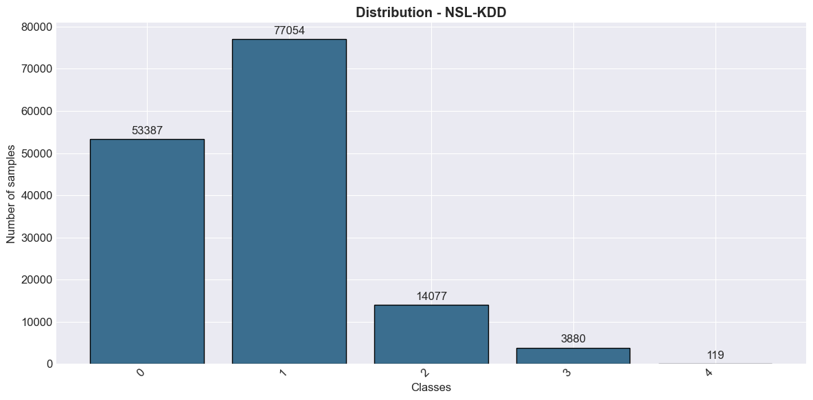

Train: 125973 Test: 22544
Classes: ['DoS' 'Normal' 'Probe' 'R2L' 'U2R']
Original distribution: {1: 67343, 0: 45927, 3: 995, 2: 11656, 4: 52}
SMOTE target: 5000 | cap 5.0x | min class 100
SVM... 2.6s
RF... 2.2s
XGB... 9.3s
CNN... [CNN] features=40, classes=5, epochs=15
[CNN] Epoch 5/15 - Train: 0.442 | Val: 1.85
[CNN] Epoch 10/15 - Train: 0.2978 | Val: 0.946
[CNN] Epoch 15/15 - Train: 0.22 | Val: 1.252
21.1s
Hybrid (RF+XGB+CNN) [balanced XGBoost meta]...
113.0s

================================================================================
RESULTS - NSL-KDD
================================================================================
Model | Acc | Prec | Rec | F1-macro | MCC | Kappa
------------------------------------------------------------------------------
SVM | 76.35% | 59.81% | 48.52% | 49.25% | 0.6552 | 0.623
RF | 75.46% | 77.43% | 52.1% | 53.37% | 0.6468 | 0.6083
XGB | 78.38% | 81.57% | 58.42% | 60.6% | 0.6886 | 0.6594
CNN | 77.52% | 87.74% | 54.48% | 55.77% | 0.6755 | 0.6462
Hybrid | 79.99% | 78.02% | 60.71% | 62.42% | 0.7101 | 0.6864

================================================================================
DETAILED ANALYSIS - HYBRID (NSL-KDD)
================================================================================

Confusion matrix:
DoS Normal Probe R2L U2R
DoS 6308 978 174 0 0
Normal 69 9404 230 3 5
Probe 190 335 1895 1 0
R2L 0 2430 30 405 20
U2R 0 38 0 9 20
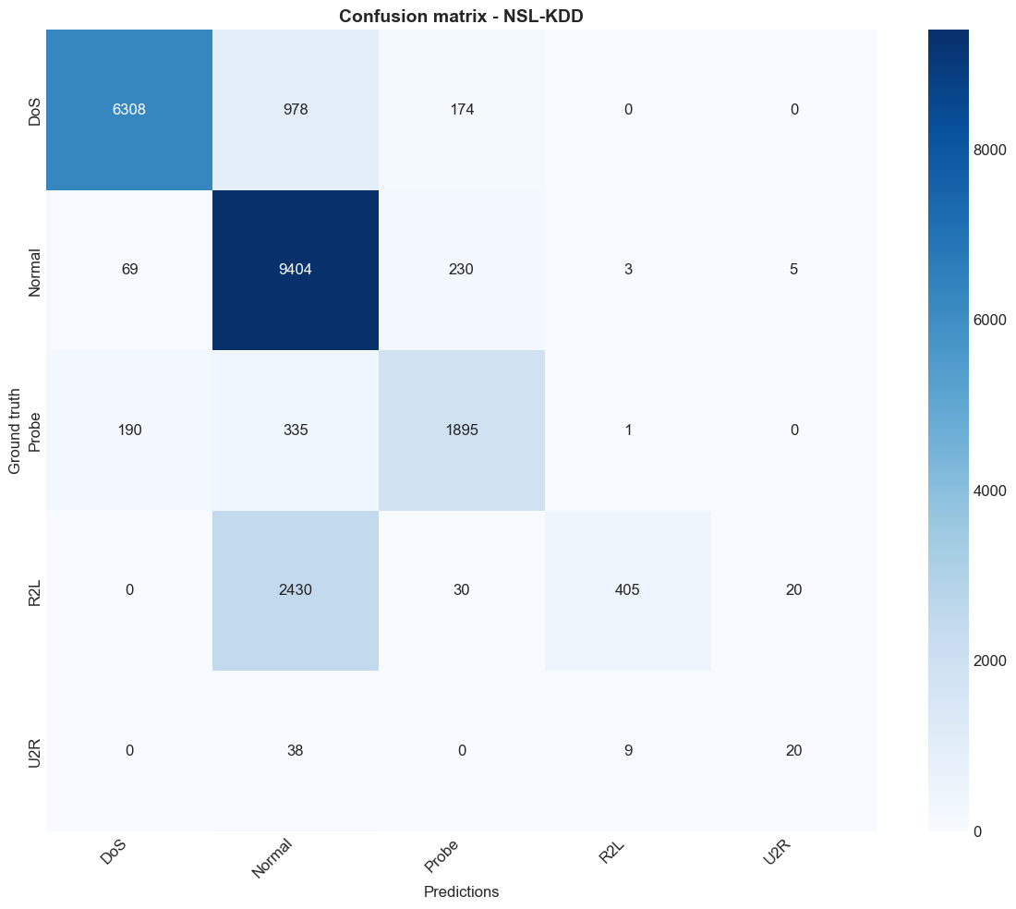
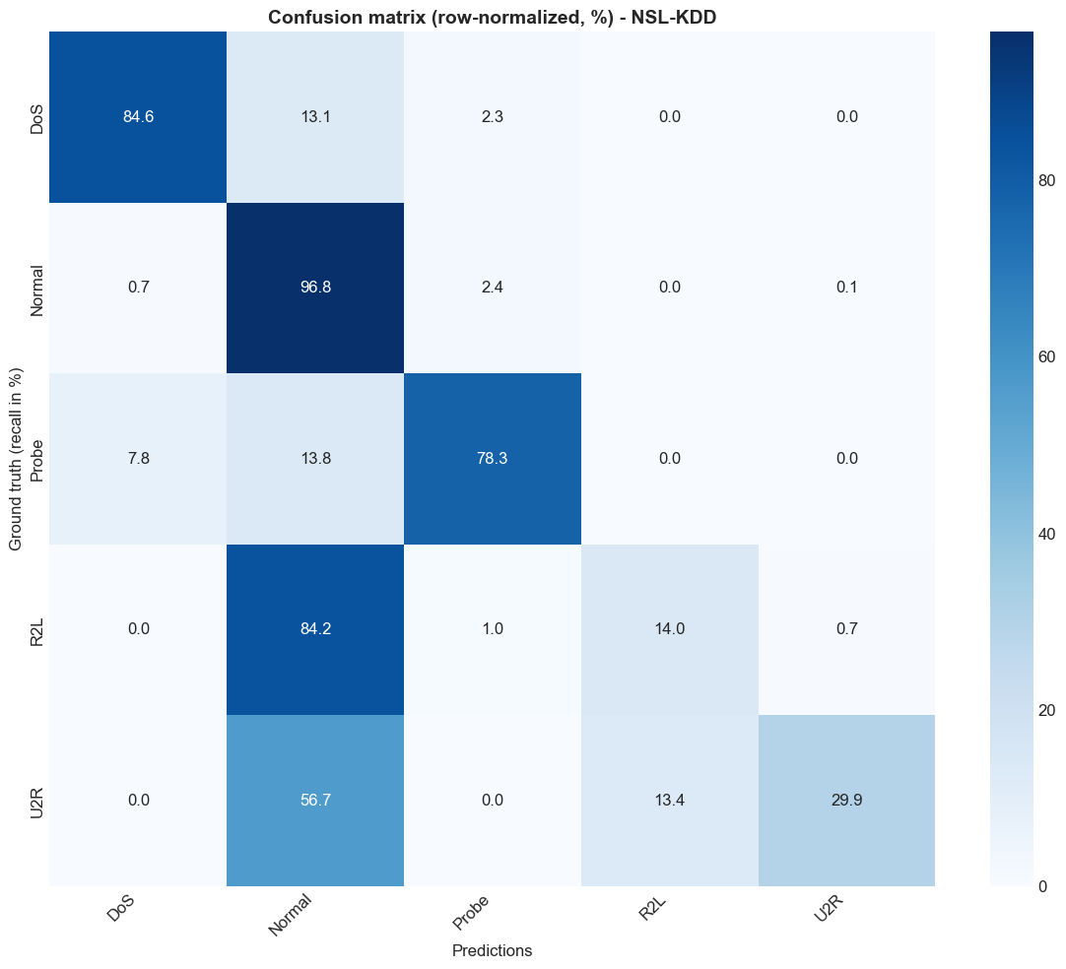

[Top confusions - sensitive classes - NSL-KDD]
R2L recall=14.0% | mainly confused with: Normal (84.2%, n=2430), Probe (1.0%, n=30)
U2R recall=29.9% | mainly confused with: Normal (56.7%, n=38), R2L (13.4%, n=9)

Classification report:
precision recall f1-score support

DoS 0.961 0.846 0.899 7460
Normal 0.713 0.968 0.821 9711
Probe 0.814 0.783 0.798 2421
R2L 0.969 0.140 0.245 2885
U2R 0.444 0.299 0.357 67

accuracy 0.800 22544
macro avg 0.780 0.607 0.624 22544
weighted avg 0.838 0.800 0.770 22544

Per-class performance:
----------------------------------------------------------------------
DoS | Prec: 0.9606 | Rec: 0.8456 | F1: 0.8994
Normal | Prec: 0.7132 | Rec: 0.9684 | F1: 0.8215
Probe | Prec: 0.8137 | Rec: 0.7827 | F1: 0.7979
R2L | Prec: 0.9689 | Rec: 0.1404 | F1: 0.2452
U2R | Prec: 0.4444 | Rec: 0.2985 | F1: 0.3571

==========================================================================================
TP / FP / TN / FN PER CLASS - NSL-KDD
==========================================================================================

Model: SVM
----------------------------------------------------------------------------
Class | TP | FP | TN | FN | TPR | FPR
----------------------------------------------------------------------------
DoS | 6222 | 228 | 14856 | 1238 | 0.834 | 0.015
Normal | 9463 | 4556 | 8277 | 248 | 0.974 | 0.355
Probe | 1319 | 372 | 19751 | 1102 | 0.545 | 0.018
R2L | 209 | 157 | 19502 | 2676 | 0.072 | 0.008
U2R | 0 | 18 | 22459 | 67 | 0.0 | 0.001

Model: RF
----------------------------------------------------------------------------
Class | TP | FP | TN | FN | TPR | FPR
----------------------------------------------------------------------------
DoS | 5760 | 232 | 14852 | 1700 | 0.772 | 0.015
Normal | 9430 | 4981 | 7852 | 281 | 0.971 | 0.388
Probe | 1712 | 303 | 19820 | 709 | 0.707 | 0.015
R2L | 102 | 7 | 19652 | 2783 | 0.035 | 0.0
U2R | 8 | 9 | 22468 | 59 | 0.119 | 0.0

Model: XGB
----------------------------------------------------------------------------
Class | TP | FP | TN | FN | TPR | FPR
----------------------------------------------------------------------------
DoS | 6008 | 220 | 14864 | 1452 | 0.805 | 0.015
Normal | 9445 | 4207 | 8626 | 266 | 0.973 | 0.328
Probe | 1916 | 431 | 19692 | 505 | 0.791 | 0.021
R2L | 283 | 7 | 19652 | 2602 | 0.098 | 0.0
U2R | 17 | 10 | 22467 | 50 | 0.254 | 0.0

Model: CNN
----------------------------------------------------------------------------
Class | TP | FP | TN | FN | TPR | FPR
----------------------------------------------------------------------------
DoS | 5776 | 276 | 14808 | 1684 | 0.774 | 0.018
Normal | 9410 | 4311 | 8522 | 301 | 0.969 | 0.336
Probe | 1940 | 458 | 19665 | 481 | 0.801 | 0.023
R2L | 346 | 23 | 19636 | 2539 | 0.12 | 0.001
U2R | 4 | 0 | 22477 | 63 | 0.06 | 0.0

Model: Hybrid
----------------------------------------------------------------------------
Class | TP | FP | TN | FN | TPR | FPR
----------------------------------------------------------------------------
DoS | 6308 | 259 | 14825 | 1152 | 0.846 | 0.017
Normal | 9404 | 3781 | 9052 | 307 | 0.968 | 0.295
Probe | 1895 | 434 | 19689 | 526 | 0.783 | 0.022
R2L | 405 | 13 | 19646 | 2480 | 0.14 | 0.001
U2R | 20 | 25 | 22452 | 47 | 0.299 | 0.001
TP/FP/TN/FN CSV: C:\Users\desir\Desktop\CARINE EX FINAL\results\tp_fp_tn_fn_NSL-KDD.csv

[Statistical tests - NSL-KDD]
McNemar Hybrid vs RF : n01=1086 n10=66 p=0.0 -> significant (p<0.05)
McNemar Hybrid vs XGB : n01=492 n10=129 p=0.0 -> significant (p<0.05)
Hybrid Accuracy : 79.99% 95% CI [79.49, 80.52]
Hybrid F1-macro : 62.42% 95% CI [60.15, 64.76]
SMOTE report: C:\Users\desir\Desktop\CARINE EX FINAL\results\smote_report_NSL-KDD.csv
Models and preprocessors saved: C:\Users\desir\Desktop\CARINE EX FINAL\results\models\NSL-KDD

[Generating figures - NSL-KDD]
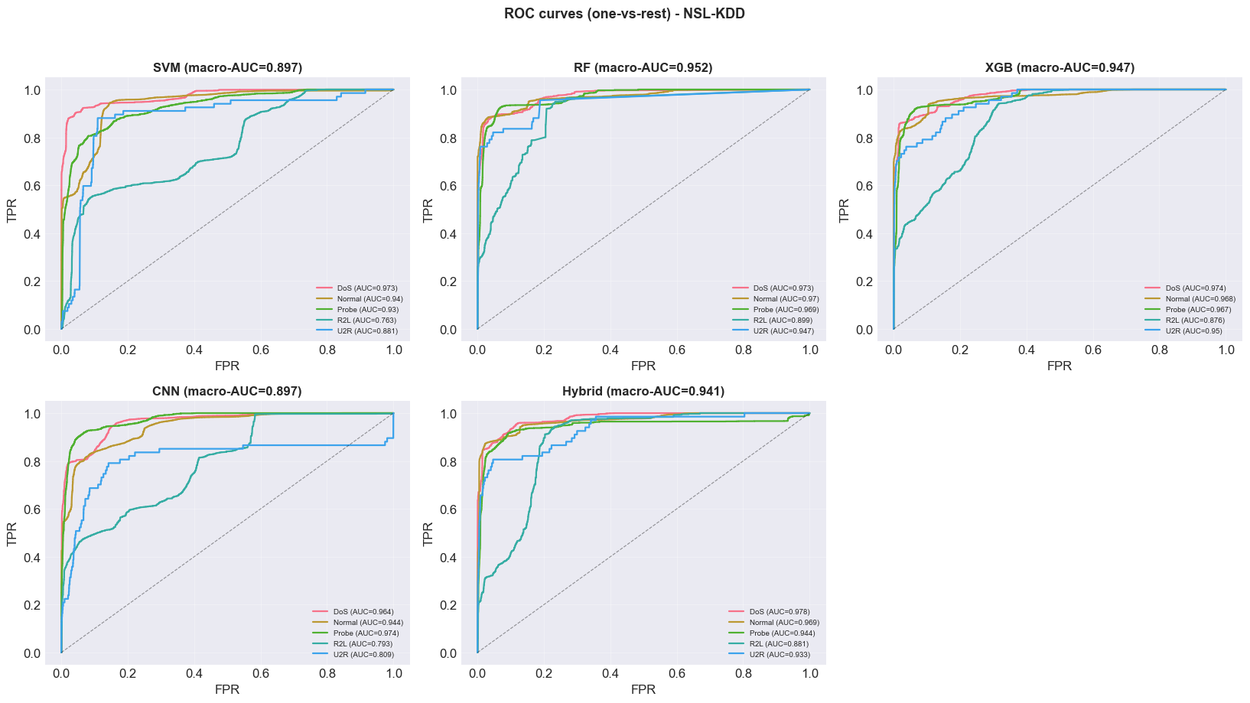
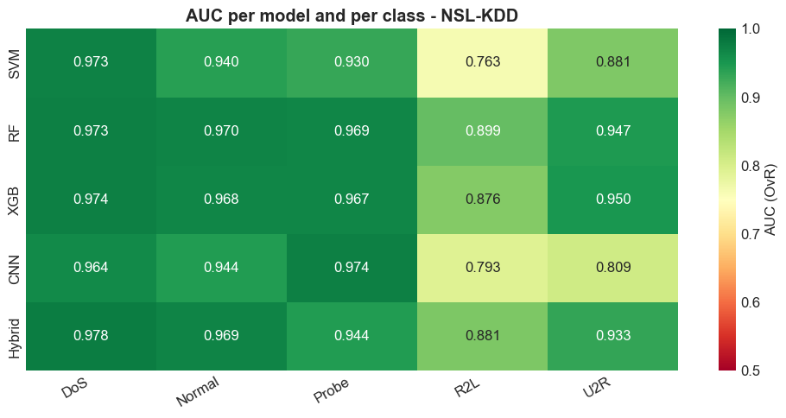
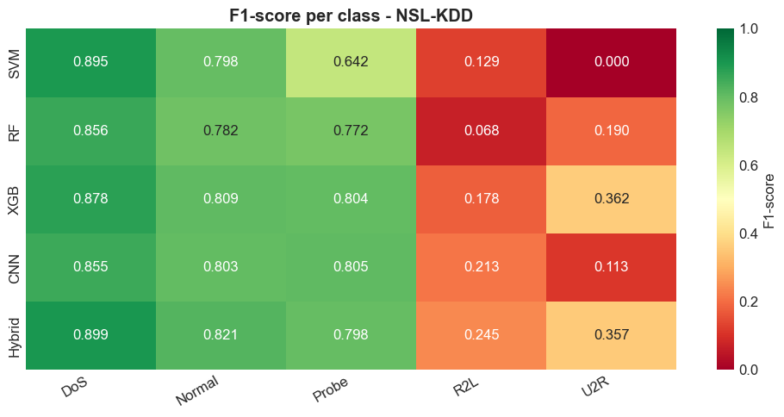
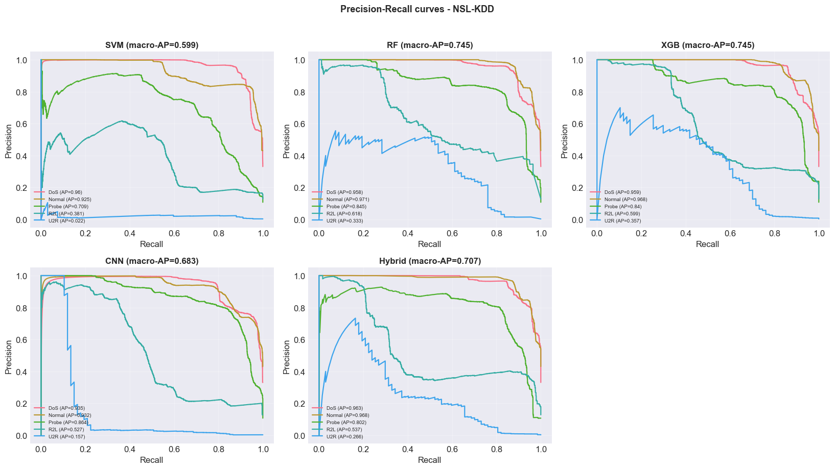
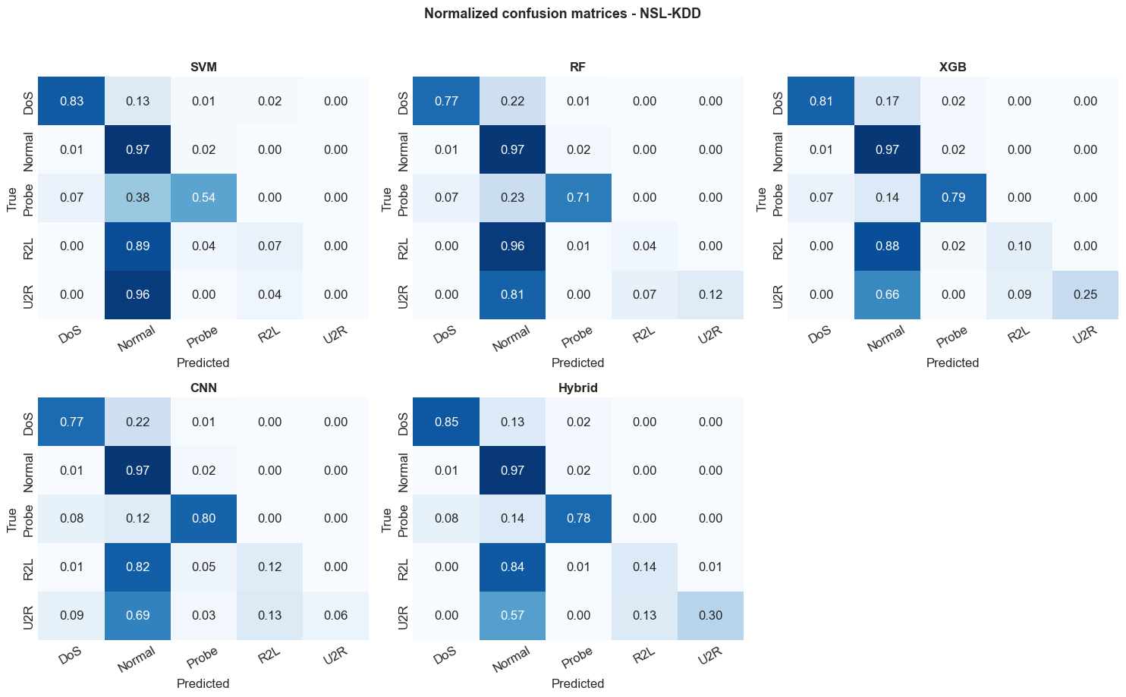
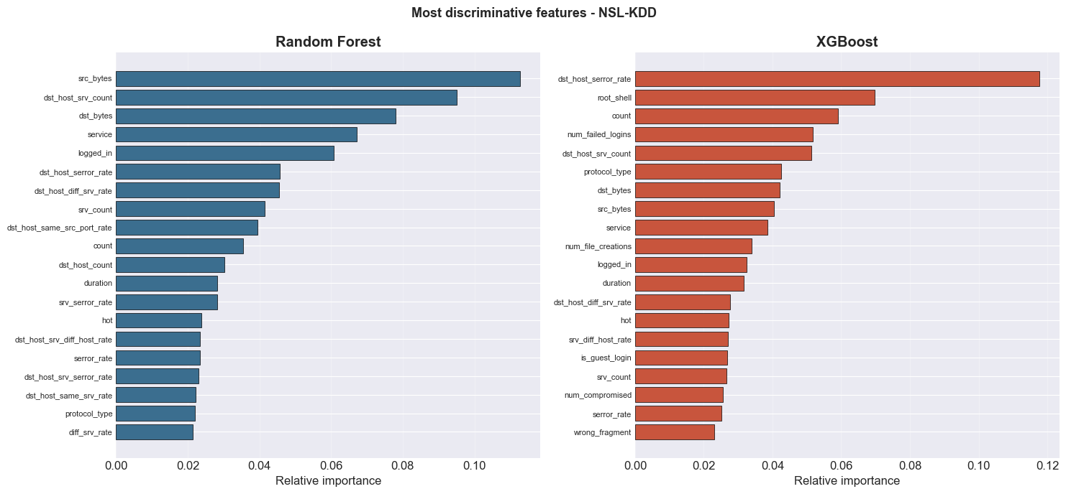
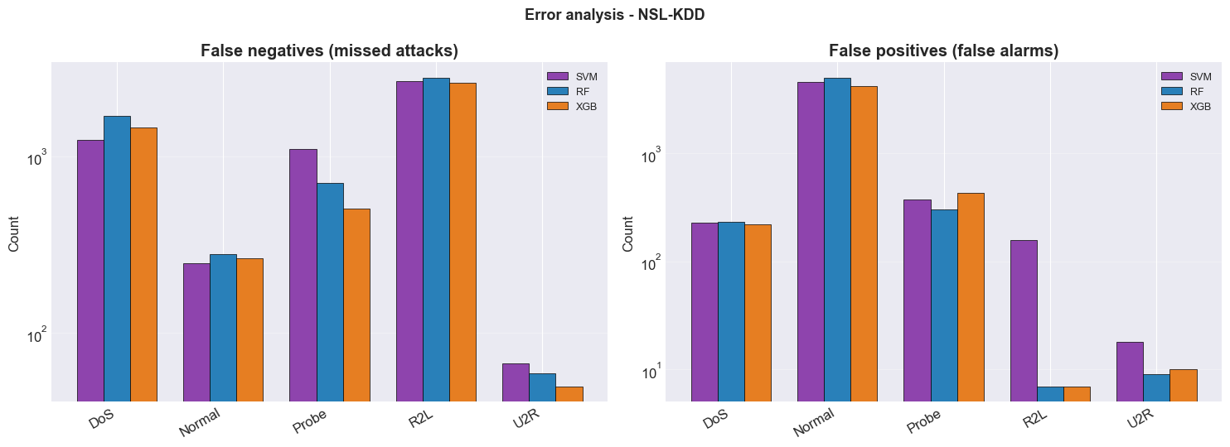
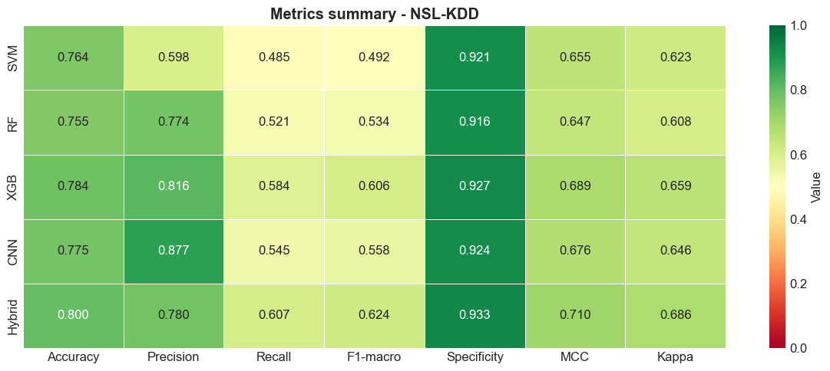
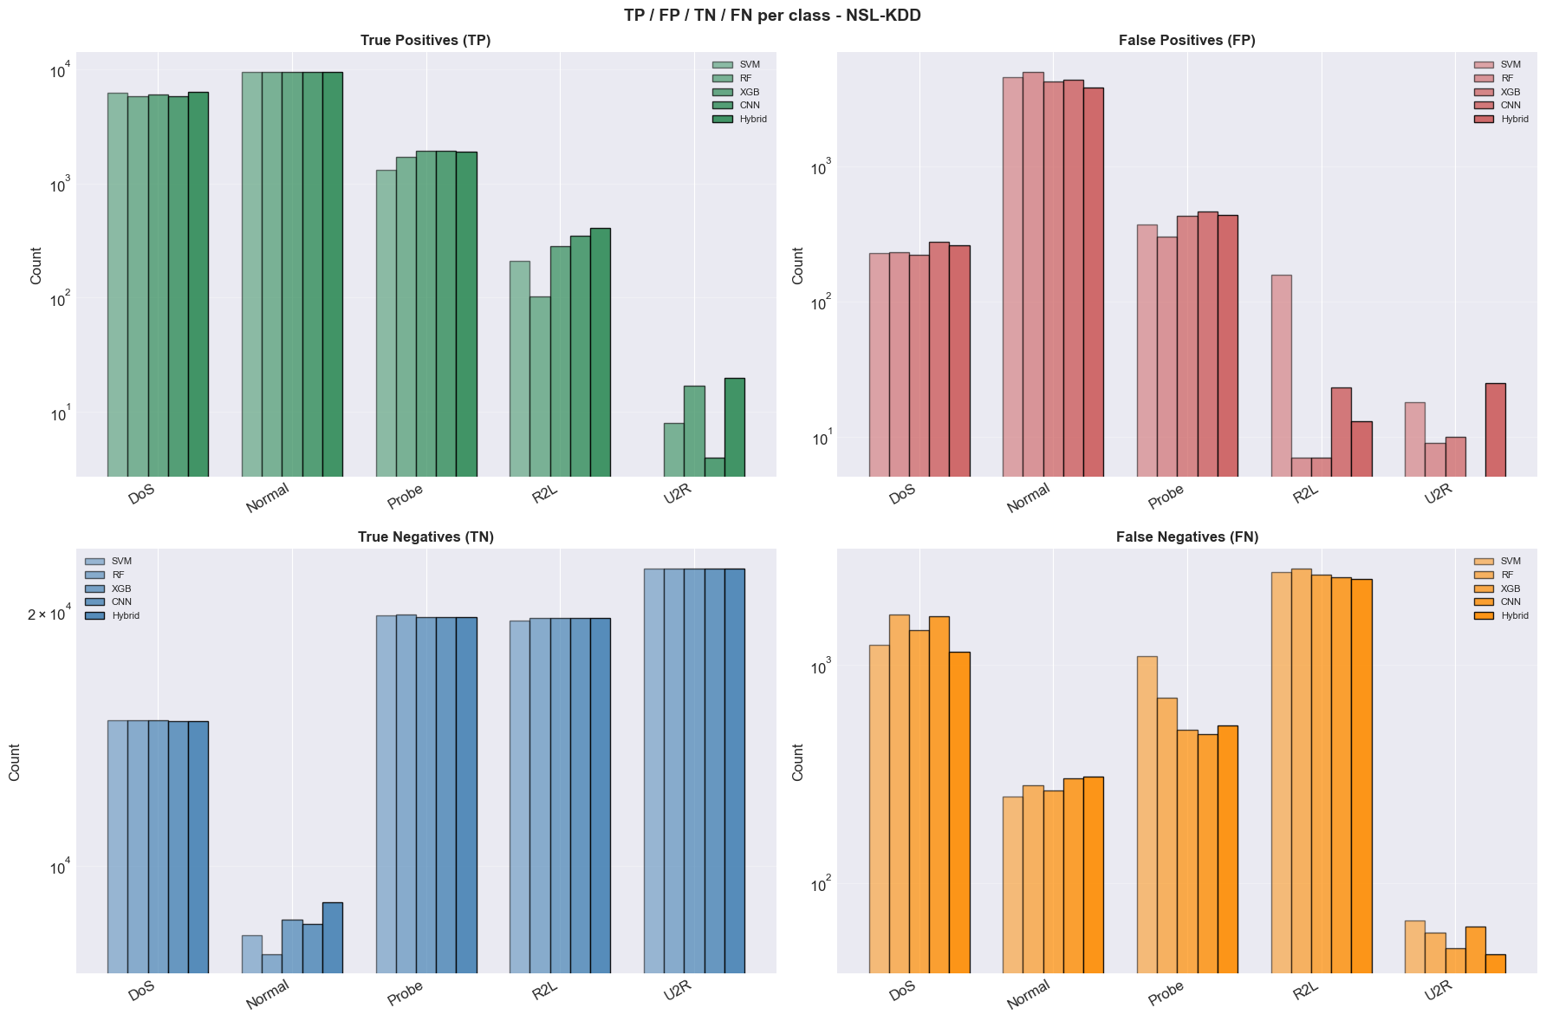
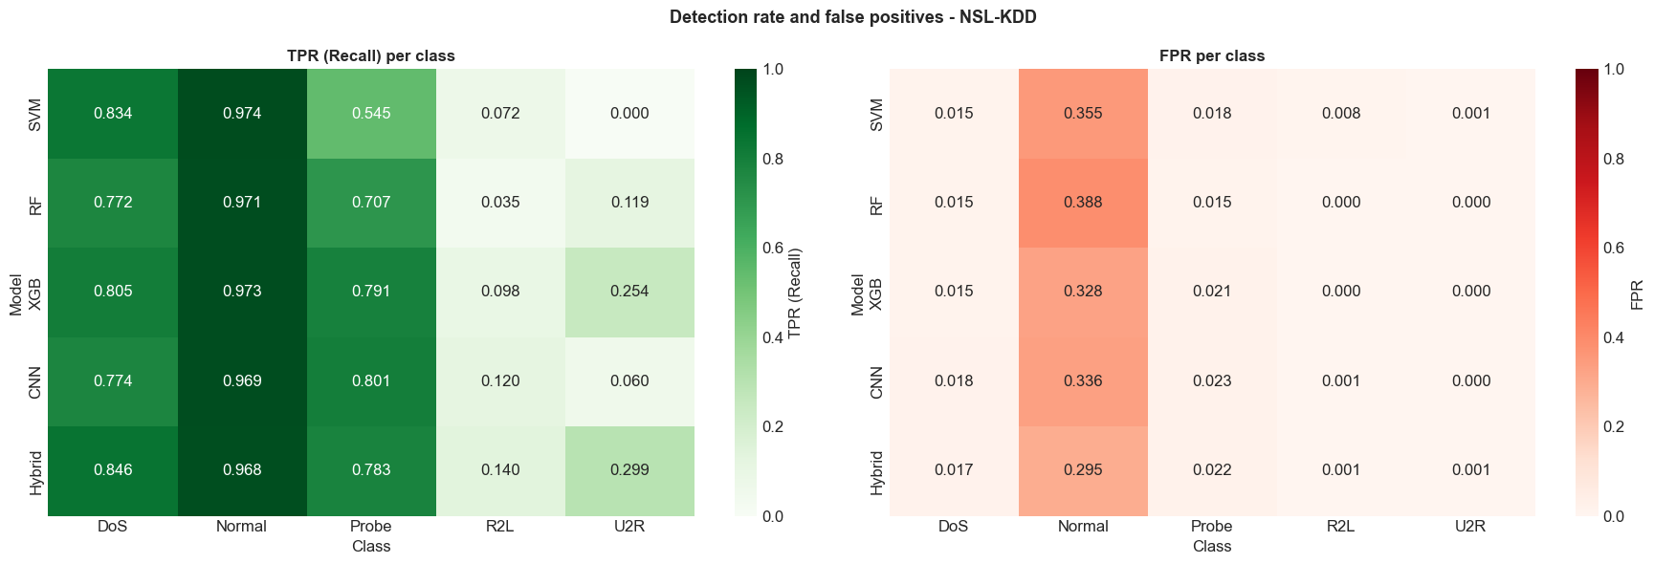
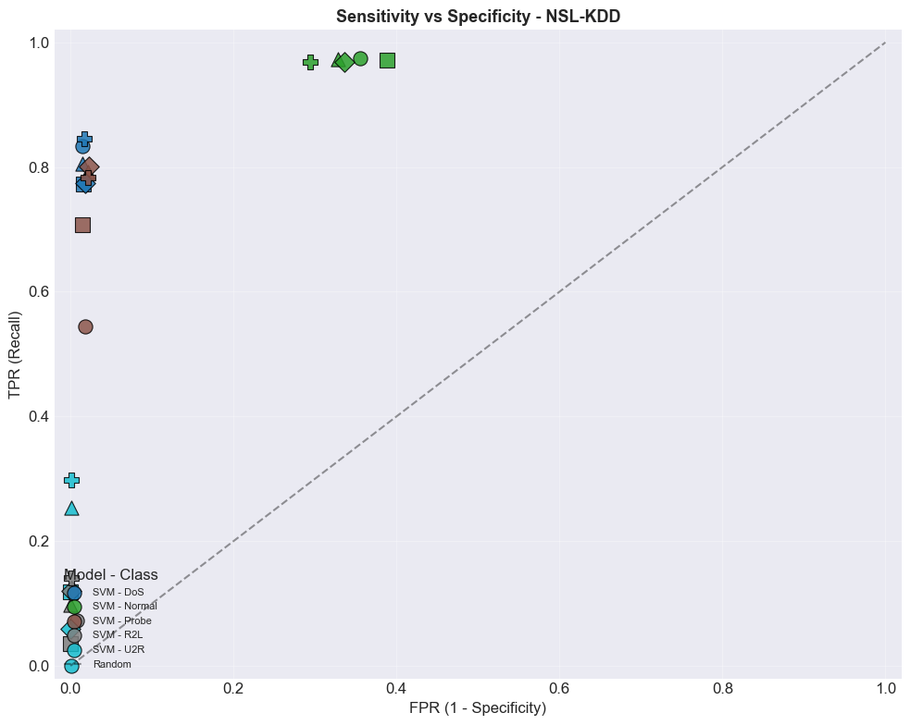
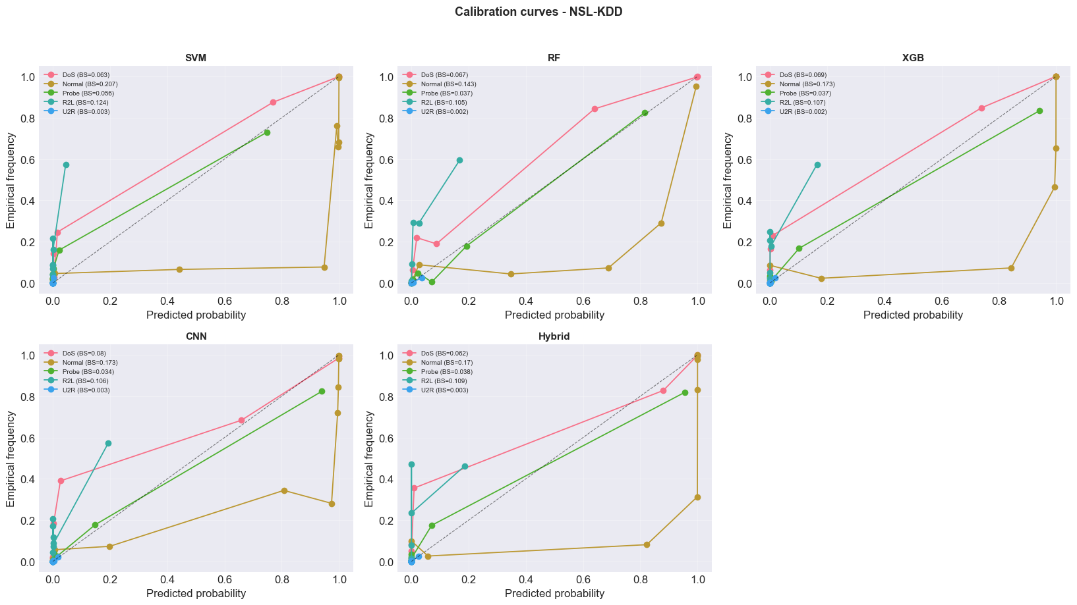
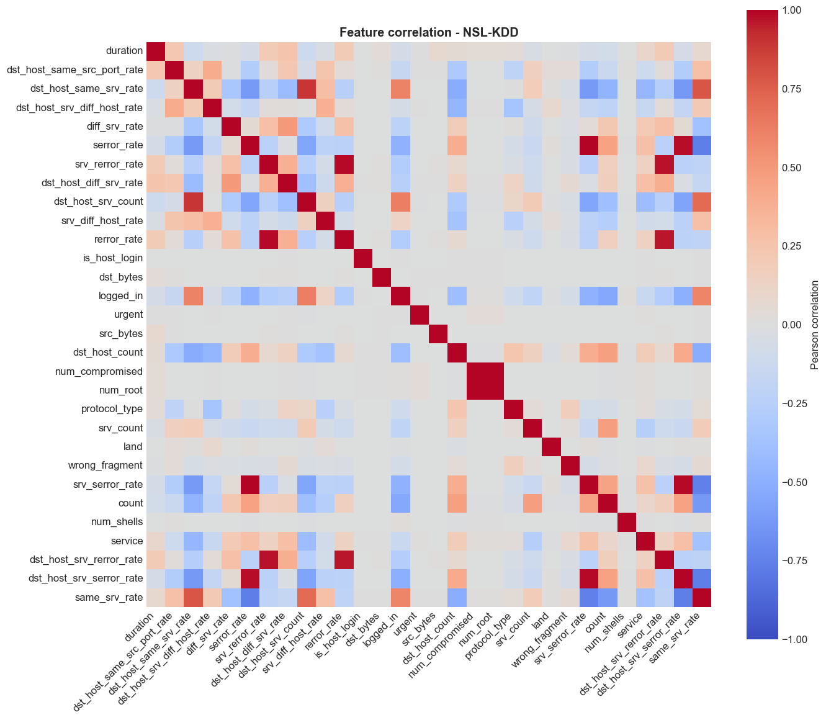
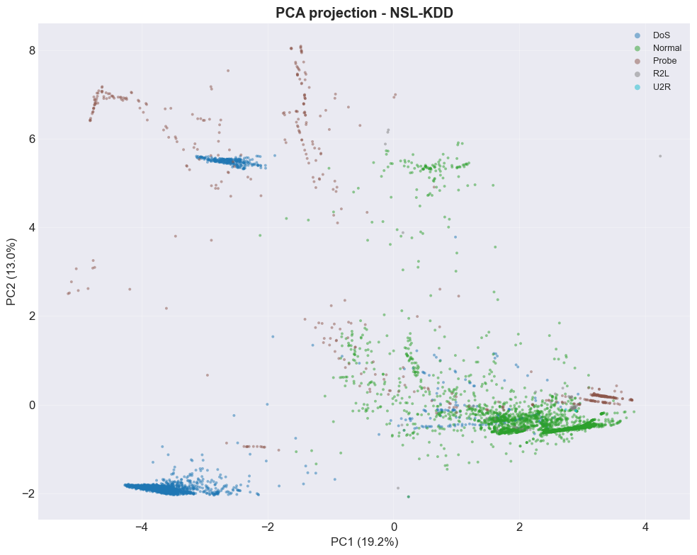
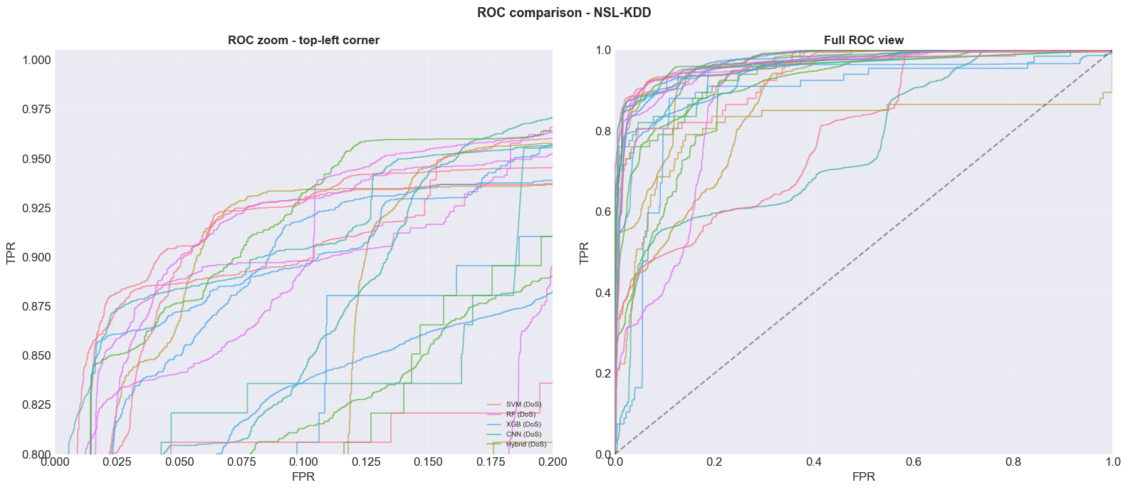
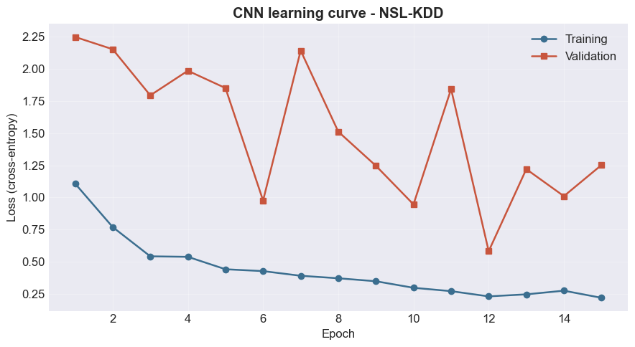
-> Figures generated successfully

[SHAP analysis - NSL-KDD]
RF : SHAP values computed (shape = (500, 40, 5))
XGB : SHAP values computed (shape = (500, 40, 5))
Hybrid_rf : SHAP values computed (shape = (500, 40, 5))
Hybrid_xgb : SHAP values computed (shape = (500, 40, 5))
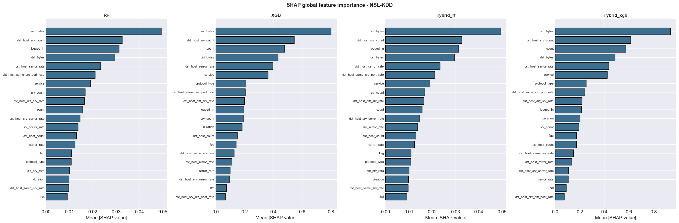
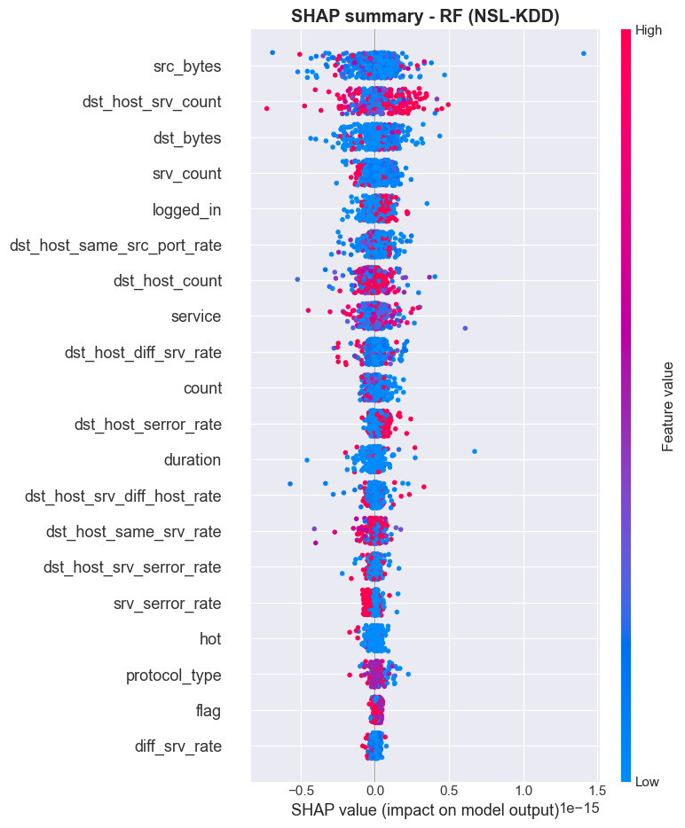
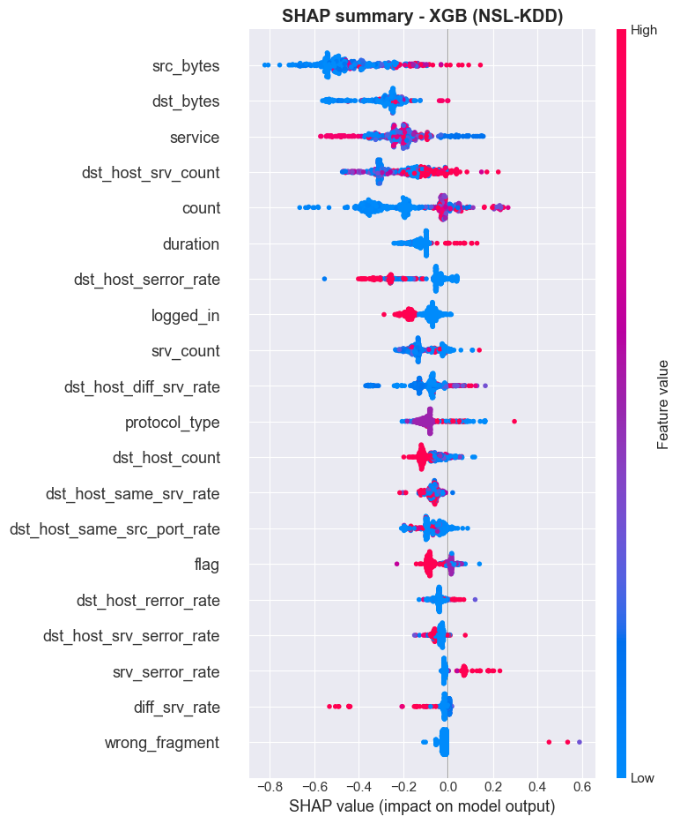
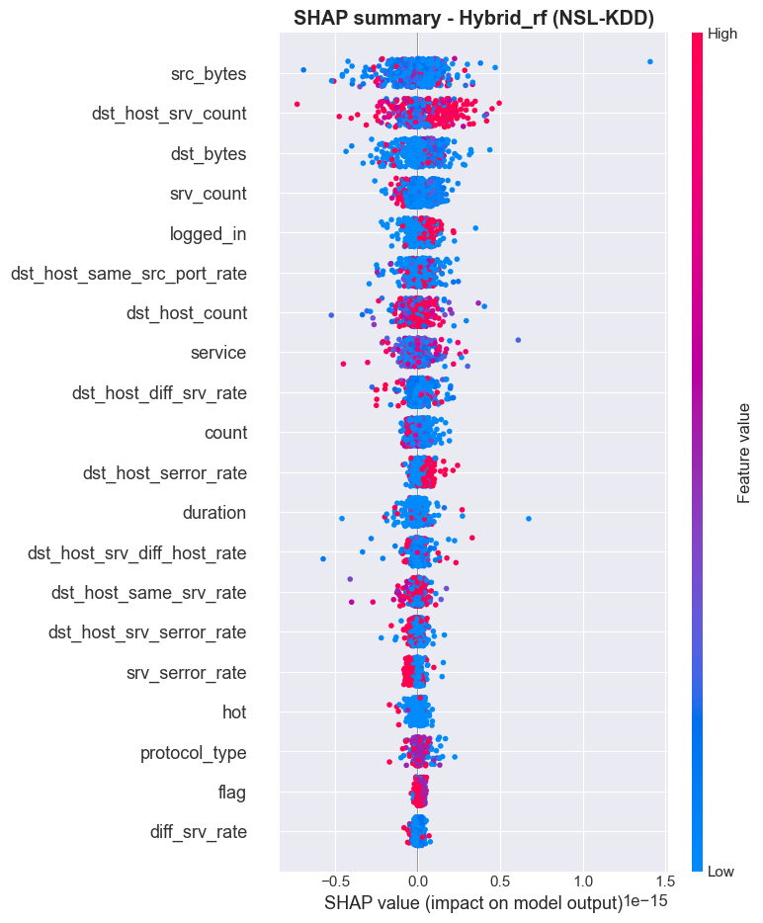
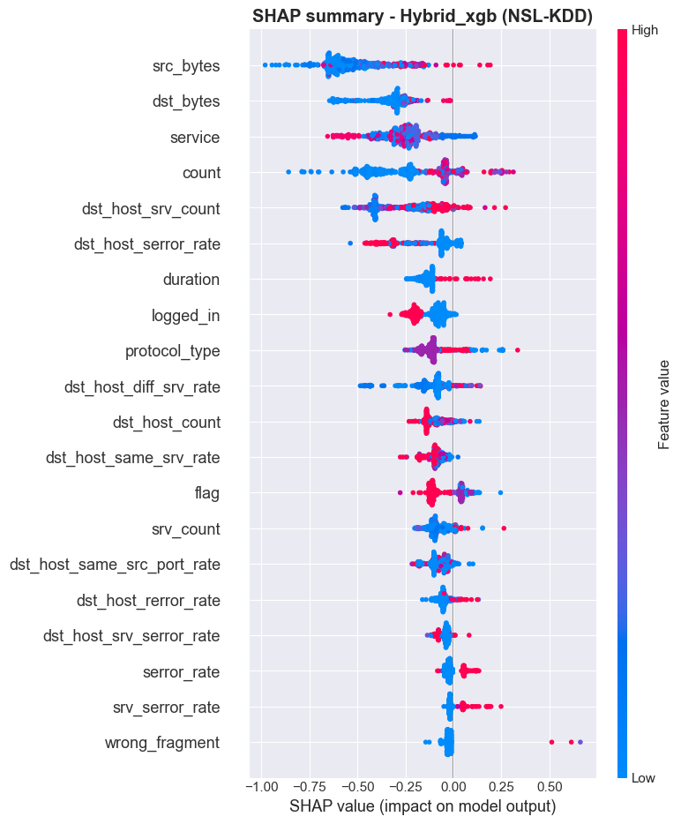

================================================================================
ABLATION STUDY - NSL-KDD
================================================================================

>>> Variant: Without CNN
Acc=80.04% | F1=63.28% | Rec=61.34% | Time=43.3s

>>> Variant: Without XGB
Acc=78.88% | F1=61.57% | Rec=59.86% | Time=64.0s

>>> Variant: Without RF
Acc=79.02% | F1=60.95% | Rec=58.84% | Time=107.9s

>>> Variant: Without SMOTE
Acc=78.51% | F1=59.44% | Rec=58.2% | Time=106.6s

>>> Variant: Without balanced (native meta)
Acc=76.45% | F1=58.2% | Rec=55.48% | Time=113.4s

>>> Variant: Meta = LogisticRegression
Acc=79.63% | F1=60.12% | Rec=61.26% | Time=109.2s

>>> Variant: Meta = RandomForest
Acc=79.0% | F1=58.39% | Rec=67.5% | Time=114.6s

>>> Variant: Full
Acc=79.84% | F1=63.33% | Rec=60.65% | Time=105.1s

=========================================================================================================
ABLATION TABLE - NSL-KDD
=========================================================================================================
Variant | Acc | Prec | Rec | F1-macro | MCC | Time
----------------------------------------------------------------------------------------------------
Without CNN | 80.04% | 78.88% | 61.34% | 63.28% | 0.7105 | 43.3s [+0.2]
Without XGB | 78.88% | 78.55% | 59.86% | 61.57% | 0.6938 | 64.0s [-0.96]
Without RF | 79.02% | 79.6% | 58.84% | 60.95% | 0.6977 | 107.9s [-0.82]
Without SMOTE | 78.51% | 77.87% | 58.2% | 59.44% | 0.6876 | 106.6s [-1.33]
Without balanced (native meta) | 76.45% | 81.43% | 55.48% | 58.2% | 0.6599 | 113.4s [-3.39]
Meta = LogisticRegression | 79.63% | 67.77% | 61.26% | 60.12% | 0.7043 | 109.2s [-0.22]
Meta = RandomForest | 79.0% | 71.9% | 67.5% | 58.39% | 0.6959 | 114.6s [-0.85]
Full | 79.84% | 80.23% | 60.65% | 63.33% | 0.708 | 105.1s

Ablation CSV: C:\Users\desir\Desktop\CARINE EX FINAL\results\ablation_NSL-KDD.csv
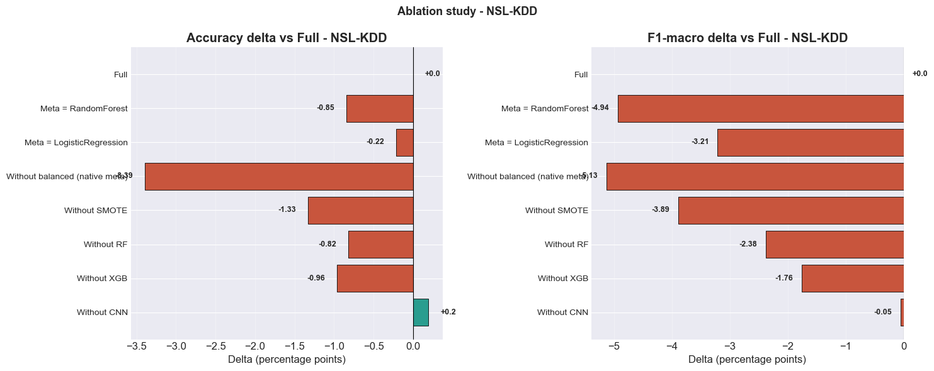
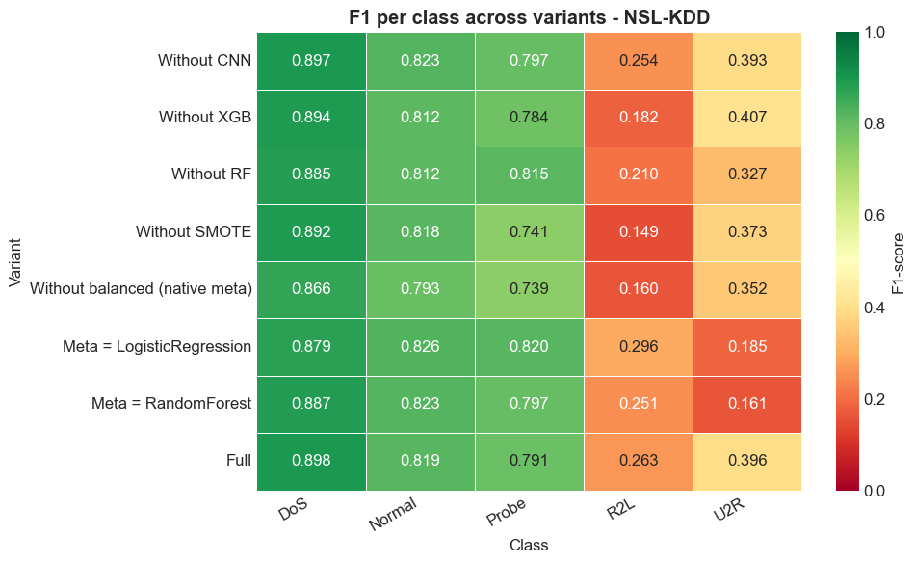

================================================================================
2. CICIDS2017
================================================================================

============================================================
LOADING CICIDS2017 - CHRONOLOGICAL SPLIT
============================================================
8 CSV files
Friday-WorkingHours-Afternoon-DDos.pcap_ISCX.csv : 225745
Friday-WorkingHours-Afternoon-PortScan.pcap_ISCX.csv : 286467
Friday-WorkingHours-Morning.pcap_ISCX.csv : 191033
Monday-WorkingHours.pcap_ISCX.csv : 529918
Thursday-WorkingHours-Afternoon-Infilteration.pcap_ISCX.csv : 288602
Thursday-WorkingHours-Morning-WebAttacks.pcap_ISCX.csv : 170366
Tuesday-WorkingHours.pcap_ISCX.csv : 445909
Wednesday-workingHours.pcap_ISCX.csv : 692703
Raw total : 2830743
After duplicates : 2574059

Distribution (after exclusion of Other):
category
Normal 2148196
DoS 193733
DDoS 128016
Port_Scan 90819
Brute_Force 10622
Botnet 1953

Chronological split by day
Friday-WorkingHours-Afternoon-DDos.pcap_ISCX : train= 156178 | test= 66934
Friday-WorkingHours-Afternoon-PortScan.pcap_ISCX : train= 149879 | test= 64235
Friday-WorkingHours-Morning.pcap_ISCX : train= 128892 | test= 55240
Monday-WorkingHours.pcap_ISCX : train= 352034 | test= 150872
Thursday-WorkingHours-Afternoon-Infilteration.pcap_ISCX : train= 177037 | test= 75873
Thursday-WorkingHours-Morning-WebAttacks.pcap_ISCX : train= 114520 | test= 49081
Tuesday-WorkingHours.pcap_ISCX : train= 295274 | test= 126546
Wednesday-workingHours.pcap_ISCX : train= 427520 | test= 183224

[Leakage fix #2] Minimum class size (>= 50) on TRAIN only

[Leakage fix #3] Class filtering based on TRAIN only
Retained classes: ['Botnet', 'Brute_Force', 'DDoS', 'DoS', 'Normal', 'Port_Scan']
After capping - Train: 170871 Test: 62290
Excluded columns: [' Destination Port']
Valid numerical columns: 77
CICIDS2017 : Train=170871, Test=62290, 77 raw columns
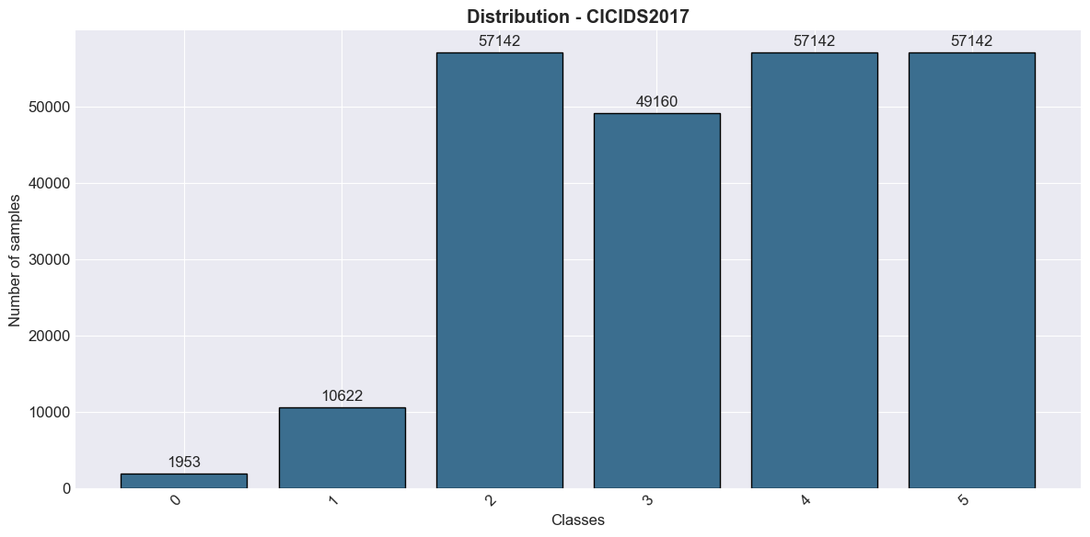
After variance: 69 features
After SelectKBest: 55 features

Train: 170871 Test: 62290
Classes: ['Botnet' 'Brute_Force' 'DDoS' 'DoS' 'Normal' 'Port_Scan']
Features: 55
Original distribution: {4: 40000, 2: 40000, 5: 40000, 0: 1508, 1: 9363, 3: 40000}
SMOTE target: 10000 | cap 5.0x | min class 100
SVM... 10.8s
RF... 2.2s
XGB... 4.7s
CNN... [CNN] features=55, classes=6, epochs=15
[CNN] Epoch 5/15 - Train: 0.2491 | Val: 0.9526
[CNN] Early stopping epoch 8 (val=0.3386)
15.1s
Hybrid (RF+XGB+CNN) [balanced XGBoost meta]...
131.5s

================================================================================
RESULTS - CICIDS2017
================================================================================
Model | Acc | Prec | Rec | F1-macro | MCC | Kappa
------------------------------------------------------------------------------
SVM | 82.29% | 71.12% | 66.99% | 66.33% | 0.7675 | 0.7599
RF | 92.35% | 83.73% | 92.13% | 84.22% | 0.9008 | 0.8977
XGB | 94.38% | 90.35% | 93.82% | 90.79% | 0.9275 | 0.9247
CNN | 82.45% | 64.58% | 69.04% | 61.67% | 0.7736 | 0.7688
Hybrid | 94.81% | 95.32% | 93.35% | 93.7% | 0.9333 | 0.9304

================================================================================
DETAILED ANALYSIS - HYBRID (CICIDS2017)
================================================================================

Confusion matrix:
Botnet Brute_Force DDoS DoS Normal Port_Scan
Botnet 421 0 0 0 24 0
Brute_Force 0 1255 0 2 2 0
DDoS 0 0 17119 14 9 0
DoS 0 11 0 6115 3034 0
Normal 47 8 2 15 17070 0
Port_Scan 0 2 0 33 28 17079
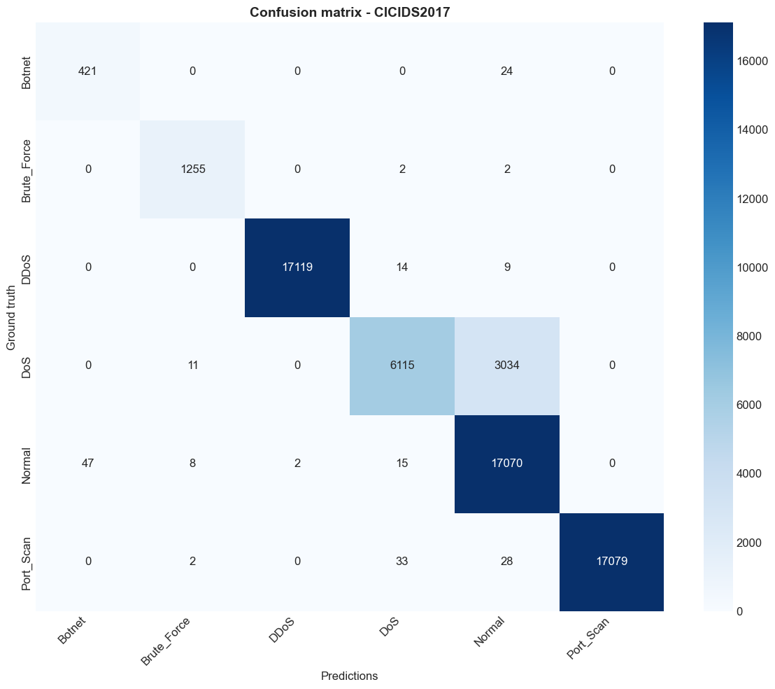
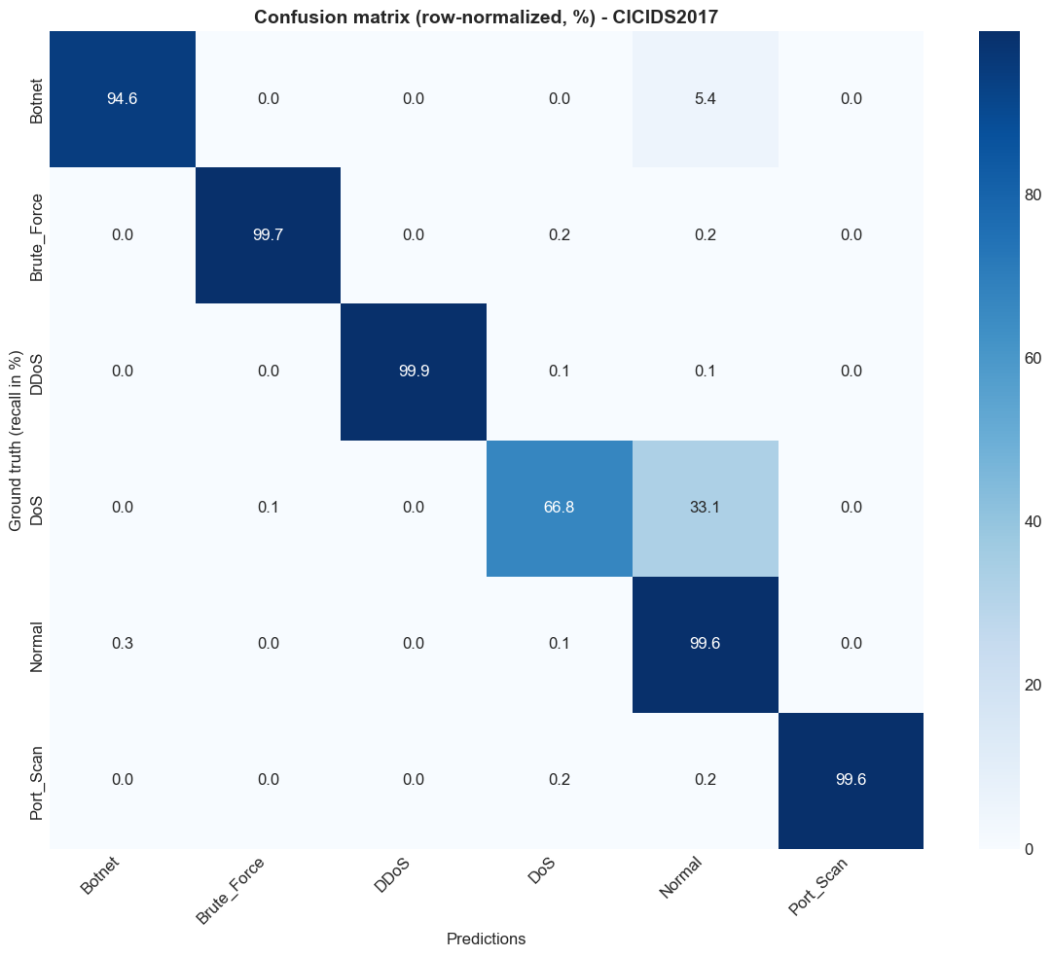

[Top confusions - sensitive classes - CICIDS2017]
Botnet recall=94.6% | mainly confused with: Normal (5.4%, n=24), Port_Scan (0.0%, n=0)
Brute_Force recall=99.7% | mainly confused with: Normal (0.2%, n=2), DoS (0.2%, n=2)

Classification report:
precision recall f1-score support

Botnet 0.900 0.946 0.922 445
Brute_Force 0.984 0.997 0.990 1259
DDoS 1.000 0.999 0.999 17142
DoS 0.990 0.668 0.797 9160
Normal 0.846 0.996 0.915 17142
Port_Scan 1.000 0.996 0.998 17142

accuracy 0.948 62290
macro avg 0.953 0.934 0.937 62290
weighted avg 0.955 0.948 0.945 62290

Per-class performance:
----------------------------------------------------------------------
Botnet | Prec: 0.8996 | Rec: 0.9461 | F1: 0.9222
Brute_Force | Prec: 0.9835 | Rec: 0.9968 | F1: 0.9901
DDoS | Prec: 0.9999 | Rec: 0.9987 | F1: 0.9993
DoS | Prec: 0.9896 | Rec: 0.6676 | F1: 0.7973
Normal | Prec: 0.8464 | Rec: 0.9958 | F1: 0.9151
Port_Scan | Prec: 1.0 | Rec: 0.9963 | F1: 0.9982

==========================================================================================
TP / FP / TN / FN PER CLASS - CICIDS2017
==========================================================================================

Model: SVM
----------------------------------------------------------------------------
Class | TP | FP | TN | FN | TPR | FPR
----------------------------------------------------------------------------
Botnet | 0 | 140 | 61705 | 445 | 0.0 | 0.002
Brute_Force | 1192 | 207 | 60824 | 67 | 0.947 | 0.003
DDoS | 17102 | 254 | 44894 | 40 | 0.998 | 0.006
DoS | 2992 | 175 | 52955 | 6168 | 0.327 | 0.003
Normal | 13095 | 6315 | 38833 | 4047 | 0.764 | 0.14
Port_Scan | 16877 | 3941 | 41207 | 265 | 0.985 | 0.087

Model: RF
----------------------------------------------------------------------------
Class | TP | FP | TN | FN | TPR | FPR
----------------------------------------------------------------------------
Botnet | 443 | 932 | 60913 | 2 | 0.996 | 0.015
Brute_Force | 1246 | 144 | 60887 | 13 | 0.99 | 0.002
DDoS | 17104 | 1 | 45147 | 38 | 0.998 | 0.0
DoS | 5618 | 57 | 53073 | 3542 | 0.613 | 0.001
Normal | 16038 | 3630 | 41518 | 1104 | 0.936 | 0.08
Port_Scan | 17076 | 1 | 45147 | 66 | 0.996 | 0.0

Model: XGB
----------------------------------------------------------------------------
Class | TP | FP | TN | FN | TPR | FPR
----------------------------------------------------------------------------
Botnet | 442 | 256 | 61589 | 3 | 0.993 | 0.004
Brute_Force | 1255 | 58 | 60973 | 4 | 0.997 | 0.001
DDoS | 17113 | 1 | 45147 | 29 | 0.998 | 0.0
DoS | 6069 | 75 | 53055 | 3091 | 0.663 | 0.001
Normal | 16836 | 3107 | 42041 | 306 | 0.982 | 0.069
Port_Scan | 17076 | 2 | 45146 | 66 | 0.996 | 0.0

Model: CNN
----------------------------------------------------------------------------
Class | TP | FP | TN | FN | TPR | FPR
----------------------------------------------------------------------------
Botnet | 0 | 966 | 60879 | 445 | 0.0 | 0.016
Brute_Force | 1250 | 3822 | 57209 | 9 | 0.993 | 0.063
DDoS | 17104 | 325 | 44823 | 38 | 0.998 | 0.007
DoS | 4451 | 87 | 53043 | 4709 | 0.486 | 0.002
Normal | 12438 | 4733 | 40415 | 4704 | 0.726 | 0.105
Port_Scan | 16116 | 998 | 44150 | 1026 | 0.94 | 0.022

Model: Hybrid
----------------------------------------------------------------------------
Class | TP | FP | TN | FN | TPR | FPR
----------------------------------------------------------------------------
Botnet | 421 | 47 | 61798 | 24 | 0.946 | 0.001
Brute_Force | 1255 | 21 | 61010 | 4 | 0.997 | 0.0
DDoS | 17119 | 2 | 45146 | 23 | 0.999 | 0.0
DoS | 6115 | 64 | 53066 | 3045 | 0.668 | 0.001
Normal | 17070 | 3097 | 42051 | 72 | 0.996 | 0.069
Port_Scan | 17079 | 0 | 45148 | 63 | 0.996 | 0.0
TP/FP/TN/FN CSV: C:\Users\desir\Desktop\CARINE EX FINAL\results\tp_fp_tn_fn_CICIDS2017.csv

[Statistical tests - CICIDS2017]
McNemar Hybrid vs RF : n01=1562 n10=28 p=0.0 -> significant (p<0.05)
McNemar Hybrid vs XGB : n01=356 n10=88 p=0.0 -> significant (p<0.05)
Hybrid Accuracy : 94.81% 95% CI [94.65, 94.99]
Hybrid F1-macro : 93.7% 95% CI [93.32, 94.04]
SMOTE report: C:\Users\desir\Desktop\CARINE EX FINAL\results\smote_report_CICIDS2017.csv
Models and preprocessors saved: C:\Users\desir\Desktop\CARINE EX FINAL\results\models\CICIDS2017

[Generating figures - CICIDS2017]
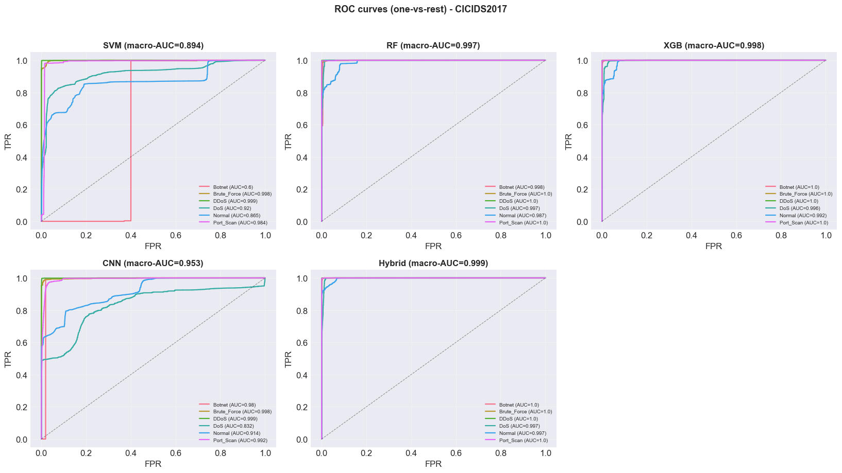
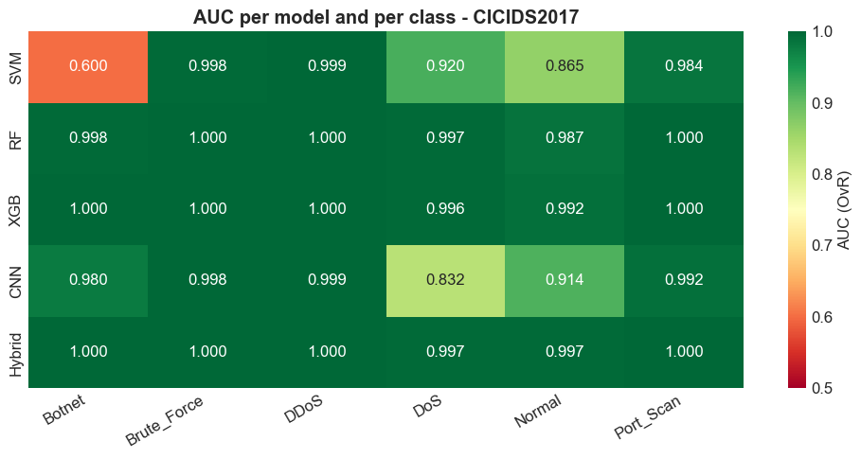
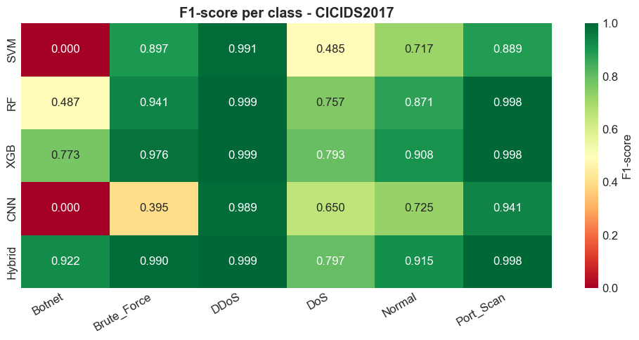
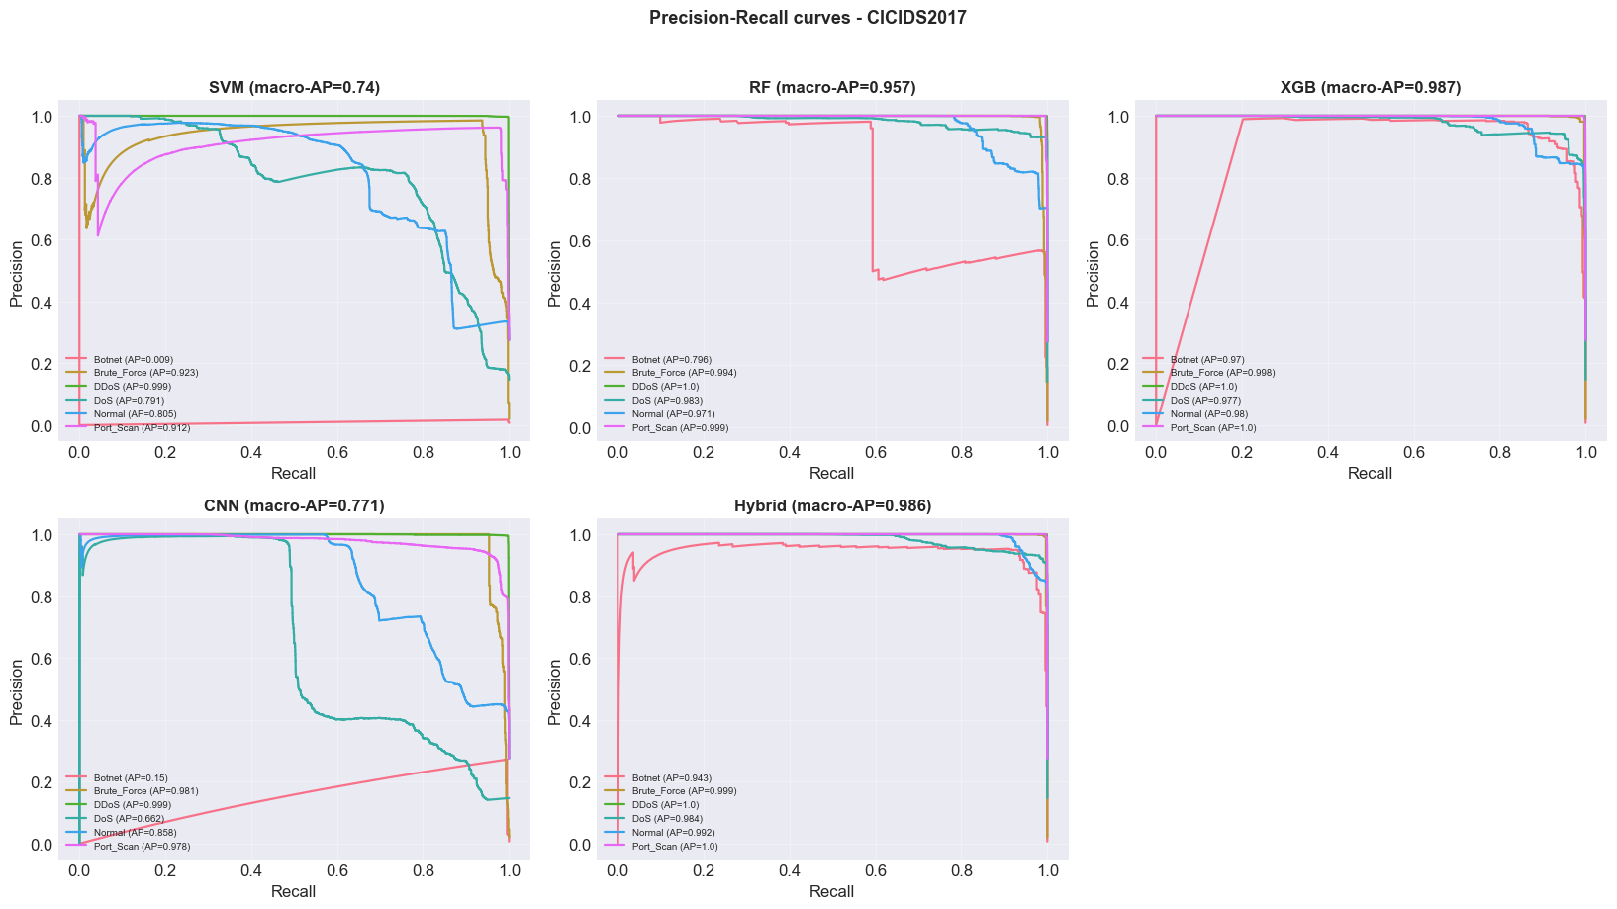
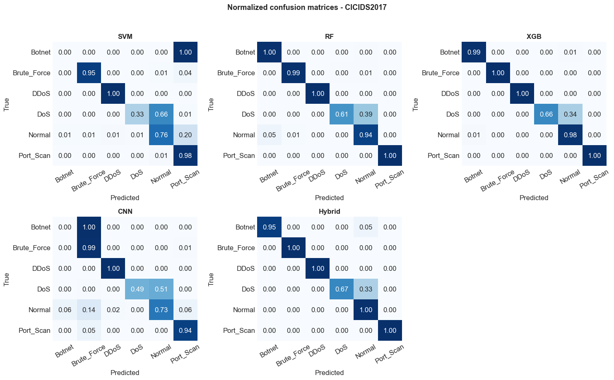
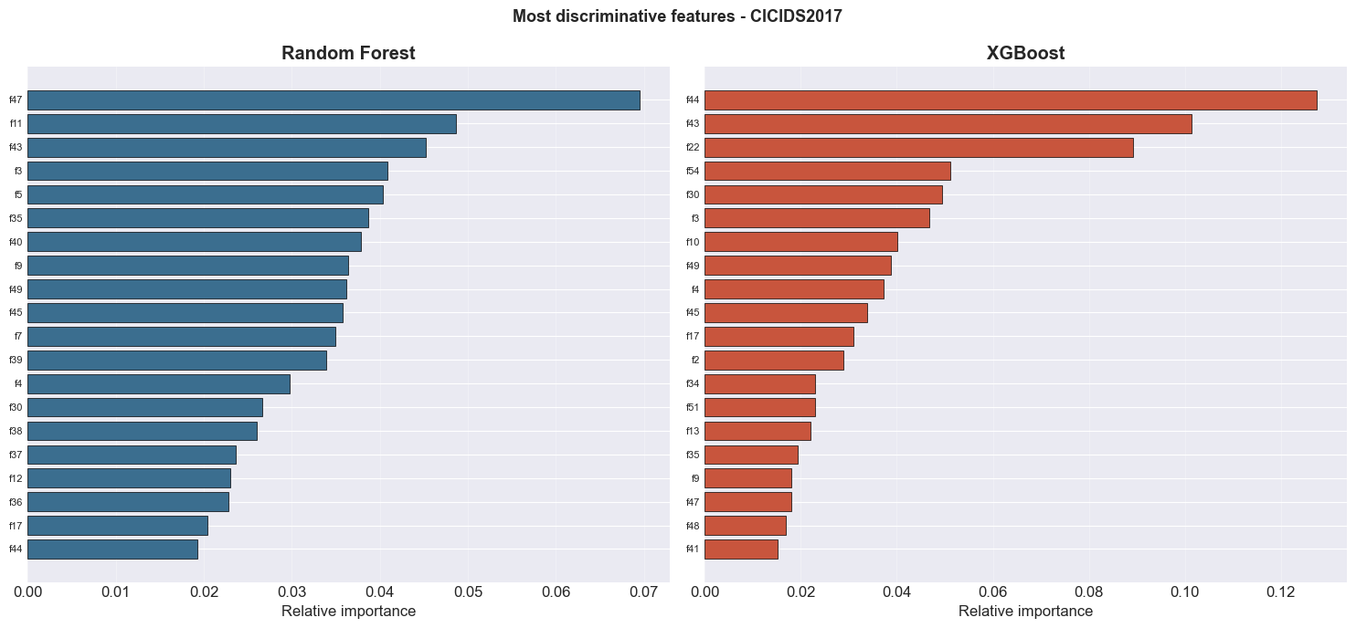
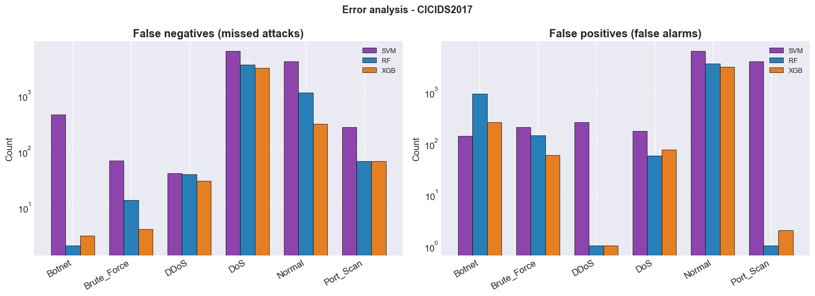
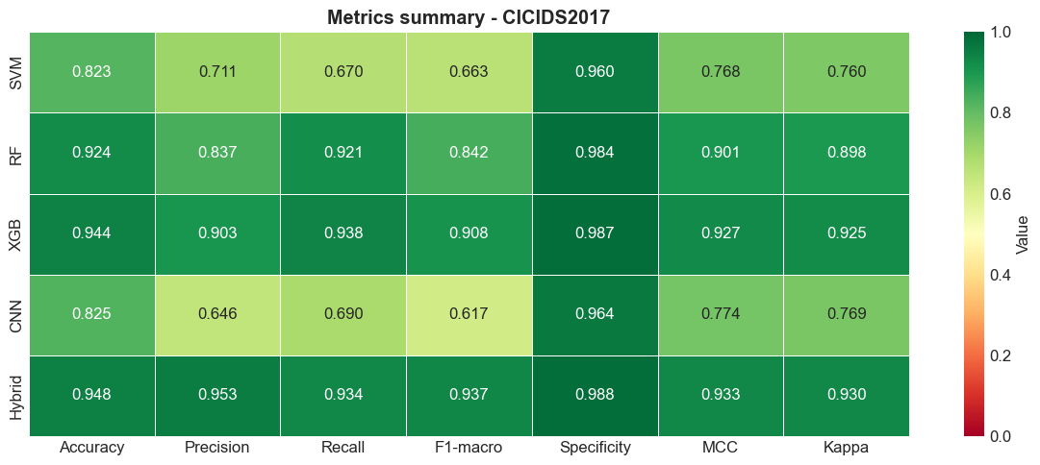
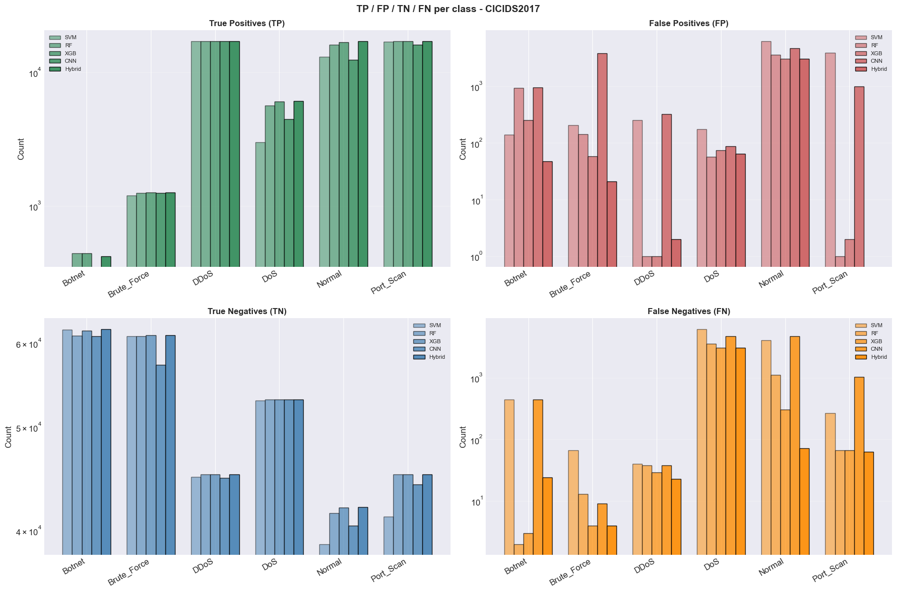
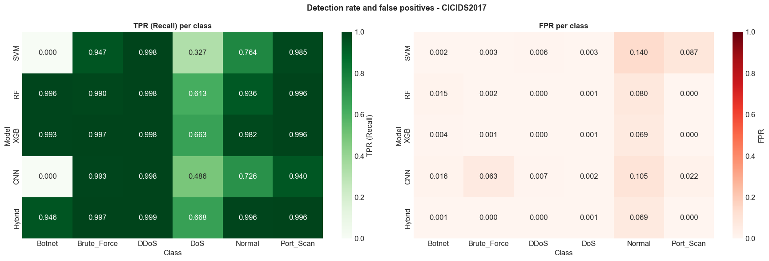
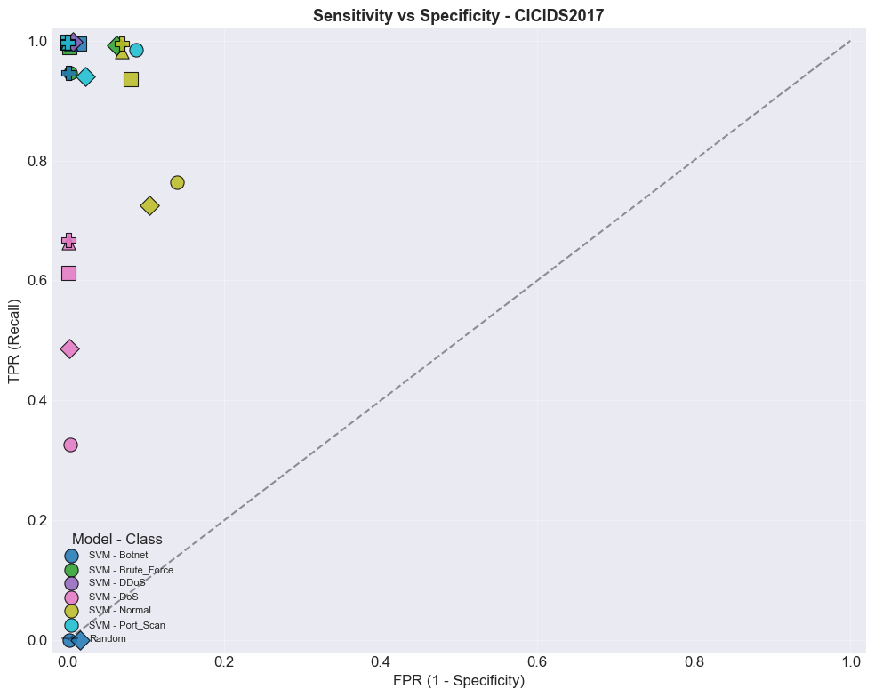
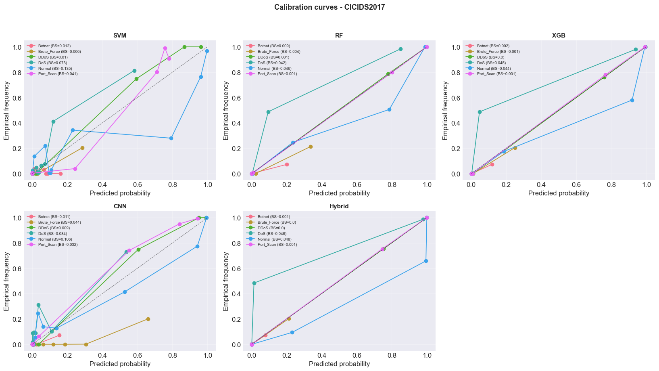
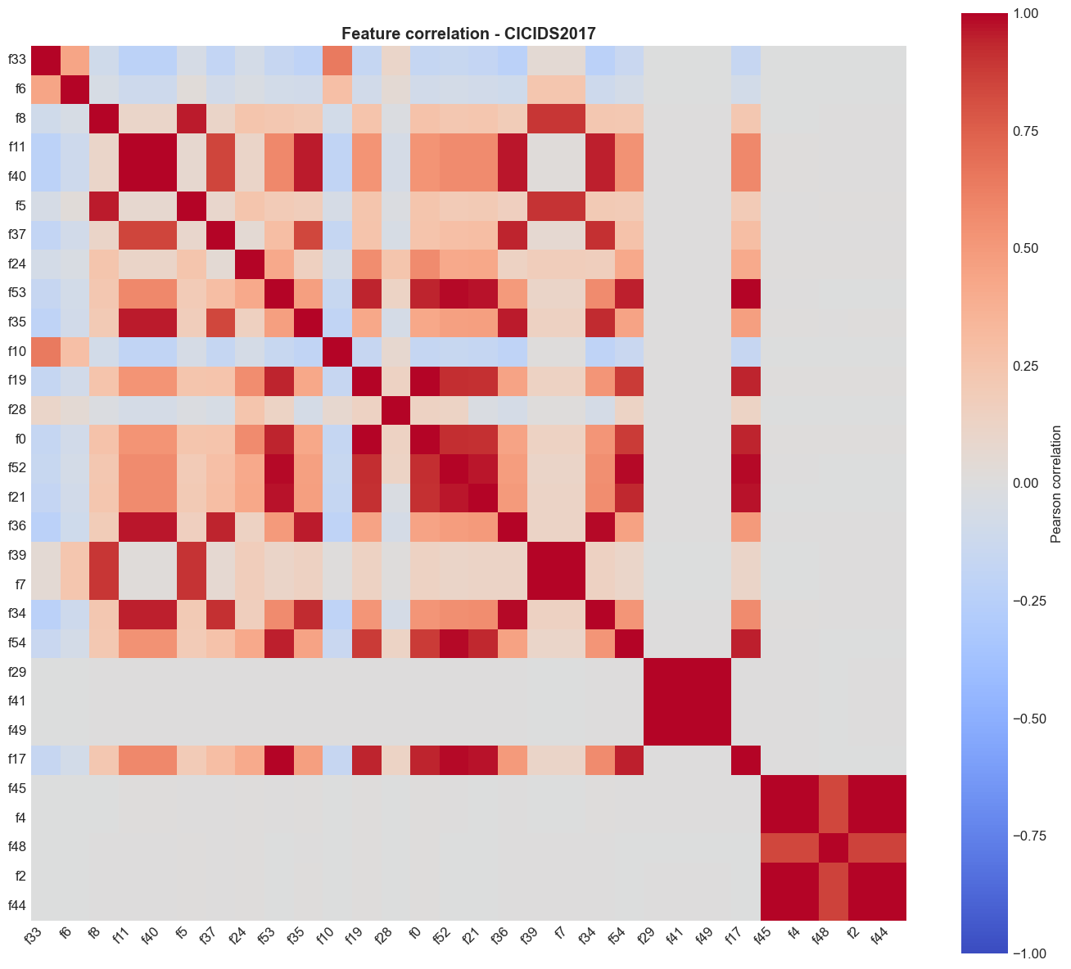
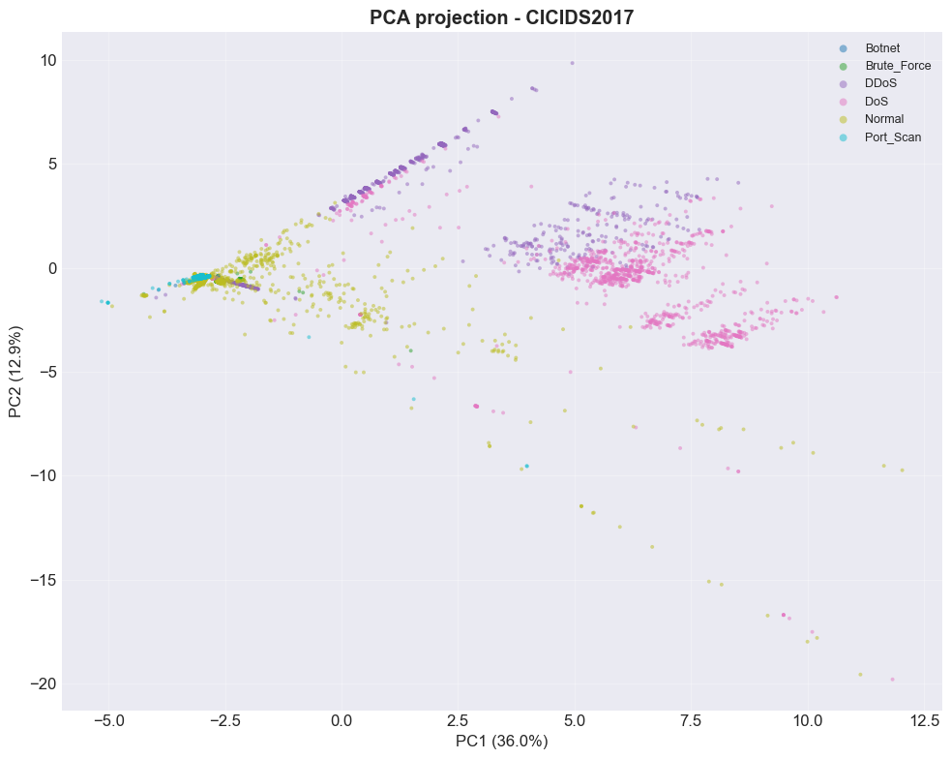
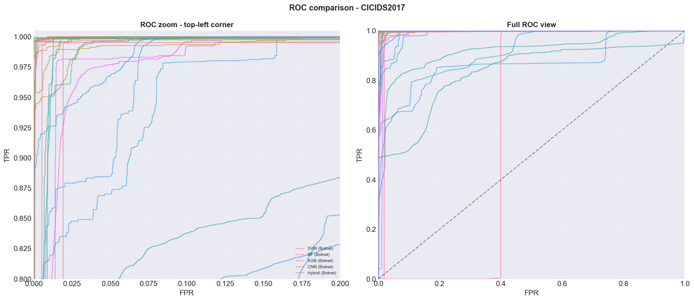
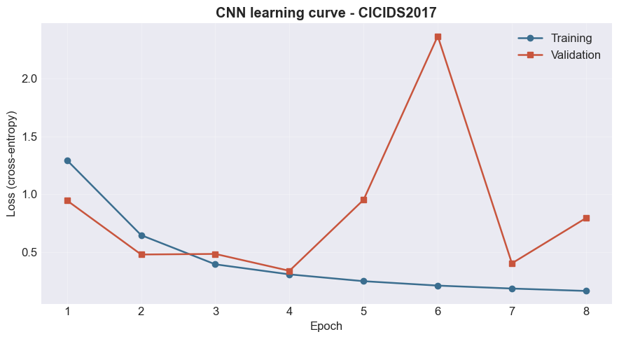
-> Figures generated successfully

[SHAP analysis - CICIDS2017]
RF : SHAP values computed (shape = (500, 55, 6))
XGB : SHAP values computed (shape = (500, 55, 6))
Hybrid_rf : SHAP values computed (shape = (500, 55, 6))
Hybrid_xgb : SHAP values computed (shape = (500, 55, 6))
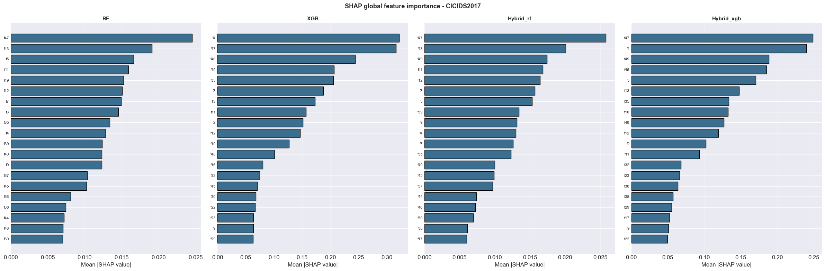
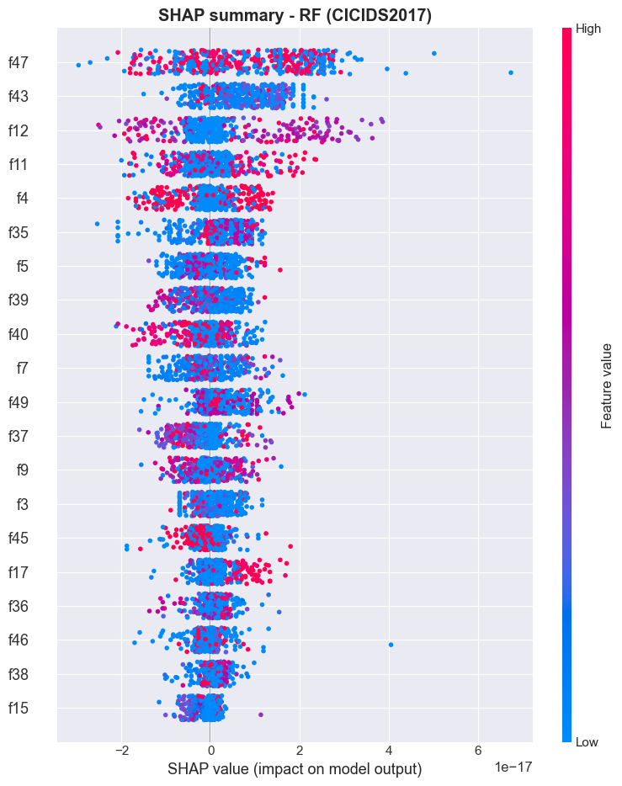
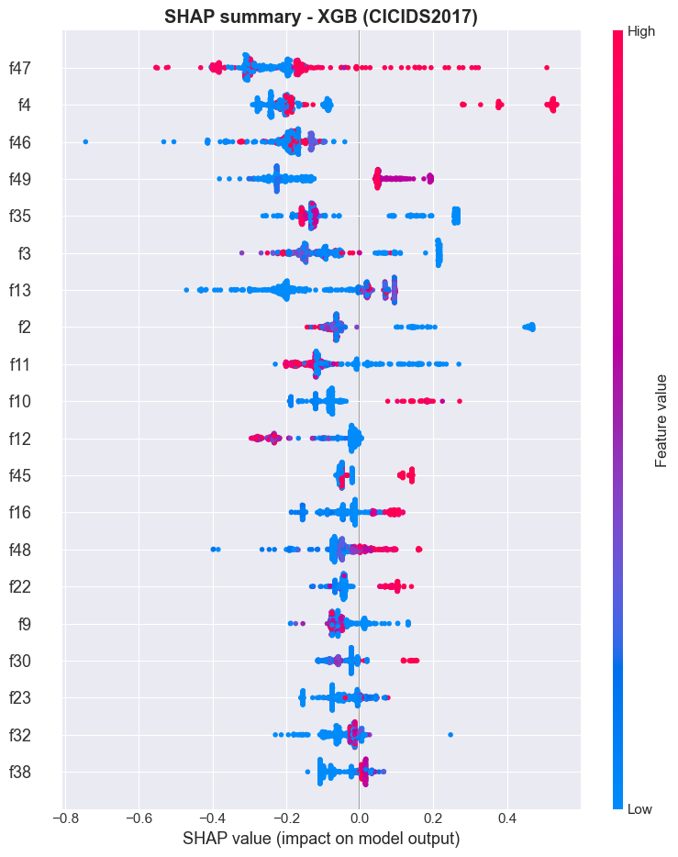
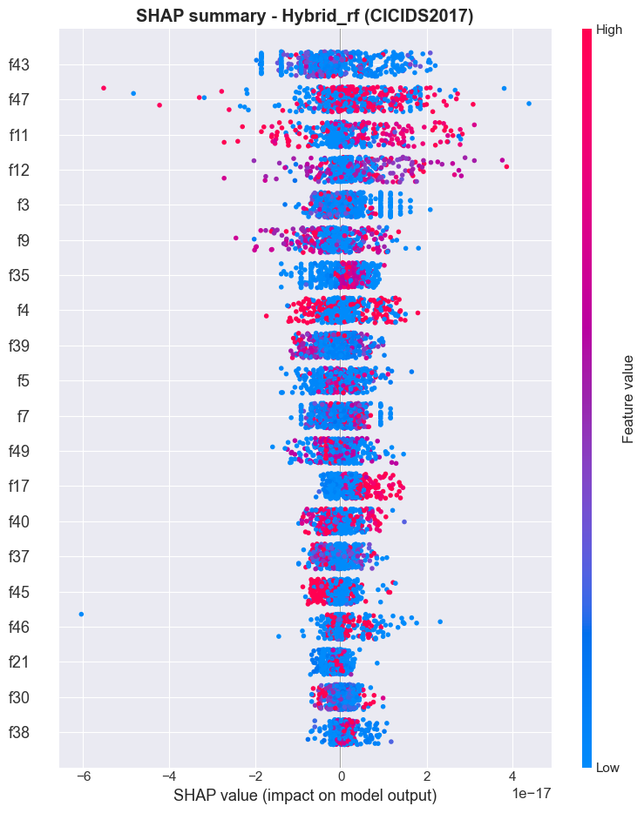
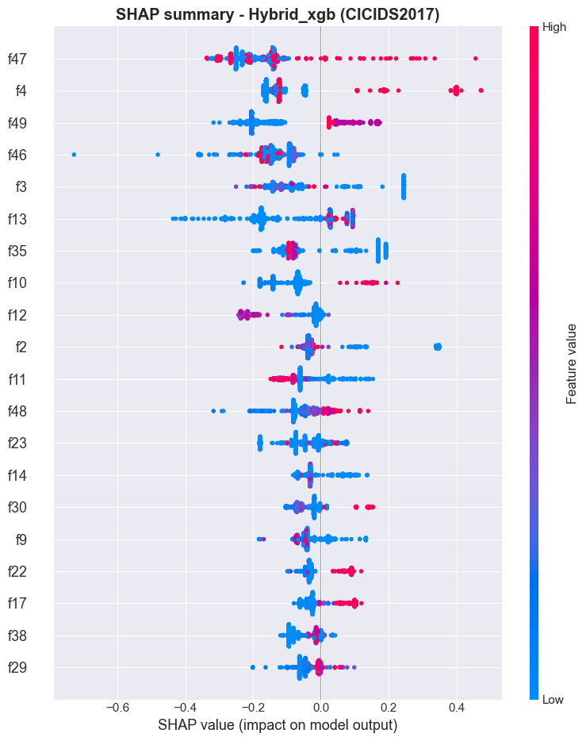

================================================================================
ABLATION STUDY - CICIDS2017
================================================================================

>>> Variant: Without CNN
Acc=94.74% | F1=92.97% | Rec=93.49% | Time=27.6s

>>> Variant: Without XGB
Acc=94.6% | F1=91.03% | Rec=94.07% | Time=108.0s

>>> Variant: Without RF
Acc=95.05% | F1=94.06% | Rec=93.57% | Time=109.5s

>>> Variant: Without SMOTE
Acc=94.87% | F1=94.38% | Rec=94.16% | Time=118.1s

>>> Variant: Without balanced (native meta)
Acc=94.63% | F1=93.11% | Rec=91.56% | Time=119.6s

>>> Variant: Meta = LogisticRegression
Acc=94.7% | F1=90.87% | Rec=94.21% | Time=117.2s

>>> Variant: Meta = RandomForest
Acc=93.82% | F1=89.84% | Rec=93.21% | Time=111.4s

>>> Variant: Full
Acc=94.8% | F1=93.65% | Rec=93.3% | Time=103.0s

=========================================================================================================
ABLATION TABLE - CICIDS2017
=========================================================================================================
Variant | Acc | Prec | Rec | F1-macro | MCC | Time
----------------------------------------------------------------------------------------------------
Without CNN | 94.74% | 93.85% | 93.49% | 92.97% | 0.9323 | 27.6s [-0.06]
Without XGB | 94.6% | 90.64% | 94.07% | 91.03% | 0.9302 | 108.0s [-0.2]
Without RF | 95.05% | 95.67% | 93.57% | 94.06% | 0.9362 | 109.5s [+0.25]
Without SMOTE | 94.87% | 95.86% | 94.16% | 94.38% | 0.9341 | 118.1s [+0.07]
Without balanced (native meta) | 94.63% | 96.08% | 91.56% | 93.11% | 0.9311 | 119.6s [-0.17]
Meta = LogisticRegression | 94.7% | 90.12% | 94.21% | 90.87% | 0.9313 | 117.2s [-0.1]
Meta = RandomForest | 93.82% | 89.79% | 93.21% | 89.84% | 0.9205 | 111.4s [-0.98]
Full | 94.8% | 95.26% | 93.3% | 93.65% | 0.9331 | 103.0s

Ablation CSV: C:\Users\desir\Desktop\CARINE EX FINAL\results\ablation_CICIDS2017.csv
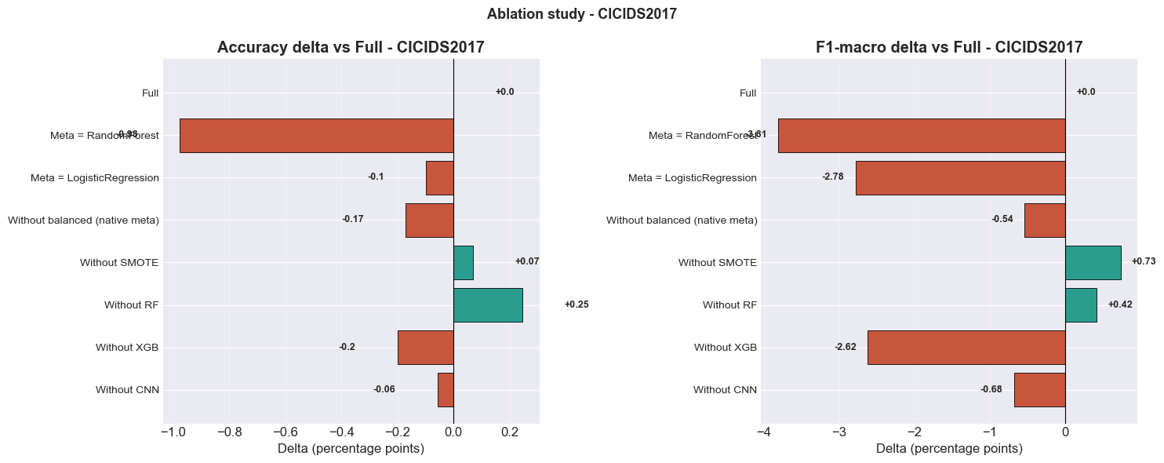
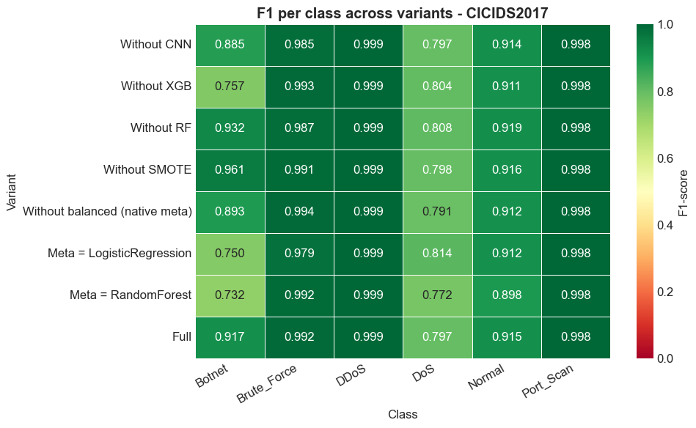

================================================================================
EXTENSION - SPLIT STRATEGY COMPARISON - CICIDS2017
================================================================================

============================================================
LOADING CICIDS2017 - RANDOM SPLIT (comparison)
============================================================
8 CSV files
Friday-WorkingHours-Afternoon-DDos.pcap_ISCX.csv : 225745
Friday-WorkingHours-Afternoon-PortScan.pcap_ISCX.csv : 286467
Friday-WorkingHours-Morning.pcap_ISCX.csv : 191033
Monday-WorkingHours.pcap_ISCX.csv : 529918
Thursday-WorkingHours-Afternoon-Infilteration.pcap_ISCX.csv : 288602
Thursday-WorkingHours-Morning-WebAttacks.pcap_ISCX.csv : 170366
Tuesday-WorkingHours.pcap_ISCX.csv : 445909
Wednesday-workingHours.pcap_ISCX.csv : 692703
Raw total : 2830743
After exact duplicates : 2574059
After near-duplicate removal (4 decimals) : 2498410 (removed 75649 near-duplicates)

RANDOM split (70/30) - ONLY difference from chronological
Train: 1748383 Test: 749307

[Leakage fix] Minimum class size (>= 50) on TRAIN only
After capping - Train: 168803 Test: 72340
Valid numerical columns: 77
CICIDS2017 (RANDOM) : Train=168803, Test=72340, 77 raw columns

>>> Training models with RANDOM split...

Train: 168803 Test: 72340
Classes: ['Botnet' 'Brute_Force' 'DDoS' 'DoS' 'Normal' 'Port_Scan']
Features: 55
Original distribution: {4: 40000, 3: 40000, 2: 40000, 5: 40000, 1: 7436, 0: 1367}
SMOTE target: 10000 | cap 5.0x | min class 100
SVM... 8.0s
RF... 1.6s
XGB... 4.5s
CNN... [CNN] features=55, classes=6, epochs=15
[CNN] Epoch 5/15 - Train: 0.222 | Val: 0.2362
[CNN] Epoch 10/15 - Train: 0.1308 | Val: 0.1426
[CNN] Early stopping epoch 12 (val=0.1261)
18.7s
Hybrid (RF+XGB+CNN) [balanced XGBoost meta]...
122.7s

================================================================================
RESULTS - CICIDS_random
================================================================================
Model | Acc | Prec | Rec | F1-macro | MCC | Kappa
------------------------------------------------------------------------------
SVM | 91.74% | 75.39% | 77.74% | 76.01% | 0.8958 | 0.8934
RF | 99.24% | 94.27% | 99.22% | 96.25% | 0.9902 | 0.9902
XGB | 99.62% | 96.38% | 99.59% | 97.81% | 0.995 | 0.995
CNN | 94.4% | 82.64% | 95.7% | 86.47% | 0.9294 | 0.9283
Hybrid | 99.83% | 98.98% | 99.67% | 99.32% | 0.9979 | 0.9979

================================================================================
DETAILED ANALYSIS - HYBRID (CICIDS_random)
================================================================================

Confusion matrix:
Botnet Brute_Force DDoS DoS Normal Port_Scan
Botnet 580 0 0 0 6 0
Brute_Force 0 3175 0 1 10 0
DDoS 0 0 17134 5 3 0
DoS 0 4 2 17117 19 0
Normal 32 7 5 13 17083 2
Port_Scan 0 3 0 6 2 17131
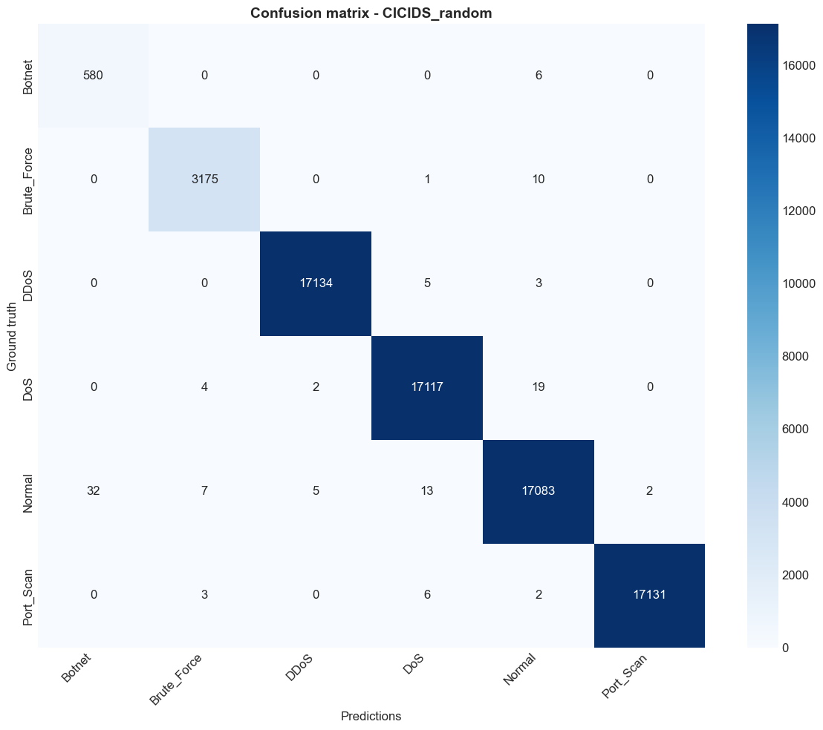
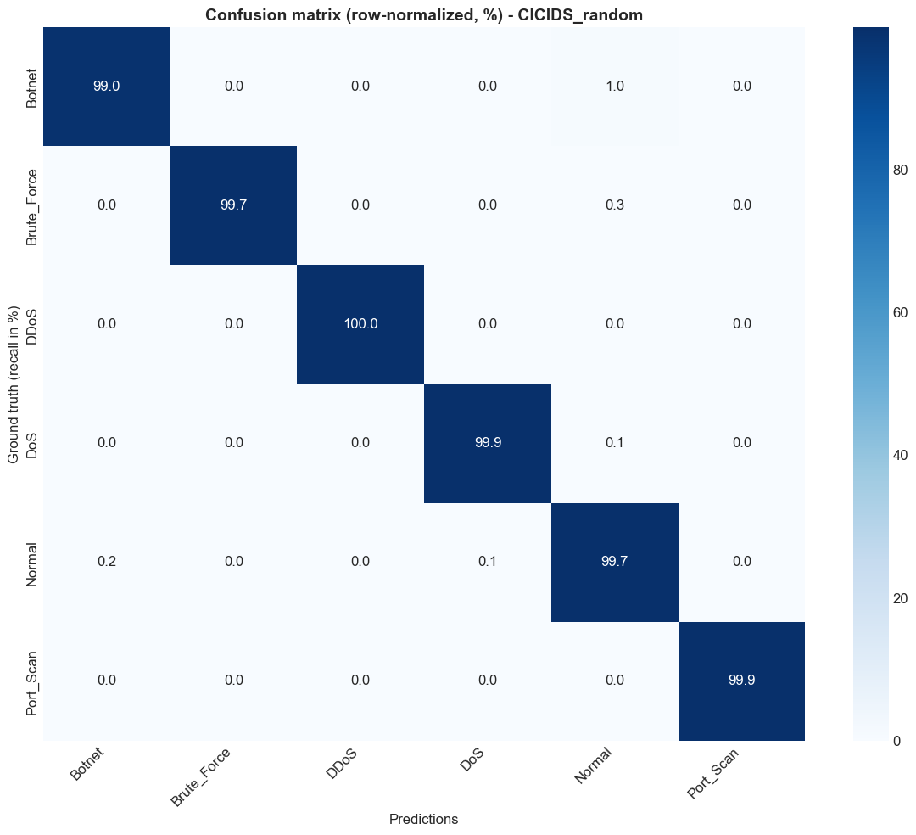

[Top confusions - sensitive classes - CICIDS_random]
Botnet recall=99.0% | mainly confused with: Normal (1.0%, n=6), Port_Scan (0.0%, n=0)
Brute_Force recall=99.7% | mainly confused with: Normal (0.3%, n=10), DoS (0.0%, n=1)

Classification report:
precision recall f1-score support

Botnet 0.948 0.990 0.968 586
Brute_Force 0.996 0.997 0.996 3186
DDoS 1.000 1.000 1.000 17142
DoS 0.999 0.999 0.999 17142
Normal 0.998 0.997 0.997 17142
Port_Scan 1.000 0.999 1.000 17142

accuracy 0.998 72340
macro avg 0.990 0.997 0.993 72340
weighted avg 0.998 0.998 0.998 72340

Per-class performance:
----------------------------------------------------------------------
Botnet | Prec: 0.9477 | Rec: 0.9898 | F1: 0.9683
Brute_Force | Prec: 0.9956 | Rec: 0.9965 | F1: 0.9961
DDoS | Prec: 0.9996 | Rec: 0.9995 | F1: 0.9996
DoS | Prec: 0.9985 | Rec: 0.9985 | F1: 0.9985
Normal | Prec: 0.9977 | Rec: 0.9966 | F1: 0.9971
Port_Scan | Prec: 0.9999 | Rec: 0.9994 | F1: 0.9996

==========================================================================================
TP / FP / TN / FN PER CLASS - CICIDS_random
==========================================================================================

Model: SVM
----------------------------------------------------------------------------
Class | TP | FP | TN | FN | TPR | FPR
----------------------------------------------------------------------------
Botnet | 14 | 317 | 71437 | 572 | 0.024 | 0.004
Brute_Force | 3014 | 1173 | 67981 | 172 | 0.946 | 0.017
DDoS | 17119 | 402 | 54796 | 23 | 0.999 | 0.007
DoS | 15454 | 182 | 55016 | 1688 | 0.902 | 0.003
Normal | 13752 | 577 | 54621 | 3390 | 0.802 | 0.01
Port_Scan | 17009 | 3327 | 51871 | 133 | 0.992 | 0.06

Model: RF
----------------------------------------------------------------------------
Class | TP | FP | TN | FN | TPR | FPR
----------------------------------------------------------------------------
Botnet | 582 | 276 | 71478 | 4 | 0.993 | 0.004
Brute_Force | 3154 | 24 | 69130 | 32 | 0.99 | 0.0
DDoS | 17117 | 9 | 55189 | 25 | 0.999 | 0.0
DoS | 16992 | 25 | 55173 | 150 | 0.991 | 0.0
Normal | 16824 | 211 | 54987 | 318 | 0.981 | 0.004
Port_Scan | 17124 | 2 | 55196 | 18 | 0.999 | 0.0

Model: XGB
----------------------------------------------------------------------------
Class | TP | FP | TN | FN | TPR | FPR
----------------------------------------------------------------------------
Botnet | 583 | 146 | 71608 | 3 | 0.995 | 0.002
Brute_Force | 3173 | 37 | 69117 | 13 | 0.996 | 0.001
DDoS | 17133 | 6 | 55192 | 9 | 0.999 | 0.0
DoS | 17113 | 47 | 55151 | 29 | 0.998 | 0.001
Normal | 16929 | 40 | 55158 | 213 | 0.988 | 0.001
Port_Scan | 17131 | 2 | 55196 | 11 | 0.999 | 0.0

Model: CNN
----------------------------------------------------------------------------
Class | TP | FP | TN | FN | TPR | FPR
----------------------------------------------------------------------------
Botnet | 582 | 825 | 70929 | 4 | 0.993 | 0.011
Brute_Force | 3126 | 1832 | 67322 | 60 | 0.981 | 0.026
DDoS | 16964 | 43 | 55155 | 178 | 0.99 | 0.001
DoS | 16143 | 323 | 54875 | 999 | 0.942 | 0.006
Normal | 14473 | 499 | 54699 | 2669 | 0.844 | 0.009
Port_Scan | 17003 | 527 | 54671 | 139 | 0.992 | 0.01

Model: Hybrid
----------------------------------------------------------------------------
Class | TP | FP | TN | FN | TPR | FPR
----------------------------------------------------------------------------
Botnet | 580 | 32 | 71722 | 6 | 0.99 | 0.0
Brute_Force | 3175 | 14 | 69140 | 11 | 0.997 | 0.0
DDoS | 17134 | 7 | 55191 | 8 | 1.0 | 0.0
DoS | 17117 | 25 | 55173 | 25 | 0.999 | 0.0
Normal | 17083 | 40 | 55158 | 59 | 0.997 | 0.001
Port_Scan | 17131 | 2 | 55196 | 11 | 0.999 | 0.0
TP/FP/TN/FN CSV: C:\Users\desir\Desktop\CARINE EX FINAL\results\tp_fp_tn_fn_CICIDS_random.csv

==========================================================================================
COMPARISON TABLE - RANDOM vs CHRONOLOGICAL SPLIT (CICIDS2017)
==========================================================================================
Model | Chrono Acc | Random Acc | Delta | Chrono F1 | Random F1 | F1 Delta
--------------------------------------------------------------------------------------
SVM | 82.29% | 91.74% | +9.45% | 66.33% | 76.01% | +9.68%
RF | 92.35% | 99.24% | +6.89% | 84.22% | 96.25% | +12.03%
XGB | 94.38% | 99.62% | +5.23% | 90.79% | 97.81% | +7.01%
CNN | 82.45% | 94.4% | +11.95% | 61.67% | 86.47% | +24.8%
Hybrid | 94.81% | 99.83% | +5.02% | 93.7% | 99.32% | +5.62%

SUMMARY:
Mean accuracy overestimation (random vs chrono): +7.71 pts
Mean F1-macro overestimation: +11.83 pts
Maximum overestimation (one model): +11.95 pts
Comparison CSV: C:\Users\desir\Desktop\CARINE EX FINAL\results\split_strategy_comparison_CICIDS2017.csv

================================================================================
GLOBAL VISUALIZATIONS
================================================================================
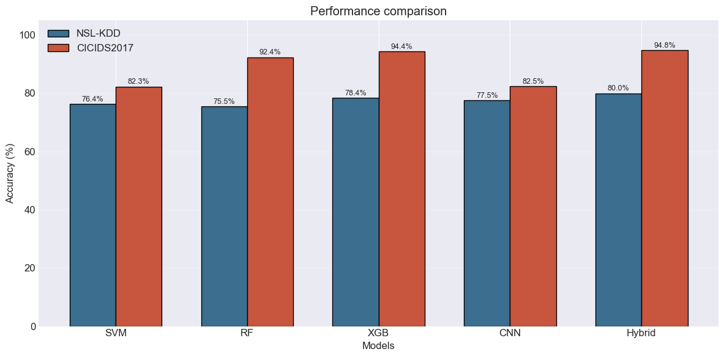
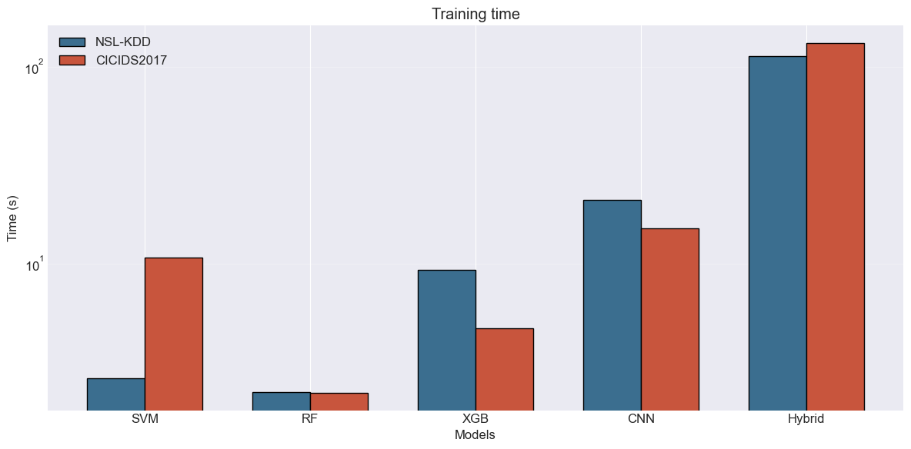
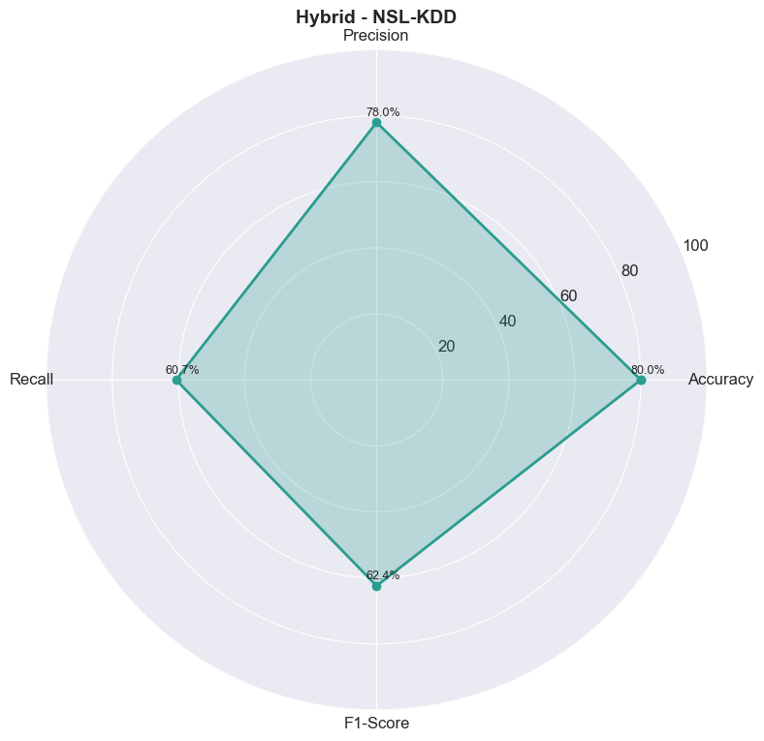
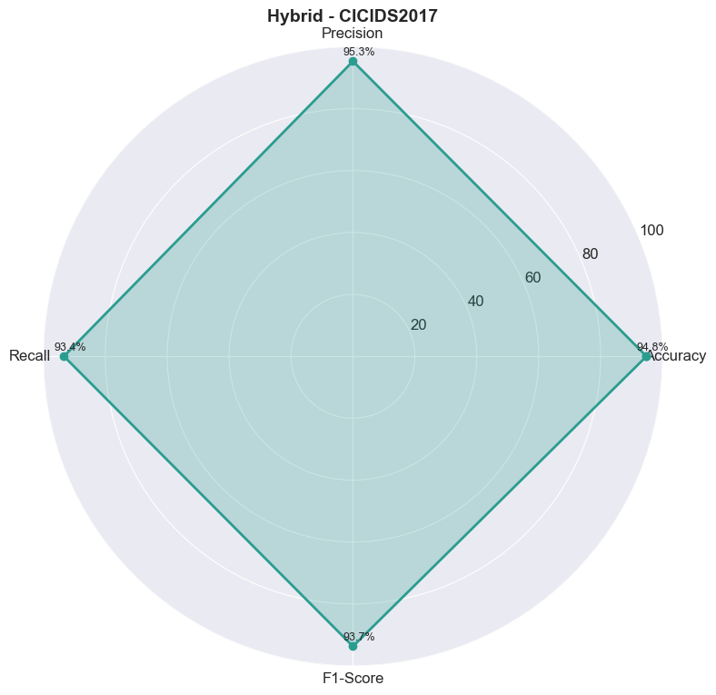
CSV: C:\Users\desir\Desktop\CARINE EX FINAL\results\experiment_results.csv

================================================================================
TABLE 4.1 - NSL-KDD (official split)
================================================================================
Model | Accuracy | Precision | Recall | F1-macro | MCC
-------------------------------------------------------------------------------------
SVM | 76.35% | 59.81% | 48.52% | 49.25% | 0.6552
RF | 75.46% | 77.43% | 52.1% | 53.37% | 0.6468
XGB | 78.38% | 81.57% | 58.42% | 60.6% | 0.6886
CNN | 77.52% | 87.74% | 54.48% | 55.77% | 0.6755
Hybrid | 79.99% | 78.02% | 60.71% | 62.42% | 0.7101 *

Best: Hybrid (79.99%)

================================================================================
TABLE 4.2 - CICIDS2017 (chronological split)
================================================================================
Model | Accuracy | Precision | Recall | F1-macro | MCC
-------------------------------------------------------------------------------------
SVM | 82.29% | 71.12% | 66.99% | 66.33% | 0.7675
RF | 92.35% | 83.73% | 92.13% | 84.22% | 0.9008
XGB | 94.38% | 90.35% | 93.82% | 90.79% | 0.9275
CNN | 82.45% | 64.58% | 69.04% | 61.67% | 0.7736
Hybrid | 94.81% | 95.32% | 93.35% | 93.7% | 0.9333 *

Best: Hybrid (94.81%)

================================================================================
TABLE 4.3 - CROSS-DATASET
================================================================================
Model | NSL-KDD | CICIDS2017 | Diff
----------------------------------------------------------------------
SVM | 76.35% | 82.29% | +5.94%
RF | 75.46% | 92.35% | +16.89%
XGB | 78.38% | 94.38% | +16.01%
CNN | 77.52% | 82.45% | +4.93%
Hybrid | 79.99% | 94.81% | +14.83%

================================================================================
TABLE 4.4 - TRAINING TIMES (s)
================================================================================
Model | NSL-KDD | CICIDS2017
-------------------------------------------------------
SVM | 2.6s | 10.8s
RF | 2.2s | 2.2s
XGB | 9.3s | 4.7s
CNN | 21.1s | 15.1s
Hybrid | 113.0s | 131.5s

================================================================================
CONCLUSIONS
================================================================================

NSL-KDD:
Best: Hybrid - 79.99%
Hybrid: 79.99%
Hybrid is best on NSL-KDD
Hybrid > XGB and RF
SMOTE gain: +5.02 pts

CICIDS2017:
Best: Hybrid - 94.81%
Hybrid: 94.81%
Hybrid is best on CICIDS2017
Hybrid > XGB and RF
SMOTE gain: +0.44 pts

================================================================================
EXPERIMENT COMPLETE - Total time: 42.3 min
Results: C:\Users\desir\Desktop\CARINE EX FINAL\results
================================================================================

Click to add a cell.

